**Academic Senate Meeting Minutes**

**Wednesday, January 25, 2023**

**Approved**

***Call to Order***

Academic Senate chairperson Martha Callison Horst called the meeting to order.

***Roll Call***

Academic Senate secretary Dimitrios Nikolaou called the roll and declared a quorum.

***Public Comment: All speakers must sign in with the Senate Secretary prior to the start of the meeting.***

Senator Horst: The Academic Senate of Illinois State University welcomes constructive communications from members of the University community and the citizens of Illinois. Students, faculty and staff are encouraged to provide information relative to the academic mission of the University.

The Academic Senate will allow up to ten (10) minutes in total for public comments and questions during a public meeting. An individual speaker will be permitted two (2) minutes for his or her presentation. When a large number of persons wish to speak on a single item, it is recommended they choose one or more persons to speak for them. The Academic Senate will accept copies of the speakers’ presentations, questions and other relevant written materials. When appropriate, the Academic Senate may provide a response to a speaker’s questions within a reasonable amount of time (24 hours or more) following the speaker’s presentation. Further comments, according to our bylaws, will be carried over to our next Senate meeting.

Just a reminder to our Public Commenter, please keep your comment to two minutes. If needed, Senator Nikolaou will provide a 30 second warning before your time has expired. We have three public commenters this evening. I would like to invite Rebekah Mangels to the microphone. She’s a Graduate Teaching Assistant in the School of Communications.

Ms. Mangels: Hello, Senators and President Kinzy. The following is a quote from an article in the Vidette: “A study done in April 2021 by frontiers in neuroscience found that in a sample of 153 graduate students 68% displayed symptoms of anxiety and 50% displayed symptoms of depression.” I, myself, find this statistic very significant. In the next few commenters, we are going to comment about the public health, and especially the mental health of graduate students at ISU. We, ourselves, are graduate students. We find this issue to be very pressing. And we believe that as faculty senators, you should all have empathy towards us as graduate students who are struggling with mental health. Personally, I have struggled with anxiety and depression over the course of my life. I have had traumatic events happen to me. Graduate students definitely know the pressures of everyday life. In summary, I believe that graduate students should be given accommodations. They should be given funds. They should be given accommodations, ways to live better, and ways to live with mental health that are beneficial to them. We contribute largely to the culture and the education at ISU, and we are an important population. As someone who has struggled with mental health, I definitely know that graduate school doesn’t exactly make that better. Thank you so much for your ear and have a great evening.

Senator Horst: Thank you so much. Our next speaker is Tiffany Bishop. She’s a graduate student in English.

Ms. Bishop: I wanted to talk more about a survey that the Graduate Workers Union assembled last semester and how that relates to this particular topic. Last semester we surveyed over 100 people and we found out that 41.3% of respondents stated that they suffer from burnout, which is one of the earlier signs of anxiety, depression -- stuff like that. I wanted to talk a little bit about those. The main things that people noted as contributors to burn out were mainly financial concerns, healthcare concerns, and then also academic concerns. This survey, while it focused mostly on graduate workers and what they need as workers, a lot of the concerns that came up actually ended up becoming student concerns, because of the environment that we work in and that we learn in is the same environment, so it can be hard to separate those. Some statistics: Financially, 69.6% of respondents noted that they are having a hard time affording student fees. 59.8% noted they are having a hard time paying rent. And 48.9% noted they are having a hard time paying for food. Then there is also 47.8% noted having a hard time paying for healthcare. This means that roughly half or greater of the survey respondents, again, over 100 graduate students and workers, are struggling to be able to afford the basic things they need to live and survive in Bloomington/Normal. Additionally, graduate students tend to be uniquely positioned to have additional challenges, especially graduate workers. 27.1% note that they have worked hours beyond what they are paid to work, and when that happens the hours that we have to do for our student work and the hours that we have to take care of our bodies and our metal health get taxed. As far as needs being specific to students, there’s also that concern that was mentioned about student fees, as well as 27.1% of respondents stating that they have issues affording materials for their student work. More specifically, in terms of discrimination, we had at least 12% of our respondents also say that they face discrimination as international students, discrimination from advisors, or discrimination based on the denial of access to a resource that they need in order to be able to do what they need to do around campus. This relates to our next speaker.

Senator Horst: Thank you so much. Our final public commenter is Steven Lazaroff. He’s a PhD student in the Department of English.

Mr. Lazaroff: Thank you. When I first came to an Academic Senate meeting in January 2021, the Senate met on Zoom. Returning now, it seems very strange that you all haven’t continued to meet on Zoom for accessibility reasons, or at least offer that. What is most strange, and in fact disturbing to me, is that the Senate and what happens here is not circulating for the majority of campus. Why shouldn’t the Academic Senate be accessible to the 20,000 people not in this room? Per ISU’s website, the Senate is the “primary governing body at ISU, provides for faculty and student participation. The Senate is the primary body to recommend educational policy.” Pretty important, it sounds like. It is interesting that the site advertises itself as, “a method of transparent governance that permits access to the process of the Senate.” Permits is a fascinating verb here, because permits as in allows access but does not encourage it. What is access? Is a PDF of minutes buried on a website access? Is the ability to hear and give public comment access? In a democratic university, the people of campus, the students, faculty, and staff, should be well informed on the events that determine their work life. In order to be well informed there should be much stronger opportunities for those 20,000 people that are not in this room. It seems hard to believe that there is some logistical reason that this particular room, out of all the rooms in the Bone Center, doesn’t have technology to stream. And it also seems hard to believe that the cost to stream would be a hardship for the University and President Kinzy and Provost Tarhule, and the folks that make these decisions. So, I ask President Kinzy, I ask Provost Tarhule, and the rest of the senators to take action to ensure that the rest of campus is able to know the decisions that occur here as well as the public comments that happen. Until this occurs, it’s really hard to say that what happens here in the Senate is democratic or public. Thank you.

***Presentation:***

* ***Winter Clean Up (Vice President for Finance and Planning Dan Stephens, Associate Vice President of Facilities Services Mike Gebeke, and Facilities Director Nick Stoff)***

**Presentation in Appendix I

* ***Illinois Board of Higher Education Funding (President Kinzy)***

**Presentation in Appendix II

* + ***IBHE FAC November 2022***
  + ***IBHE FAC November 2022 McMahon-Delaney FAC Power Point FINAL***

No discussion***.***

***Approval of the Academic Senate minutes of 11/09/22.***

Motion by Senator Miller, seconded by Senator Cline, to approve the minutes. The motion was unanimously approved.

***Chairperson's Remarks***

Senator Horst: It is great to see everyone this evening. I hope everyone had a restful and productive break and had some quality family and personal time.

I appreciate everyone braving the cold and inclement weather and coming out to the senate. Thank you all for your dedication to the senate's work. It was a nice coincidence that we had a presentation on how our facilities division goes about preparing our campus after a winter event such as what we had today. I am appreciative of all of the work that they do to make our campus safe.

This evening, I have three general announcements for faculty.

First, as you may have read in a recent email, the Provost’s office is seeking volunteer faculty for workgroups to address items that arose from the COACHE survey. The workgroups are arranged according to themes. These themes are:

1) Appreciation/Recognition, 2) Service, 3) Research, 4) Leadership, and 5) Compensation.

I am working with former senator Braswell on the Leadership working group. The deadline for nominations or self-nominations is January 30. The Provost's office has a form, and the link to that form is imbedded in a recent mass email from the Provost. Alternatively, you could email Interim Assistant Vice President Deneca Avant. Please encourage your colleagues to volunteer.

Second, the University is beginning the processes of reapplying for accreditation. Our Associate Provost is steering this effort, and she is seeking a faculty senator to serve on one of the committees. Ani will be discussing this in more detail later, but I wanted to emphasize how important this work is to the university. Without accreditation, we lose the ability to give out legitimate degrees. So, faculty senators, please consider her request for a volunteer to serve. If we have more than one volunteer this evening, than we can hold an election next time. If we have no one, then there will be not senate representative on the communications committee.

Third, the University is also working on creating a new strategic plan. We have scheduled a meeting between members of the strategic planning committee and the Planning and Finance Committee, which is charged with working on long range planning. We hope to have a presentation with the full senate in the near future as well. This is important work. I believe that a survey to the entire University campus will go out soon that will request feedback on what people would like to see in the new strategic plan. So, please encourage your colleagues to fill out this form and please try to participate in the focus groups that are occurring across campus.

Finally, I have heard from several colleagues about the untimely death of English professor Kass Fleisher. By all accounts, she was a wonderful and beloved colleague and friend. I know that her death had an emotional impact on several faculty, and my condolences go out to them -- particularly to the English department. I understand that the English department will be holding a memorial celebration later on in the spring in her honor.

***Student Body President's Remarks***

Senator Walsh: Hello all. I hope you all had a great winter break that was restful with family and friends. First, I would like to congratulate our most recent 2022 fall semester graduates. I wish them the best of luck in their careers as they move on from Illinois State University.

Next, I would like to provide an update on the work of Student Government. Recently, members of our association have been in contact with the Town of Normal regarding renter’s rights. Many students have spoken about concerns with local leasing agencies sending representatives and other workers to their apartments with extremely short notification. This results in students having strangers enter their apartment with minimal notification, which doesn’t allow them adequate time to prepare their apartment, for instance. This is a major issue for many students who live off campus. I’m eager to hear of my Student Government colleagues work in advocating for a 24-hour notice requirement for tenants in the Town of Normal.

Additionally, I’ve been in contact with state representative Jackie Haas to speak about excused mental health absences for college and university students in the State of Illinois. My goal would be to have a similar state law to that of Senate Bill 1577 that allocated five mental health days for K-12 students in the State of Illinois. A study done by Boston College showed a 135% increase in depression and a 110% increase in anxiety among college students from 2013-2021. This emphasizes how mental illness is a growing concern for higher education students across the nation. I’m currently working with students from SIUE as well as Western Illinois University to advocate to our state officials for this cause as well. I look forward to informing you all with more information as Student Government progresses with this project. Thank you.

***Administrators' Remarks:***

* ***President Terri Goss Kinzy***

President Kinzy: My remarks will be brief since I already gave you remarks. But I wanted to say happy spring semester (it doesn’t look like it, right). I’m glad to be here. Last meeting, I was in the middle of a road trip between the induction of Boomer Grigsby as the first Missouri Valley Football Conference and Illinois State University football player to be inducted into the College Football Hall of Fame. As chair of the Presidents of the Missouri Valley Football Conference, it was great to be there with two hats on. And Boomer has just been wonderful. It’s interesting he was nominated three times for the Buck Buchanan Award as defensive planner of the year and didn’t win, but Zeke won it this year. And there was no one happier than Boomer. So, it’s nice to see the legacy here. Between there, I was on my way to the Foundation Board. The Foundation Board is looking into how we can continue to raise funds for the University from donors, community members, and corporations to support our work. And then the last meeting, I’m very excited that the Red Cross chose to come back to the Bone Student Center for their Night of Stars. It is a very important event here in the community. It’s an important cause, and we love how the Red Cross supports our students in times of need, such as when there was a fire in an apartment building; even though it’s off campus, the Red Cross helps us with that. I want to say that the woman from Chicago who was in charge of the event came up to me and said that in all her days she had never worked with a better team of people and had an event run as smoothly. So, kudos to Student Affairs, the team here in the Bone Student Center, and everyone in EMDH. We know they are great. It’s great to know that other people know they’re great as well.

I just want to talk about two things that have happened that are important for everyone to know. Today I charged the Diversity and Inclusion Advisory Council sub-committee on LGBTQIA+ policies and procedures for their work to address how the university can support our community here at Illinois State University. I’m very excited that Dr. Byron Craig has joined the Office of Inclusion and Equity as a faculty fellow and will be leading that work.

Secondly, Dr. Jonathan Lackland has left Illinois State University in December from his role of Director of Government Affairs. We have hired Illinois State University alumni Brian Bernardoni as our outside representation. His is a very enthusiastic supporter of Illinois State University and a former vice president of Student Government. He will help us with our current needs in terms of relations with the legislature in the Governor’s office, help us to update our job description to reflect what’s really needed in Springfield, as well as our federal relations, and help us identify candidates with his network for the role of director, which will be filled. We hope to be posting that position soon so that we can have a government affairs person again in the cabinet. But also, he will help us to re-envision our vision of how we interact with the state and federal government to support Illinois State. It worked really well. We brought in an outside firm and Dean Neubrander lead the effort, working with Provost Tarhule, to get a $2 million earmark from the federal government, thanks to Senator Durbin and Representative LaHood. $2 million towards our simulation center. Let’s see what else we can do. Thank you.

* ***Associate Provost Ani Yazedjian (Provost Aondover Tarhule- Excused)***

Senator Horst: Provost Tarhule is traveling this evening, so he asked Associate Provost Ani Yazedjian to give a report in his absence.

Dr. Yazedjian: As Chairperson Horst said, Provost Tarhule could not be here this evening, so I will be giving his remarks. We are very pleased to have hired Dr. Tom Keyser to be the founding dean of the new College of Engineering. He’ll be beginning his position on April 1. Our office has begun searches for the chair of Electrical and Mechanical Engineering. We anticipate candidates will be on campus sometime in April and that Dr. Keyser will have the opportunity to meet with them at that time.

Additionally, our office has three other ongoing searches taking place. Associate Vice President for Academic Administration, Associate Vice President for Faculty and Staff Development, Diversity, and Learning, and the Dean of the College of Applied Science and Technology. The search committees are in place and these positions are currently posted. We expect to have candidates on campus later this spring.

This spring, Illinois State University is also convening seven work teams to begin work on our ten-year re-accreditation process through the Higher Learning Commission (HLC). Our self-study process will continue for the next year and a half and culminate in a site visit in late October 2024. As part of this process, this spring the work teams will be collecting evidence to document our policies and practices, and then Dr. Cooper Cutting and I will then draft the narrative over the summer. Different opportunities will be available for folks to provide feedback on the draft assurance argument in the fall semester. This is an institutional reaccreditation. It’s not just something for Academic Affairs, so to that end, our seven work teams include over 50 representatives from all four divisions and Athletics. Many variables were taken into consideration when appointing work team members. Every dean was provided the opportunity to provide names of interested faculty and staff from their colleges to serve on the taskforce. Chairperson Horst is representing the Senate and co-chairing one of the work groups. Tonight, I’d like to invite one more senator to serve on the Communications Work Team. This team will not be responsible for collecting or reviewing any evidence but rather keep the campus community apprised of progress through the completion of the self-study process between now and October 2024.

In other news, the interdisciplinary collaborative research opportunity Advancing Research and Creative Scholarship, also known as ARCS, is now accepting letters of intent, relative information, including detailed application guidelines, FAQs, etc. may be found on the program website. <https://research.illinoisstate.edu/arcs/>

For the last few weeks, support staff have focused on helping those instructors and students in the campus pilot program start the semester strong. We’ve already received valuable feedback and discovered minor issues which need to be addressed. In short, the pilot program is working as a pilot is intended to. I can report that we are on track to adopt Canvas as the sole learning management system for the fall of 2023. We now begin the next phase, which is engaging all faculty members through targeted communications to ease them into the transition from Reggie Net to Canvas. All instructors should expect regular updates this semester. The first communication will encourage instructors to take simple steps now to back up content from their Reggie Net courses. This is the best transition method for instructors who perhaps only use Reggie Net for posting a syllabus and course readings. Faculty will also receive instructions on how they can request the migration of one version of any course they taught between spring 2021 and fall 2022, including summer and winter intercession courses. Stay tuned for more information from Dr. Deneca Winfrey-Avant.

Finally, I’ll close my comments and just ask for us to reflect on the loss of Professor Kass Fleisher. Our office was saddened to learn of her death in January. As a professor of English, she was an extremely talented writer. She taught creative writing and literature here for many years. Her passing is a loss to the English Department and the university as a whole. We send our condolences to her family, friends, and colleagues.

* ***Call for Higher Learning Commission Planning Taskforce (Accreditation process) (1 Faculty Senator seat)***

There were no volunteers for the accreditation working group.

* ***Vice President for Student Affairs Levester Johnson***

Senator Johnson: I want to welcome everyone back to campus. Happy New Year. I want to start off by following up with fall semester incident that involved vandalism, hazing, slurs, and actions against our LGBTQIA+ community. I also want to introduce some staff move forward who will be critical in the work that we do in supporting our students. I’ll start with the results of the hearing that took place last semester. Again, we appreciate the campus community for their patience as we let the conduct system work its way out. But as a result of fall semester incident, that did involve Tri Sigma House as well as Alpha Sigma Phi sorority houses, (that’s where the vandalism took place) Kappa Sigma was found responsible for its actions and did receive a sanction of suspension for three years. In addition to the organization being sanctioned, several individuals within the chapter were also found responsible for their personal involvement and received sanctions of anything from probation through several suspensions as well. This information, as relates to the results of hearings, all that’s posted at the Dean of Students office Student Conduct website. You can see the results for that—except for individual cases—but you will see organizations and their status listed there.

There are a number of other additional programs and services that we have put in place in order to support students moving forward. The first one I’ll talk about that we are hoping and seeking to secure funding for is our Safe Redbirds Ambassador program. This would be a program that will promote additional awareness for our students and escort service to promote safety on our campus. As far as the outreach program, a component of this, we have some programming for some student groups, organizations, and residential students, with inclusivity being our primary goal. The focus with targeting our outreach to marginalized groups is so that they are aware of the support services and how they can make reports on our campus as well. Our outreach will also include listening circles, support for when students want to rally and have demonstrations, as well as additional safety initiatives. We would also do some additional education with different groups on our safe awareness app awareness program. The next component would be to expand existing program for escorting students on campus if they feel unsafe. We’re going to call it STOP, STudents On Patrol. We are going to hire some additional students who will escort students from one point on campus to the next point on campus. So, we’re very excited about our safe Redbirds Ambassadors program moving forward and hope to secure funds such that we can start this program during the next academic year.

In addition to the Safe Redbirds Program, we have also added a case manager to the Dean of Students office. That individual is Ron Givens, who will focus on providing support for our students during the evening hours. Ron will be located in the Dean of Students suite and serving Monday- Friday 2:00-10:30 p.m. Students can reach Ron by calling 309-438-8603 or by emailing him at [rgivens@ilstu.edu](mailto:rgivens@ilstu.edu).

Also, we have a new addition to our Student Affairs leadership team. I’m pleased to announce the selection and joining to our campus community of Dr. Andy Morgan as our New Assistant Vice President and Dean of Students. Dr. Morgan brings 25 years of higher education administration experience, including serving as the Associate Vice President and Dean of Students at Indiana State University, where he also served as the interim Vice President for Student Affairs there, and also as the Associate Dean of Students at Southern Illinois University in Carbondale. I want to welcome him. And there is one more component to our safety program that he in the Dean of Students office as well as our previous interim Dean of Students helped develop -- that’s a support piece for our faculty and staff in order for you all to be aware of some of the programs that we have on campus. I’m going to distribute this while he talks a little about our guide to help students get help on campus.

DoS Morgan: Thanks for allowing me to talk this evening. He’s passing around the guide to helping students get help. This is for faculty and staff as a resource guide when they see a student that may need help. The main thing is when our students need assistance you or the student can always call the Dean on Duty in the Dean of Students office or refer them to Redbird Care. We’ll get them the care that they need, and we’ll get them help. General advocacy, always call the Dean of Students office. There is a QR code in this. We will be shipping these to each of the departments on campus so faculty and staff can have it on hand. The other thing is on absence and leave issues. There’s always some confusion on that. The Dean of Students office handles those, and there’s a QR code regarding that. Mental healthcare and consultation, obviously our great staff over at the Student Counseling Services are there to assist students, and they are also located in the Students’ Services Building on the same floor as the Dean of Students office. Medical care and consultation -- our staff in Student Health Services are on the second floor of the Student Services Building. And then, serious and concerning behaviors is the Redbird Care. We have a great group of staff that are part of that team where we collaborate across campus to assist students in need, especially those with serious issues. Reporting violations of the Code of Student Conduct are Staff and Student Conduct and Community Responsibilities, and then just making official reports you can refer them to the Safe Redbirds app. The main thing to remember, we are here to help all our students whenever a situation may arise; and when in doubt, always contact the Dean of Students office.

Senator Mainieri: My only question was if this awesome resource is available in electronic format?

Senator Johnson: We will make that available, yes. The other thing we will be doing, again, I don’t want to bypass this, but we will be going out and doing additional sessions, and making students aware of our Safe Redbirds app. Where a lot of this information is located. We know that you want it right in your hands.

* ***Vice President for Finance and Planning Dan Stephens***

Senator Stephens: I want to thank Nick for presenting this evening on this important campus safety topic. For the sake of saving times for other topics on the Senate agenda, I will not share any additional remarks tonight. However, I’ll be happy to answer any questions.

***Consent Agenda: (All items under the Consent Agenda are considered to be routine in nature and will be enacted by one motion. There will be no separate discussion of these items.)***

* ***Mathematics:*** [***Mathematics Actuarial Science Online Masters Sequence***](https://academicsenate.illinoisstate.edu/consent/2022-11%20Mathematics%20Actuarial%20Science%20Online%20Masters%20Sequence.pdf)
* ***School of Information Technology:*** [***General Computer Science Accelerated***](https://academicsenate.illinoisstate.edu/consent/2022-11%20General%20Computer%20Science%20Accelerated.pdf)
* ***Special Education:*** [***LBS I Endorsement Certificate***](https://academicsenate.illinoisstate.edu/consent/2022-11%20Special%20Ed%20LBS%20I%20Endorsement%20Certificate.pdf)
* ***Marketing:***  [***Advanced Marketing Analytics Accelerated Sequence***](https://academicsenate.illinoisstate.edu/consent/2022-12%20Advanced%20Marketing%20Analytics%20Accelerated%20Sequence.pdf)
* ***Health Science:*** [***Executive Summary: Healthcare Leadership Sequence***](https://academicsenate.illinoisstate.edu/consent/2022-12%20Healthcare%20Leadership%20Sequence.pdf)

Motion by Senator Pancrazio, seconded by Senator Garrahy, to approve items on the Consent Agenda. The motion was unanimously approved.

***Action Item:***

***From Academic Affairs Committee:***

***11.16.22.15 Policy 4.1.18 Transfer of Credit from Other Institutions and Credit by Examination_ Current Copy***

***12.01.22.01 Proposed Policy 4.1.18 Credit Earned through Transfer_ Examination_ and Prior Learning_ Mark Up***

***11.29.22.01 Proposed Policy 4.1.18 Credit Earned through Transfer_ Examination_ and Prior Learning_ Clean Copy***

Senator Cline: The Academic Affairs Committee brings policy 4.1.18 Credit Earned through Transfer, Examination, and Prior Learning. The was an information item at the last meeting. Since then, one thing has come up that I would like to offer a friendly amendment from the committee. At the end of the first paragraph that is titles Collegiate Sources, we would follow that, at the last sentence with the following sentence, “Credit may be granted for general education, major courses, major electives, non-major electives, or graduation requirements such as AMALI and IDEAS.”

Motion by Senator Cline, on behalf of the Academic Affairs Committee, to approve policy 4.1.18 Credit Earned through Transfer, Examination, and Prior Learning. The motion was unanimously approved.

***Information/Action Item:***

***From Janice Bonneville:***

***11.29.22.02 Policy 3.1.11_Summary of changes for Senate***

***01.12.23.01 Policy 3.1.11 Leave of Absence_Current Copy***

***01.20.23.02 Policy 3.1.11 Leave of Absence_Mark Up***

***01.20.23.01 Policy 3.1.11 Leave of Absence_Clean Copy  
820 ILCS 154_  Family Bereavement Leave Act***

Senator Horst: This came to the Executive Committee due to a change in Illinois law. There are some additional bereavement benefits that went into effect on January 1, 2023. The Executive Committee thought this was important to make sure that the Illinois State University community have these benefits, so we decided to send it directly to the floor and not to an internal committee. I would like to invite Vice President Bonneville to brief us on the law changes that lead to the revisions her office is proposing.

AVP Bonneville: Some of you may recall, because you’ve been in these rooms on Wednesday evening every other week for a while, that we made a change about a year ago which expanded bereavement leave in the event of a loss of a child. This last legislative session they expanded again to a family bereavement leave approach. What they did, obviously they change the definition, they added a general statement regarding the use of bereavement leave, and they added some additional language about the loss of a child related to still birth or miscarriage. The law also expanded greatly on unpaid time off for bereavement. So, we have bereavement leave is paid time off, the number of days dependent on the relationship of the individual requesting leave to the individual who passed away. Now, we have a much larger section on unpaid bereavement leave including areas of unsuccessful rounds of artificial insemination or assisted reproductive technology. It includes a failed adoption or adoption match that is not finalized because it’s contested by another party, a failed surrogacy agreement or a diagnosis that negatively impacts pregnancy or fertility. So, all of those reasons are now under unpaid bereavement leave. Additionally, we clarified how you can use unpaid bereavement time, and indicated what kind of documentation may be needed to take that time. And then we also simply just relocated some language within the policy to make it clearer between the paid and the unpaid bereavement leave.

Senator Nikolaou: I had a question. When we have the bereavement leave, it’s up to three working days. When we did the student bereavement policy, it mentioned that they can also get extra time depending on the distance of where they have to travel so it has details if it is more than 100 miles, more than 50 miles, or whatever. Is this something that can be incorporated, or have we considered it? And the other part was if these three days need to be continuous or can it be noncontinuous?

AVP Bonneville: So, I’m going to answer the second question first, and it can be noncontinuous. So, if I lose a member of my family, I can take two days off now, and then I can take another day off later that would still be deemed bereavement leave based upon the schedule for the family. In terms of expanding, I think it’s important to realize that when we look at the number of days, we’re talking about the number of days for which you’re not required to take your own personal leave time. So, these are three days or one day, depending on the relationship of the individual who passes away, that are compensated separate and distinct from any other compensation the employee is entitled to from the university. With the expansion of the unpaid leave, in the example you gave, an employee can be granted up to an additional ten workdays of unpaid leave. So, if there is a situation where the person has to travel or there’s some other extenuating circumstance or maybe… bereavement is difficult, and sometimes three days isn’t enough. But people can use their own time, or they can take unpaid leave to address any issues they may be having. So, there is an ability to extend it, and then obviously if the individual is having some own personal issues with the loss, they can take a leave of absence. There’s a number of avenues available. So, the definition of three days versus one days is simply the paid time off for bereavement. Then there is additional time that may be available to the employee if they need to take that time.

Motion by Senator Pancrazio, seconded by Senator Cline, to move to action. The motion was unanimously approved.

The revisions to policy 3.1.11 Leave of Absence were approved.

***Information items:***

***From Planning and Finance Committee:***

***03.24.22.25 Policy 3.4.7 Employment for Teaching Purposes of Administrative_Professional Personnel Current Copy***

***12.09.22.02 Propose Policy 3.2.21 Employment for Teaching Purposes of Administrative Professional and Civil Service Personnel_Mark Up***

***12.09.22.01 Propose Policy 3.2.21 Employment for Teaching Purposes of Administrative Professional and Civil Service Personnel_Clean Copy***

Senator Valentin: The Planning and Finance Committee initially reviewed this policy last year and incorporated certain suggested revisions from Human Resources. There were some questions that came up when the revision was sent to Exec Committee. The policy went back to our committee this year for additional review, and now we present this policy as an information item. Associate Vice president for Human Resources Janice Bonneville has graciously agreed to help stay here to answer any questions regarding this policy.

One thing to point out here is rather than update policy 3.4.7 Employment for Teaching Purposes of Administrative/Professional Personnel and create a second identically worded policy under section 3.6 for Civil Service Personnel, we are proposing to create a new policy under section 3.2 which is faculty, A/P, and civil service policies, entitled employment for Teaching Purposes of Administrative Professional and Civil Service Personnel. AVP Bonneville suggested this move and ran it by the General Counsel’s office, and they are in agreement with this request for renumbering of the policy.

The suggested changes in this policy are to combine and include civil service. There was a question specifically in the section regarding summer appointments. The question that the Exec committee brought up was since tenured/tenure track faculty are not typically under contract in the summer, do NTT faculty with summer appointments have priority over A/P and CS personnel seeking to teach? And, no, that is not the case. A/P and CS exempt employees who are hired on an overload are hired as NTTs for that overload, so there is no inconsistency or conflict between the contract link, which for those employees and policy.

Senator Horst: Thank you, Senator Valentin. I know you inherited this policy. Could you or AVP Bonneville give a brief summation as to what motivated these changes?

AVP Bonneville: One of the biggest issues is the fact that we didn’t have a policy that addressed civil service employees. So, we do have hourly A/P, hourly Civil Service, exempt A/P, and exempt Civil Service. So, exempt A/P and exempt Civil Service staff can teach courses. Hourly employees cannot teach classes—not because they are not able, but because we cannot pay them appropriately under Fair Labor Standards Act rules if they are an hourly employee. So, we thought it was prudent to change this because, as I’m sure many of you know, Human Resources did a very large project roughly a year ago where we were required by the State University Civil Service System to reclassify a number of our A/P employees from A/P to Civil Service exempt. So, we felt it prudent at this time to ensure that we had this policy updated to cover both of those entities.

Senator Cline: I would just point out that there is something going wrong with the Teams. Both of the files are corrupt and will not open, so I’m not able to look at the details. I apologize to the committee, but there’s about five computers in a row that also can’t. I figured it was me, but it’s not.

Senator Horst: Alright. Perhaps, we can have an information/action item next time? For the people who could open the file, are there any questions?

Senator Nikolaou: I have a question in the first paragraph where it says, “to teach not more than one course in each regular semester.” Is there a limitation when we say, is it, for example, one three credit hour course? Because if it is a three-credit hour course, could we have someone teaching three one credit hour courses? Because right now, if it says one course, we would treat it the same if it is a one credit hour of if it is a three credit hour.

AVP Bonneville: We look at it in terms of the FTE appointment as opposed to the number of hours of the course. But there is, although it’s not written into the policy, if there is a request by the department for a person to teach more than one course that comes to me for review. And it’s a review based on the FTE.

Senator Nikolaou: So, maybe we want to clarify that a little bit; because if someone just sees this and they see one course, they will not automatically think that it has to do with the FTE. So, if there is something we could put here to make it a little bit clearer.

AVP Bonneville: I’ll take that back to my academic employment team and we’ll come up with something before the next Senate meeting.

Senator Nikolaou: My other question had to do with the overload wording. If it isn’t, where it says, “salary shall be at least the minimum of the non-tenure track range of the appropriate degree,” it is the end of the second paragraph. That new sentence. If it is an overload, shouldn’t they receive what is their base pay? And then something on top of it?

AVP Bonneville: They are already receiving their base pay. So, this is an overload on top of an A/P/ civil service position.

Senator Nikolaou: Right now, it says, “shall be at least the minimum of the non-tenure track range.”

AVP Bonneville: That’s correct.

Senator Nikolaou: But it specifies the minimum of the non-tenure track, but then if it’s an A/P…

AVP Bonneville: But they are being hired, their overload appointment is that of an NTT. They don’t get hired as an overload… they’re teaching in an NTT role.

Senator Horst: that’s what we clarified for the summer. They get hired as an NTT. So, that’s why it didn’t break the contract.

Senator Nikolaou: That was my other question. At the very end where we added the sentence, “for these specific terms summer and winter they are going to be designated as an overload.” So, is there a reason why in one case it is designated as an overload and the other time it’s not?

AVP Bonneville: Because we specifically classify summer and winter terms as summer teaching…So, all summer teaching assignments are loaded as summer teaching, and then winter term assignments load as winter teaching. But for fall and spring that’s not how they’re designated. They’re designated as overloads. So, even for faculty appointments that are summer, they’re summer teaching faculty, not overloads.

Senator Nikolaou: Okay. So, it doesn’t have any implications in terms of the earlier sentence which is about the salary.

AVP Bonneville: It has no implication with respect to salary.

Senator Nikolaou: Okay.

***From Faculty Affairs Committee:***

***12.09.22.04 Policy 3.3.11 Endowed Chairs and Professorships_Current Copy***

***12.09.22.05 Policy 3.3.11 Endowed Chairs and Professorships_Mark Up***

***12.09.22.03 Policy 3.3.11 Endowed Chairs-Professorships_Clean Copy***

Senator Smudde: When you looked at the mark up copy, what you see is a whole lot of reorganization. There’s also been correction in different places. Your retinas may thank you if you were to look at the clean copy and compare it to the mark up copy so you can see what’s what. Like I said, there’s a lot of reorganization, which is for the better, so this policy is clearer and certain terminology changed in different places; but it’s not onerous, it’s actually quite simple. Like trying to make sure that we understand the difference between an endowed position and a named position, and that the two are kind of co-functional. But it still clarifies what’s going on here. When you look at the Mark up copy, you’ll see that a lot of stuff is crossed off, but if you look later on, it actually appears somewhere else, and a little bit corrected or clarified, as I said. This item has actually been around for quite a while and has not been able to be dealt with until this year. It’s been reviewed by Vice President Vickerman, Associate Vice President Bonneville, and General Counsel. This version that you have here includes our committee but also those other three organizations that have a stake in it.

Senator Mainieri: At the end of the first paragraph, it talks about endowed positions, and then the next paragraph talks about named appointments, and then the next paragraph just calls them appointments. I’m wondering if those differences in terminology are intentional or if they should be consistent throughout? Are they all named appointments, or what’s the term?

Senator Smudde: I’m not really sure what the difference is of the terms other than what we are able to do when you have an endowed position. That endowed position is indicated by the name that it has. So, the Bill Smith chair of whatever the department is.

Senator Horst: The third one, “appointments to individuals new to Illinois State University shall follow all the procedures,” that’s just using the words appointments. It is a more generic application. But I think the difference she’s pointing out between endowed positions and named appointments is something that we also saw in the old version. It’s a little confusing. You might think about standardizing it. Other questions?

Senator Nikolaou: In the first paragraph, one question was what does it mean when we say an appointee’s productive career? So, do we need to have the productive there? Does this mean we are talking about academic career? Then at the end of this same paragraph where it says, “faculty holding a named appointment may be removed from the position at any time by the President.” So, at any time, is it for any reason or is it due to specific reasons that someone might be removed?

Senator Smudde: I don’t think we could list the reasons. I don’t think that would be very effective or prudent. But we can scrutinize it to see if we can do something more specific to it.

Senator Valentin: Recently, we passed 3.2.10 Emeriti Academic Employees Defined and that included language referring to alternate title designations of emeritus, emerita, emerit, and emeritum. And I was wondering if in the sentence at the end of the section Expiration of Term, Termination, and Reappointment, …the sentence that reads, “faculty who retire while holding an endowed chair may hold the title of name of chair, professor emeritus,”… if those additional title variances could be included in that description.

Senator Nikolaou: I have one more. Above the paragraph that Senator Valentin mentioned, where it says, “in the third semester prior to the expiration of the term of an endowed position,” is it here really the intention that we are looking at pretty much a year and a half before a term ends to start the process? Because at the beginning, the policy says that a position might be for two years. So, if it is for two years, in essence, after I hold the position for a semester, I need to start the process for renewing it for another term. So, that’s the question, or there might be a specific reason why it’s a year and a half and it’s not, for example, a semester before it expires or a year before it expires.

Senator Horst: It does say they may submit a plan for renewal review to the Provost. So, it’s all optional. And it might just be to accommodate the Provost’s schedule.

Senator Nikolaou: The way I’m reading this, the “may” is if they want to renew. So, if they want to renew it, they are going to submit it three semesters prior to the expiration. But if they don’t want to renew it…

Senator Horst: Perhaps you could reach out to the Provost’s office and clarify the process there.

***From Planning and Finance Committee:***

***12.09.22.06 Policy 4.1.14 Laboratory Schools_Current Copy***

***12.09.22.07 Policy 4.1.14 Laboratory Schools_Mark Up***

***12.09.22.08 Policy 4.1.14 Laboratory Schools_Clean Copy***

Senator Valentin: This policy has a couple of minor changes as recommended by the College of Education Dean, Francis Godwyll and the Director of Laboratory Schools Anthony Jones. In fact, one of the changes in this policy is changing the title of superintendent of laboratory schools to director to laboratory schools to reflect that change in title. And then a couple of minor changes, Thomas Metcalf School no longer has the word elementary in its title, so that was changed. And then the inclusion in the first paragraph, in addition to training of pre-student teachers also including interns and student teachers along with other educational personnel.

Senator Cline: Just two small things. First, you’re lacking the date, that was also lacking on the initial policy, so you would just need to add that at the bottom. Then I understand it was also in the initial document, but this sort of emphasis added by italics I would hope we could get rid of that. I’m finding sometimes some of the policies I get have random bolds in them and I don’t understand the italics used there. I think those could be cleaned up in the second paragraph.

Senator Valentin: To clarify, “and applicable sections of the school code,” and the word “public.”

Senator Cline: Yeah. In my opinion we don’t need that.

Senator Valentin: Thank you.

***Internal Committee Reports:***

* ***Academic Affairs Committee: Senator Cline***

Senator Cline: The Academic Affairs Committee met tonight with no absences. We were a full group, all there on board to talk about policy 4.1.17 Classroom Disruption. We are not done.

* ***Administrative Affairs and Budget Committee: Senator Nikolaou***

Senator Nikolaou: Contrary to the Academic Affairs Committee, Administrative Affairs and Budget tried to meet but we didn’t have a quorum.

* ***Faculty Affairs Committee: Senator Smudde***

Senator Smudde: Faculty Affairs Committee met tonight. We are short one person, but we had quorum. We received the Ombudsperson annual report for 2022 which we found to be acceptable and approved of it. We examined policy 3.2.14 Assignment of Persons Holding Faculty Rank and Administrative or other non-Departmental Positions and we scrutinized that, approved it, and we’ll pass it on to the Executive Committee. Policy 3.3.10 Termination Notification of Faculty, we have examined the language that Executive Committee asked us to examine, and I will send you a revision of that. We have a bushel basket full of policies we still have yet to get to. That is all.

* ***Planning and Finance Committee: Senator Valentin***

Senator Valentin: The Planning and Finance Committee reviewed the status of the policies on our Issues Pending list. And then for the bulk of our meeting today as part of our committee’s exploration on the priority topic of Campus Pedestrian and Vehicular Safety. We had an enlightening conversation with guest Patrick Dollard, president of the friends of the constitution trail and bike Blo/No and focusing on bicycle safety and issues related to bicycle safety, and also pedestrian safety.

* ***Rules Committee: Senator Blum***

Senator Blum: We had a rousing discussion about the new Article VI of the Senate bylaws. We made it through all of the major issues. We’re going to make another pass at it next week. Hopefully, before long we’ll have a new article of the bylaws for the Senate to consider.

***Communications:***

Senator Horst: Faculty we have no Faculty Caucus tonight.

***Adjournment or Hard Stop 9:00 p.m.***

Motion by Senator Pancrazio, seconded by Senator Myers, to adjourn. The motion was unanimously approved.

|  |  |  |
| --- | --- | --- |
| |  | | --- | | **2022-23 ACADEMIC SENATE ROSTER  Wednesday January 25, 2023** | | | |
|  |
|  |
|  |
|  |
|  | **Senate** |  |
| **Name** | **Attendance** |  |
| Blair, Cobi | 1 |  |
| Blanco Lobo, German | 1 |  |
| Blum, Craig | 1 |  |
| Bonnell, Angela | 1 |  |
| Carney, Lania | 1 |  |
| Cline, Lea | 1 |  |
| Duffy, Alexander | 0 |  |
| Ebikhumi, Ash (student trustee)* | 1 |  |
| Fulton, Megan - EXCUSED | 0 |  |
| Garrahy, Deb | 1 |  |
| Gillan, Aneel | 1 |  |
| Graham, Rhiannon - EXCUSED | 0 |  |
| Gudding, Gabriel | 0 |  |
| Hammond, Tom | 1 |  |
| Harpel, Tammy | 1 |  |
| Helms, Jeff | 1 |  |
| Hofstetter, Paige | 1 |  |
| Hollywood, Mary | 1 |  |
| Holmes, Jimmy | 1 |  |
| Horst, Martha | 1 |  |
| Hurd, Amy* | 1 |  |
| Johnson, Levester* | 1 |  |
| Kinzy, Terri* | 1 |  |
| Lucey, Tom | 1 |  |
| Mainieri, Tracy | 1 |  |
| McHale, John | 1 |  |
| McLauchlan, Craig* | 1 |  |
| Midha, Vishal - EXCUSED | 0 |  |
| Miller, Chloe | 1 |  |
| Monk, Eduardo | 1 |  |
| Myers, Braxton | 1 |  |
| Nichols, Wade | 1 |  |
| Nikolaou, Dimitrios | 1 |  |
| Novotny, Nancy | 1 |  |
| Palmer, Carl | 1 |  |
| Palmer, Stuart | 1 |  |
| Pancrazio, Jim | 1 |  |
| Peters, Steve | 1 |  |
| Rardin, Nate | 1 |  |
| Samhan, Bahae | 1 |  |
| Schmeiser, Benjamin | 1 |  |
| Smith, Zoe | 1 |  |
| Smudde, Pete | 1 |  |
| Stephens, Daniel* | 1 |  |
| Tarhule, Aondover* - EXCUSED | 0 |  |
| Torry, Mike - EXCUSED | 0 |  |
| Valentin, Rick | 1 |  |
| Walsh, Patrick | 1 |  |
| Webber, Julie - EXCUSED | 0 |  |
| Wielgosz, Alexander | 0 |  |
| Wilburn-Johnson, Jayden | 1 |  |
| Wollard, Jason | 1 |  |
| Wollard, Justin | 1 |  |
| Woodard, Jewel - EXCUSED | 0 |  |
| Vacant - 1 CAS SCI Faculty | 0 |  |
| Vacant - 1 COB Faculty | 0 |  |
| Vacant - 1 COE Faculty | 0 |  |
| Vacant - 1 Faculty associate | 0 |  |
| Vacant - 1 Student senator | 0 |  |
| Vacant - 1 Student senator | 0 |  |
| Vacant - 1 Student senator | 0 |  |
| Neubrander, Judy (dean rep)* | 1 |  |
| Lynd, Julie (chairperson rep)* | 1 |  |
| **QUORUM (VOTING) (28) (*=NV)** | 37 |  |
|  |  |  |

# Appendix I

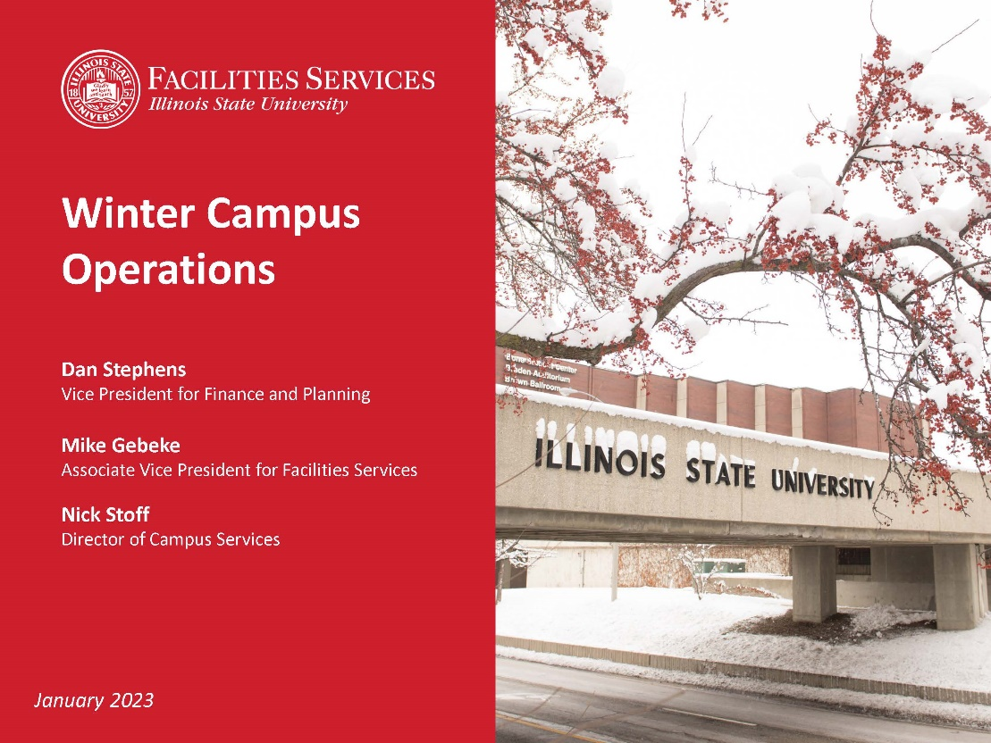

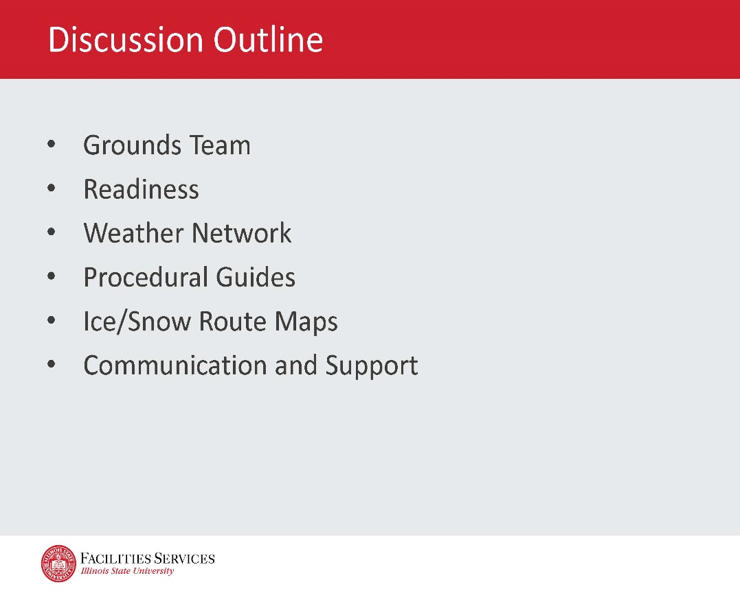

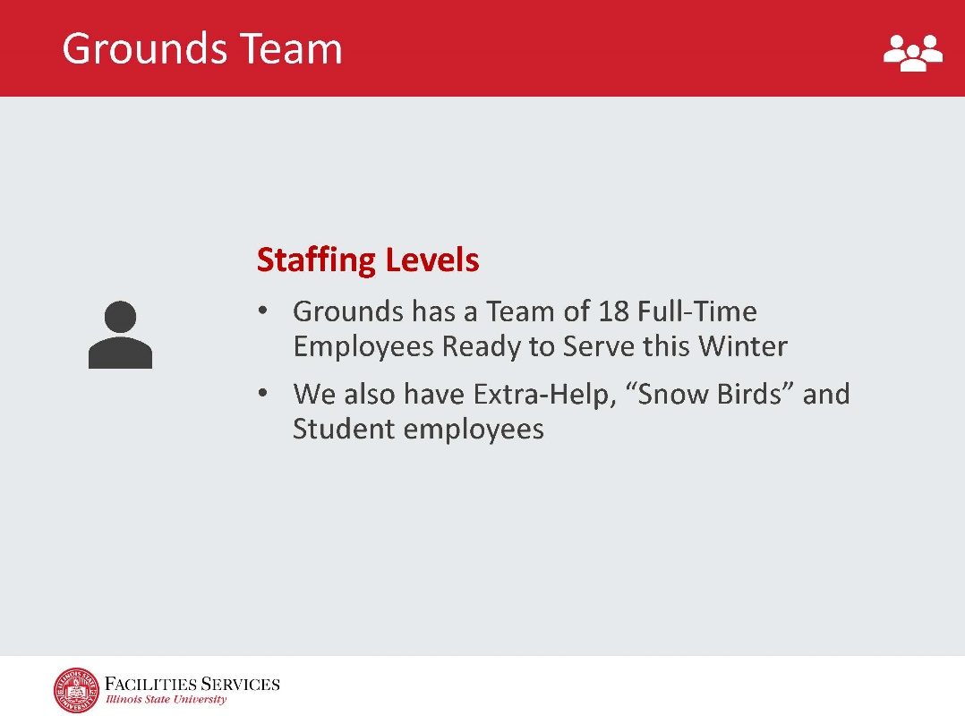

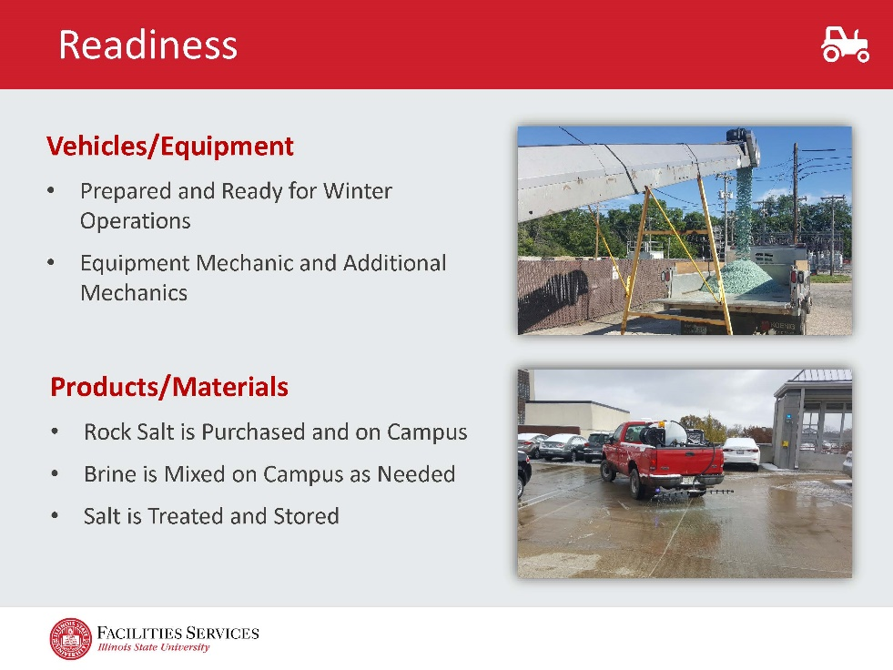

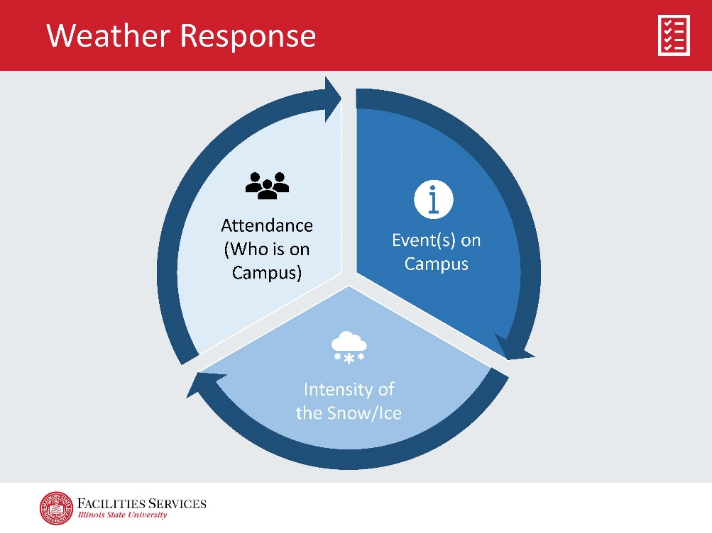

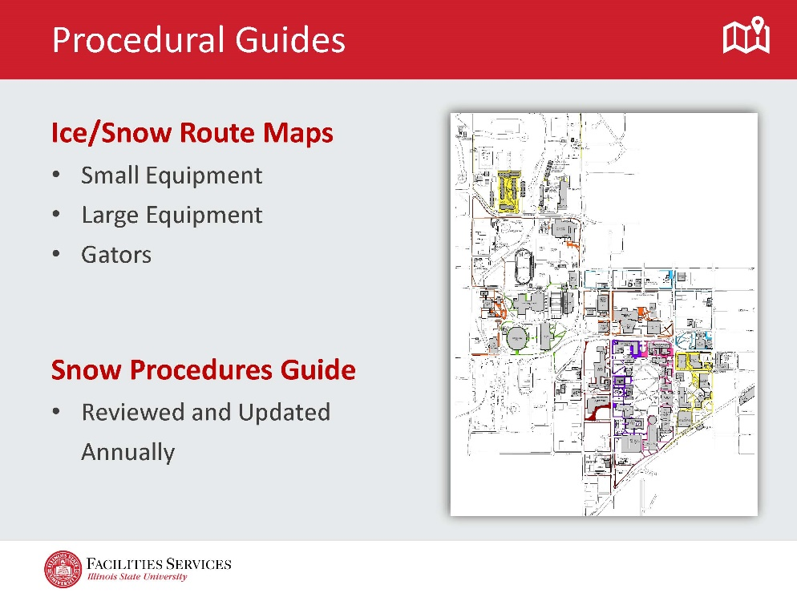

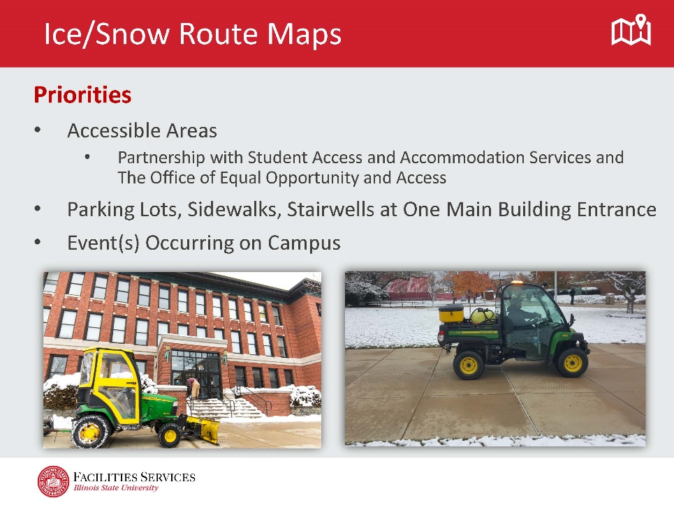

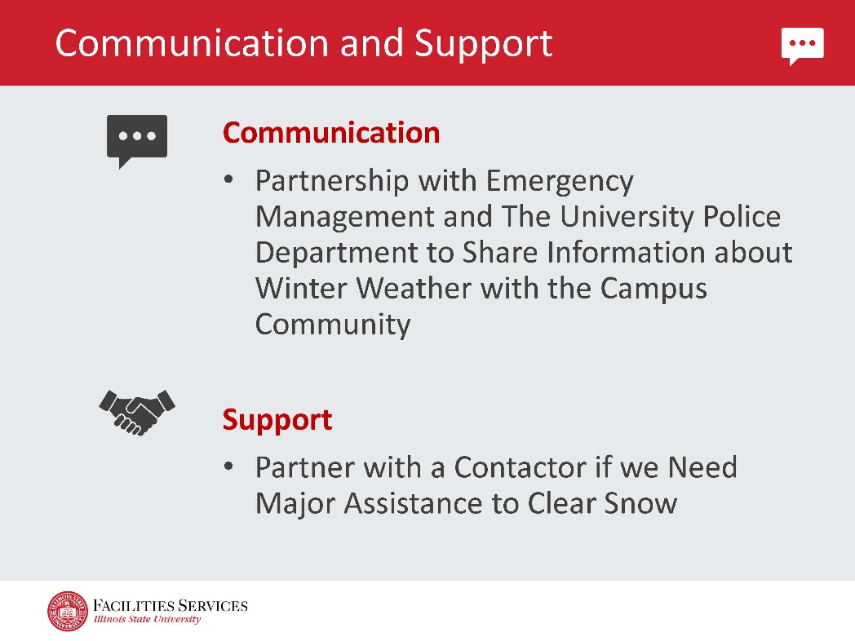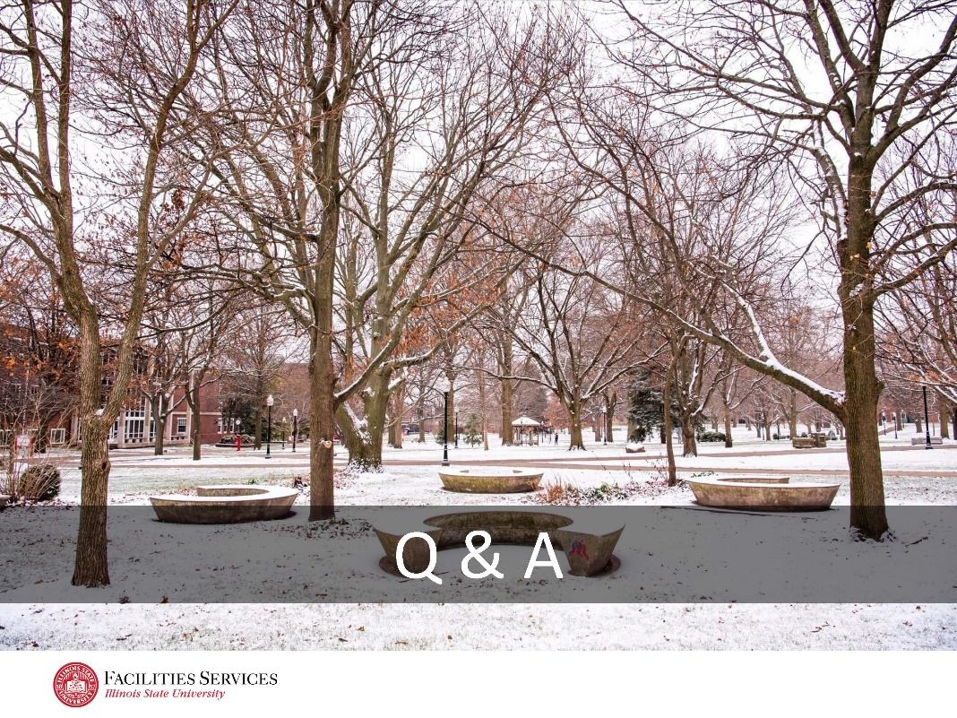

# Appendix II

