Academic Senate Meeting Minutes
Wednesday, September 14, 2022
Approved

Call to Order
Academic Senate chairperson Martha Callison Horst called the meeting to order.

Roll Call
Academic Senate secretary Dimitrios Nikolaou called the roll and declared a quorum.

Public Comment: All speakers must sign in with the Senate Secretary prior to the start of the meeting.
None.

Presentation: Color of Money (Vice President of Finance and Planning Dan Stephens, Assistant Vice President for Budgeting and Planning Sandi Cavi, and University Budget Officer Amanda Hendrix)
*Presentation is in Appendix 1

Senator McHale: This question is related to the relationship between Athletics and medical. I couldn’t tell from that whether those two are related, there was a slash there. In particular, this comes from a conversation with my son that in a very exciting football game on Saturday, what used to be a Redbird first down was a Redbird Toyota first down, and then towards the end of the game it just became a Toyota first down. I’m wondering--that Toyota money--how is that negotiated and does that just stay in Athletics? What is the relationship between the revenue we get for Athletics and medical? It was kind of unclear on that chart.

Senator Stephens: No. It’s just, unfortunately, the way some of our grouping that we have to report under, that they take that particular student health fee itself. We have our own student health fee, and then in the athletic fees we have a number of athletic fees that provide support, not only for the athletic facilities that we have, but also to support the teams. So, all those types of resources are kept separate from each other.

Senator Lucey: So, in your chart you talk about the funding. We’re measuring the funding trend over 20 years, and I’m wondering why are we measuring it over 20 years? To what extent have governmental funding conditions been constant over those times? And how do the circumstances of the government and they economy relate to that 20-year period?

Senator Stephens: It was just simply a way of looking back rather than just reporting how our appropriations have been targeted over five years; it was looking back over two decades. So, unfortunately, with the trend in our state over the last two decades, there was a rise at a point in time where in the late 1990 or early 2000 the university kind of peaked with $92 million. That’s where it sat at its highest point. And ,unfortunately, it has declined over a number of years. The other part of the chart, if you see in 2016, which many of you were around, that’s when we had the budget impasse. And Governor Rauner only provided us around $21 million. So, unfortunately, the trend over the time was going down. We are appreciative of Governor Pritzker. He’s trying to increase that, and we’re hoping in our next legislative meetings this particular year that we may get an increase in FY24.

Senator Lucey: It seems to me, last year or the year before, there was a presentation in terms of the amount of funding that was given per student by the state. And there was something that indicated that Illinois State University received less funding per student than other universities. My understanding was that there were going to be conversations with our university at the state level about that. Has there been any progress in those conversations? And how is that relating to the funding formula?

Senator Stephens: If I can, I’ll make a short response to that and then pass it over to President Kinzy. Yes, in my presentation next week I do provide that slide itself. But if my memory serves me well, the University gets around $3,500 to $3,600 per student. The next lowest--we are by far the lowest in the state—is University of Illinois which is around $6500. So, when you take that difference, we’re about 40% below the second lowest. If you quantify that, if you just simply use that metric, we’ve asked the state, if you can just move us up to the second lowest or just at the state average—I think the state average is around $6500—it would move our $70+ million appropriation close to about $115 million. It’s about a $40 million dollar difference. So, it’s quite significant. President Kinzy has been having conversations with IBHE and is actually on a committee, so I’ll let her speak from this point here.

President Kinzy: So, the state legislature has mandated a commission on equitable funding to look at a funding formula for the State of Illinois. Commission has representatives of the state universities and groups that are particularly interested in increasing the representation of underrepresented individuals in higher education in Illinois and to increase the pipeline. That group will meet and is required by July of 2023 to provide a formula. The important thing about this commission is the state legislature has indicated this is a hold harmless process. Therefore, all of the base funding that the universities get, which varies between about $3,500 per student for us, to a high of $20,000 per student particularly for universities that have seen reduced enrollments, will not change. The only change is based on the new formula and will be based on any new funding that the state gets. So, last year when the state gave a 5% increase for higher education, Illinois Board of Higher Education recommended they not do that across the board. They recommended the fact that Illinois State University get 7%. The legislature chose to give everyone 5%. That’s the current status. We’ll know more before July, then it will go to the legislature, which will make a determination.

Senator Horst: Thank you. And I believe, President Kinzy, you said you could update us in a couple of months, is that correct?

President Kinzy: Yes. The two working groups that are looking at defining what the base definition is of acceptable funding, and the group that’s defining what resources go into the formula are currently meetings. Once we have some final recommendations there, I’ll be able to tell it in a cohesive way. All of the meetings are open meetings, under the Open Meeting Act, and all of the information is posted. But right now, it’s still very preliminary, so I can’t actually give you a final description. Those two groups will then come together to create the actual formula. I’ll be on the formula creation group.

Senator Blum: Just kind of a suggestion, I would really love to see those numbers in an inflation adjusted numbers. Honestly, that graph is tremendously generous to the state. An inflation adjusted numbers; those are going to be dramatically different, particular where that 20-year period is.

Senator Horst: I agree with you, Senator Blum, and perhaps next meeting we can also discuss the impact of inflation on this whole process.

Presentation: LMS Update (Dr. Rosie Hauck, Executive Director of the Office of Advanced Technology for Faculty and Dr. Tony Piña, Director of Online Education/Chief Online Learning Officer for the Center for Integrated Professional Development)
*Presentation is in Appendix 2

Senator Blanco-Lobo: Talking about the selection for the pilot courses in spring 2023, so you sort of implied that it will be a self-selection process.

Dr. Hauck: For summer. For spring, what we’ve been doing is collecting any requests that we have from people because of the new article people have come out to volunteer for spring. I have those names and contacts, and what we’ll do is see how things are going in the migration, which learning tools get integrated (because maybe I want to teach it, but I use this learning tool and if it’s not ready by spring, maybe I don’t want to teach it yet because I really rely on that tool). So, what will happen is anyone who’s requested to be part of the pilot, you will get a survey to tell us what class you teach. Our goal is to…given what we can manage, get a representation across different colleges, different classes, different class sizes, the class that do stuff in foreign language and music, and the sciences where they have equations. We’re trying to look across the board to get representation, so that with that pilot we can work closely with those instructors and get that feedback; because that’s when we’re going to be tweaking before we release it to the whole campus. So, if you are interested, we are collecting that contact information.

Senator Blanco-Lobo: Just caution, because it is self-selection, even though it might look like representative, people that are likely to be self-selecting are people that already have some sort of experience in working with Canvas or with the data conclusions that you might be getting from the pilot aren’t going to be that represented.

Dr. Hauck: Yes. And that’s something that we’re keeping in mind. We will take a closer look. You are correct, because a lot of them in the email say they used Canvas, and so on. So, if you have colleagues who don’t want to move to Canvas, please fill out that form and put their name in there, and we’ll reach out to them when it’s time. Especially, if they need extra hand holding. And they would be a great perspective to get.

Senator Walsh: I know that you mentioned the Center for Integrated Professional Development will have “how to” videos for faculty. Will those also be available for students if they wanted to learn more about Canvas? I’m not the most tech savvy person. I would definitely benefit from those videos. I just wanted to know if those were also available to students and where you could go for them.

Dr. Hauck: Absolutely. One of the things that we’ve talked about, in addition to the Center for Professional Development, we also have the helpdesk. The helpdesk services a lot of the students, and college IT as well. They are all using the same source of training materials. So, we want everyone to be pulling from the same bucket of videos. It makes it easier for us, so we’re all on the same page. The nice thing with Canvas, and this is what the advisory team figured out, is if you go on YouTube or Google, there’s videos on everything. You can’t find anything about Sakai. But you can search “how do I do this in Canvas”, and there are lots of videos on how to do things. Because a lot of people are using it. And there is going to be a push for the students themselves. We’ve got some fun things planned for the students to try this out and get some feedback, so the students can begin to play and use the mobile app as well.

Dr. Piña: Also, those student resources and how to turn in assignments, check grades, all of that. Actually, there is going to be a link to it from within every course as well. So, if students forgot how to do something, there will be a link in the course for them to be able to learn how.

Dr. Hauck: Great reminder. Canvas, because we played with it in the sandbox, right, if you want to go to a tool and do something, right at the tool there’s a “I need help” button. You don’t need to search for it. In the tool itself if you need help with accessibility, it’s all built into the tool. So, you don’t have to search for it; it’s right there. They’ve thought about these things, and how to make it easy for people to use it.

Senator Mainieri: I’m really excited about this. I’m curious with the pilot happening in spring and then the soft roll out faculty choice in the summer. I’m imagining there could be student who have in their schedule courses that are still in Sakai and courses that are in Canvas. If you can just talk about what support and what heads-up students will have in terms of what that experience with both will be like.

Dr. Hauck: For spring semester, for the faculty involved in the pilot, we will lean on them quite a bit. Part of being the pilot is you’re willing to be very communitive on how things are going with the class. We will push resources for the students. As far as accessing the different LMS, this is a big focus for us. Right now, if you go to the MY portal and look at your list of classes, there’s a button on the right that says ReggieNet for each class. For the students that are using Canvas, for that particular class, there will be a button still there at the same place; but when they click on it, it says Canvas. So, it will go straight to Canvas. They don’t have to go to a different URL or anything. It’s still within MY. And the nice thing, because we have another company doing the migration, our DEV team can focus on that user experience and integrating it to how students currently get to LMS and into MY portal. But yes, as a partner, we are going to be looking very closely with the pilots, the instructors, but also the students as well, getting feedback. Again, Tony mentioned, we do have a little army—a lot are grad students—he’s already started to train them to help push out to those instructors who are part of the pilot. I think the feedback is going to be very valuable to us.

Dr. Piña: Some students might have one or the other. I could say jokingly, but perhaps not, those students who are using Reggie Net and Canvas will probably put a lot of pressure on their teachers who are still using ReggieNet to switch over to Canvas.

Senator Holmes: My questions was the old LMS was obviously branded, it was called ReggieNet. Is Canvas going to be Canvas or is it going to be ReggieNet?

Dr. Hauck: Canvas.

Senator Holmes: Okay.

Dr. Hauck: We decided with this to call it what it is.

Dr. Piña: 10 years ago, it was really common for institutions to rebrand their LMS systems locally. That’s no longer the fad that it used to be.

Senator Webber: When will the pilot be decided?

Dr. Hauck: We have started talking about putting together that survey. Once we start the migration, we have a technical meeting next week to start talking about the migration. At the same time while the technical team is refining how they’re going to migrate—and they’re doing this across all classes—we’ll be working with those who volunteered for the pilot to collect some information to see if we can start to segment out and see who we are missing on the list so we can start reaching out to them and confirming if this is what they want to do. So, there are a lot of moving parts going on at the same time, but it’s going to be an exciting semester.

Dr. Piña: We hope before December.

Senator Taylor: I just wanted to say, in regard to Senator Walsh’s question earlier, we do have a student tech orientation that goes over a bunch of technology sources. It’s for freshman, but anyone can access it. It also saves your progress through it so you can click around and search things. It does cover ReggieNet currently, but I know it is getting switch over to Canvas, so you could use that.

Senator Horst: I have one question. You talked about the cost of bringing in a consultant for the migration, and then the duplications of the two LMSs. So, all in all what’s the price tag for all of this?

Dr. Piña: The total price for everything is a little over $2 million.

Dr. Hauck: That’s for five years.

Dr. Piña: That’s also 24/7 support from Canvas too. So, it’s not just the LMS.

Dr. Hauck: That includes all licensing, hosting, support, implementation, migration, and training for five years. I think we budgeted $2.5 million when it went before the Board of Trustees.

Chairperson's Remarks
Senator Horst: Good evening, everybody. I wanted to thank all of our presenters this evening. And on behalf of the Senate, I also just want to say that we appreciate your detailed presentations and also your willingness to take all of our questions. I also appreciate Dr. Hauck really integrating the Senate into this process this time. I believe last time when we switched to ReggieNet there was not this much consultation with the Senate.

I hope everyone had a good first internal committee meeting. As a formal committee chair, I do want to make a plug to all of the people on the committee, please reach out to your committee chairs, ask how you can help, don’t expect your committee chairs to doing all the work. They really do need your help. It’s a group effort to do the work of the internal committees.

I want to remind the committee chairs, if you have anything to send to the Executive Committee, the deadline is Thursday at noon. I have a request from Cera to send in attendance and minutes as soon as they are approved so we can post those and be in compliance with the Open Meetings Act.

I had contact from Dr. Gatto and there is a strong possibility that the Faculty Caucus will be reviewing some ASPT material in the near future.

Student Body President's Remarks
Senator Walsh: Hello everyone. I hope you all have had a great week so far. I’d like to congratulate our football team on the win against Valparaiso. I went home Saturday night very proud to be a Redbird for multiple reasons: 1) we took home the win; 2) the fabulous zero waste tailgate that was occurring from the Sustainability Office; and 3) how amazing it was to see the student section so filled with students. The Redbird spirit was high, and I want to continue that. I’m looking forward to working with those in the Athletic department to find ways to continue to fill those stands and bleachers with students.

I would also like to commemorate the two students who ran for student trustee, Nik Muzzarelli and Ash Ebikhumi. Student representation is always a high priority, so filling that vacancy is imperative. I’m looking forward to hearing the announcement of who won the election soon.

Getting students registered to vote is always of extreme priority as well. That is why Student Government Association is hosting a Voter Registration Drive this September 19-22, in coordination with the Center for Civic Engagement. We will be tabling on the Quad and in the Bone Student Center from 10:00 a.m. to 2:00 p.m. As we approach midterms on November 8th Student Government Association wants to assist in eliminating barriers that students may face when it comes to registering to vote.

Continuing the civic engagement trend, Student Government Association is co-sponsoring a 91st district forum Tuesday September 27th from 6:00-7:30p.m. in the Prairie Room. This will provide a great opportunity for students to hear from the state representative candidates running for this office. Ensuring that students can make informed decisions on who to represent the district they currently live in is imperative, and the Student Government is eager to assist in that process.

Additionally, the Student Government Association has also recently created a new secretary position that resolves around parking and transportation issues students may face. I’m looking forward to improving the relationship between Parking and Transportation Services and Student Government to help create open dialogue.

Finally, September is suicide awareness month. As we all know, college student can face high levels of mental health issues. A study done by Stanford University found that one in every five students face a mental health issue. Because of this I have been working with Carrie Haubner, the interim Director of Counseling Services, to help bring more mental health initiatives to the Illinois State University community. One of these events is coming up on September 26 at 7:00 p.m. here in the Bone Student Center in Ballroom 3 where we will have mental health speaker Kevin Fowke to speak on how students can handle stress to complete the correct response cycle. I invite you all to attend, as beyond the great speaker, there will be food.

Administrators' Remarks:
- President Terri Goss Kinzy
President Kinzy: Good Evening. Last night, myself, Senator Tarhule, Senator Johnson, and maybe a few more of you had the chance to attend the premier of Amazon Prime’s The College Tour at the Normal Theater. The College Tour follows ten of our Illinois State University students through their experiences on our campus. It was awesome. It was truly amazing. Our students that were featured are fantastic. It’s going to be shared widely on social media and premiere on Prime Video, as well, in November. I hope you take the 30 minutes to watch it. It didn’t feel like 30 minutes; share it on your own social media to tell the story about Illinois State University. It was really a lot of work by a collaboration between Enrollment Management, Admissions, and our folks in University Marketing and Communication. Some of them were actually in the credits. It was really wonderful to see. It’s real creativity because, believe it or not, with this excitement we are planning for next years class. Yes, we’re already recruiting the class of 2023-2024. And with this kind of creativity, we are really excited about what people will see across the country and the world.

I also want to extend my thanks and congratulations to our teams in Admissions and Enrollment Management for the amazing effort that they had in terms of recruiting our incoming class. I specifically want to highlight that we cannot do this without the dedicated assistance of all of you in departments who help us to recruit these wonderful students and work with us to make sure that we can make every student who’s qualified a Redbird for life. This year we had our largest freshman class in 35 years, so that’s pretty remarkable. But what’s really remarkable is the fact that the average GPA went up to 3.64 on a 4.0 scale, and the ACT to 24. There are 440 more students in the Honors program, and 37% of this year’s class comes from traditionally underrepresented groups. In fact, now, almost 30% of our student population comes from underrepresented groups, and that’s an exciting thing for the future of the total commitment of this institution making sure that all intellectual capacity is welcomed, grown, advanced, and sent off into the world to change it for the better, based on Illinois State University experience. It takes all of us for this to happen. So, make sure you tell your Illinois State University story, all of our students, and as you become alumnus, and our faculty and staff. It really makes a difference.

You may have also seen on the news last week that Illinois State University will be hosting a gubernatorial debate 7:00 p.m. on October 6 in Braden Auditorium. In partnership with AARP, and Next Star Media Group, and significant input from our Student Government leaders. This is an opportunity to showcase Illinois State University and provide a really unique opportunity for civic engagement. Planning is well underway. Student, faculty, and staff from across campus are coming together to plan for this debate, as well as pre and post events, and watch parties for students. So, stay tuned for more information.

You may also remember that at the end of last spring the University conducted a staff success survey. The results are in, and we’re in the process of developing a website that will be ready to go sometime very soon. We’ll talk a little bit more about this at the State of the University Address. But what’s happening right now is that Athletics, Academic Affairs, University Advancement, Student Affairs, Finance and Planning, and the Office of the President are looking at the results in total and for these specific units and determining divisional areas of focus for the coming year. The Cabinet will get together, look at these areas, identify some, which are university-wide, for collaborative attention as well as those that are unit specific. This process is engaging people within all of the units. From there, we’ll know where we want to bring together people to look at some of these opportunities. But I wanted to share that. While the survey was last spring, we didn’t wait until we got through this process to start making some changes. The newly revised, what used to be called Alternative Work Policy is now a Flexible Work Policy. We’ve already seen 150% increase from when we started in the number of people that have remote working agreements, and we believe that number is still going up. We instituted Dress for you Day. We talked a lot more about flexibility, particularly in the summer, and we had a 3.5% merit-based salary increase for eligible employees effective September 1 that will show up in October paychecks.

You also know that the University did the COACHE survey of faculty, and I’ll leave it to the Provost to update you on that. But rest assured these were very large amounts of data that have been thoroughly reviewed, will be made accessible in different ways, and I’ve already spoken with our A/P and Civil Service leadership about how we can work together to share this information in a more interactive forum.

I also want to give one point of pride. Last week, in the Chicago Tribune two of our recent ISU English Education alumnus Junior Sanchez and Chris Recendez who returned this fall to teach English in their former high school, Rolling Meadows, were highlighted. It’s always great to see alumni achievements, and what I’ve learned from our friends in admissions is a single day in the Chicago Tribune cost $18,000. So, that is an amazing example of what Illinois State University can do and our commitment to advancing education.

Lastly, the State of the University Address will be at 2:00 p.m. Tuesday, September 20. It will also be live-streamed in addition to being live, in the Center for Preforming Arts, and recorded and available for future viewing.

Senator Cline: Two weeks ago, the US Center for Disease Control and Prevention recommended the update COVID-19 vaccine boosters, following the US Food and Drug Administrations authorization. Additionally, health officials are recommending that Americans also take the seasonal flu vaccine, as all indications are that we will likely see a worse than average flu season while COVID-19 is still circulating at a higher level. Is the University planning to sponsor dual COVID booster and flu vaccination clinics this fall for your faculty, staff, and students?

President Kinzy: Thank you for that question. As everyone knows I’m a very strong proponent of vaccinations. I’ve personally gotten the flu shot every year, as well as the COVID vaccine and the two boosters. One of the things that changed with COVID-19 vaccination is the government is no longer making it available for the vaccination clinics we used to have at sites like Illinois State University. It’s now available through the traditional sites where you get vaccinations such as pharmacies, your personal doctor, hospitals, things like that. So, we do not have access to the COVID vaccine anymore. You may have seen an email come out that we will be running our traditional flu vaccine. That vaccine was ordered last December. There are four dates available: September 19, 20, 21, and October 2. Research is still progressing on a combined vaccine. So, there is no option to get them in a single shot, although we are all very hopeful that the folks at Pfizer and Moderna will have significant progress. I know they’re testing some of that now. We will continue to encourage booster shots or vaccinations for those that have not gotten them yet. There’s also a new booster available, but the best place to go is to our COVID informational website where we will continue to provide updated information on where it is accessible. But right now, my recommendation is the CVS on Fell; that’s personally where I got my shot. You make your appointment online. It’s very accessible to campus. That’s the best opportunity we have right now.

- Provost Aondover Tarhule
Provost Tarhule: I’d like to comment on the LMS. As you saw Senator Pancrazio asked the cost of the LMS. It’s over $2 million. This comes from the AEF—Academic Enhancement Fee—that students pay. So, my appeal to all of you in here and faculty, students, is when we migrate to the new LMS, please use it. One of the things we found last time was that with Sakai some people were using other types of systems, some of which actually required students to pay extra. Knowing the cost of education and just how much our students are bearing, it seems somewhat unfair that they pay for one system and then they’re required to pay for something else. So, my very very strong appeal is making sure you use the new LMS exclusively. I know that some of you have programs with other publishers that you like to integrate. I’ve had lots of conversations with Tech Solutions about how to help you do that. Please contact them if you need that kind of help and they will try to connect your publishing information, your quizzes with your publishers into Canvas. But please use the new Canvas. The other reasons why this is really important is, imagine if, heaven forbid, something happens to a faculty member and we don’t know where their grades are being kept. How are we going to help the students? So, for all those reason,s please keep that information in the LMS and use it when it comes out.

Interim Assistant Vice President for Student Success Dr. Amelia Noel-Elkins is going to be leaving ISU for another opportunity. As many of these things happen when people leave, especially for a better opportunity, it’s good for them, but it’s always bitter for those of us that are here. Amelia has worked at ISU for 17 years. She’s served as Director for University College and then the last two years in this interim position in the Provost’s office. Amongst the many important and impactful contributions that she brought to the University, she helped to write the proposal that secured the GEER Funding, which was very critical during COVID in helping us support our students. She led the AAPLU Institutional Transformation project. She has worked very conscientiously on the Persistence Committee. She’s a very strong advocate, as anyone who has worked with her knows, of staff rights and equity, and never misses an opportunity to advocate for staff. And she’s a very strong believer in the fact that students’ voices and perspectives must be respected and included in all discussions. So, Amelia will be a very big miss.

I’ll be running two searches in my office that will require a Panel of Ten. Those will be the Associate Vice President for Academic Administration and the Assistant Vice President for Faculty Professional Development, Diversity, and Learning. So, the process requires me to make that announcement to this body so that we can get a list of search committee members for me to pick from to make those committees. Some of those titles may change, but at this point I’m following the process and informing the body that I’ll be conducting those searches this academic year, and we’ll need your support in the Panel of Ten.

I was very happy to hear President Walsh talk about the voter engagement. Very delighted to report that Washington Monthly has rated ISU amongst the 2022 best colleges for student voting honor roll. This is an amazing national recognition for the work that we do. So, congratulations to the office for Civic Engagement in helping ISU to achieve this national honor, and of course to all of our students, faculty, and staff whose participation made this engagement possible.

Lastly, the President mentioned the COACHE survey. So, I thank you again for participating in that survey. We achieved a 48% participation rate of our faculty, which is very high. We had set a very ambitious goal at the beginning and so we blew that goal out of the water. As I discussed at the last meeting, we received the results. We’re working to make them accessible. We continue to work very closely with COACHE to make that happen. But we wanted to make sure you had access to these reports as quickly as possible, so we created a webpage: https://provost.illinoisstate.edu/success/coache/ that contains the summary results that we’ve received from COACHE. There is no assessment. No analysis. We just put out the results. We expect to receive college level reports from COACHE. Last time we talked to them, which was a week ago, they promised two weeks. So, each college will also receive their version of the report that will go to the deans. That has not happened yet. PRPA actually just got access to the report today. So, we still need more people to have access to the report before we can do further analysis. Please, when you go on the website, read the instructions before you look at the results. If you don’t look at the instructions and guidance for how to read it, it can be confusing.

But let me give you a couple of highlights from that report. One of the questions it asked was what is the best aspect of working at Illinois State University? So, faculty were asked to indicate what they saw as the best aspects of working at Illinois State University. The four factors were: quality of colleagues; support of colleagues; cost of living; and academic freedom. That’s not all, but these were the highest rated four of data. We also compared ourselves to our peers. Faculty were asked, compared to our peers, what are the strengths that Illinois State University demonstrates compared to our peers? The two top factors were leadership (especially divisional leadership) and promotion to full professor. Those were the two factors that our faculty felt we did much better than our peers. Another question asked was opportunity for growth for Illinois State University. So, the questions were, if you think about working here, how can Illinois State University do better? The top factors were: compensation; lack of support for research and creative work; too much service; and, too many assignments. These are things that faculty did not like. Compared to our peers, what were the concerns that faculty identified? This included appreciation and recognition, departmental collegiality, leadership at the department level, leadership at the faculty level, leadership at the senior level, nature of work (especially service), and nature of work teaching. There’s a lot more data behind this. There is almost, I believe, close to 180 comments to read. So, it’s going to take several years of analysis, and we’re putting together a number of committees to make this happen. The first is, we’re going to set up what we call the Priority Action Committee comprised of faculty and volunteers who will scan through the reports and identify priority areas that we need to work on. Then we’ll set up a second committee, again, comprised of faculty that will identify how we respond to these areas of weakness or concerns, or areas of growth. So, that’s what we are doing. Please access the website. We look forward to a lot more information to share with you. Thank you.

- Vice President for Student Affairs Levester Johnson
Senator Johnson: Like the Provost, I’ll have to start on a bittersweet note. As many of you likely already know, tomorrow is the last day for our exceptional Assistant Vice President and Dean of Students Dr. John Davenport. He has served the institution for over 22 years. We will definitely miss a lot about him. His hard work ethic, the quality of his character, that sense of humor, and, for me mostly, that easy mannerism and approach to things. I call him smooth. But we’re going to miss all that about John. With him leaving the institution, those are pretty big shoes to fill, but I think we’ve got someone who’s going to work for us on an interim basis. But before I get to that, we will definitely be conducting a national search for our next Assistant Vice President and Dean of Students. This will be a search that will include a lot of individuals from across campus, so there will be broad involvement and input from campus constituents which will include open forums, and the ability for people throughout the campus community to participate. I’ve asked Stacey Mwilambwe to serve as our interim Assistant Vice President and Dean of Students. Many of you have known Stacey as she has been with ISU for 25 years and done a tremendous job serving as our Director of University Housing Services. I know that we will be in good hands with Stacey filling in in that role.

This is Safe Redbird’s Week on campus. Individuals from ISU Police as well as Emergency Management have been out and about on campus promoting many of their safety programs. Today, if you were out on the Quad this afternoon like me, you could have participated in literally putting out a fire, and hopefully you are a little bit faster than I was so that the Quad area didn’t burn down. But you will have more opportunities for participating in some of our Safe Redbird Week activities throughout the week. Among our most important safety features that we have is our Safe Redbirds app. We have substantially enhanced this app over the summer. One of the coolest features is our virtual blue light feature within the app. I am sure you have noticed one of our 86 blue lights on campus. This feature is essentially like having a blue light with you at all times wherever you go. This allows students to use the app to contact a dispatcher in University Police. We can then use GPS to locate the student on campus and send an officer to that location. We also converted all of our written safety guides within the app to be interactive and engaging. We have also partnered with Connect Transit to include a live tracking feature for the bus system on campus, so a student doesn’t have to wait at a bus stop and not know if it’s coming in a timely manner. They can go to the app and actually see when it’s going to arrive. So, we’re excited about that new feature. I’d also like to also mention that we’ve had over 2,000 individual download the app since the beginning of the school year.

Speaking of safety on campus, this week, University Housing Services did a micro survey of all their residents asking the question, “How safe do you feel on campus?” We had over 1,000 residents respond and almost 96% of the students indicated that they felt safe or somewhat safe on campus. 4% of the respondents (about 44 students) indicated that they did not feel safe on campus, and we’re following up with those 44 students to find out how they’re feeling, what makes them feel unsafe on campus, and then make sure that they have the support that they need.

The last item along the same lines, is our Night Walk. Last year we started this new program. This is where we actually walk around the campus community with students, and student leaders to hear their perception about campus safety and to answer their questions and hear about their concerns. I will be there, as well as our representatives from University Policy, Emergency Management, Facilities, and our Student Leaders Council. Perhaps most importantly we expect a very important campus dignitary to attend as well, and that would be Pawfficer Sage. So, if you have the time please come out. It will be held on Tuesday, September 27 at 8:00 p.m. We’ll meet at the steps of Hovey on the Quad side. In case of inclement weather, we’ll meet in Rosa Parks room at Waterson Towers.

- Vice President for Finance and Planning Dan Stephens
No comments.

Action Item:
From Academic Affairs Committee:
04.07.22.17 Policy 4.1.2 Course Proposals For Undergraduate and Graduate Courses_Current Copy
09.01.22.07 Policy 4.1.2 Course Proposals for Undergraduate and Graduate Courses Mark Up
09.01.22.06 Policy 4.1.2 Course Proposals for Undergraduate and Graduate Courses_Clean Copy

Senator Cline: We had some edits to that document from the Office of General Counsel that were reviewed and approved by the committee this evening. I will read the policy as it’s been approved by our committee aloud. “Programs and departments/schools are responsible for their own curricula, subject to the approval of department/school curriculum committees (if applicable), department faculty in the case of non-IDS departmental programs, and college- and university-level curriculum committees which may include the Council for Teacher Education and/or the Council on General Education. In some instances, the Academic Senate, and the Board of Trustees, and/or the Illinois Board of Higher Education may also be required to approve the curricular proposal. Individuals outside a program or department/school may make suggestions but, except as described in Policy 4.1.9 Disestablishment of Academic Units, these are recommendations only.”

Motion by Senator Cline, on behalf of Academic Affairs Committee, to approve the revisions to policy 4.1.2 Course Proposals for Undergraduate and Graduate Courses.

Senator Nikolaou: In the previous version we had the language where it says, “Final decisions are under the jurisdiction of the department/school, or disciplinary program,” but now this has been eliminated. Do you know why this is the case?

Senator Cline: It was eliminated by General Counsel. Any changes that happened between last week and now have only been changed by General Counsel.

Senator Nikolaou: It seems it removes a significant portion where it says that the final decisions are with the departments/schools. So, the version we saw before the revisions it also had a portion where it says, after the disestablishment of the academic units where the new version ends now, it said, “final decisions are under the jurisdiction of the department/school (or the college if the college has no schools/departments) or interdisciplinary program faculty and the members of the aforementioned committees.”

Senator Cline: Okay. The text that you are reading is from the current copy of the policy, correct?

Senator Nikolaou: Yes.

Senator Cline: So, that is not in the revision that the Academic Affairs Committee put forward last time as an Information Item.

Motion by Senator Nikolaou, seconded by Senator Mainieri, to Table. The motion was unanimously approved

Information Item: None
Consent Agenda: None.

Internal Committee Reports:
- Academic Affairs Committee: Senator Cline
Senator Cline: The Academic Affairs Committee met this evening and we talked about 4.1.2 and also began our review of policy 2.1.11. And we elected potentially a member for the Academic Planning Committee.

- Administrative Affairs and Budget Committee: Senator Nikolaou
Senator Nikolaou: The Administrative Affairs and Budget Committee met this evening. We laid out our plan for the different policies and what we’re going to do throughout the year. Then we talked about the two dean evaluation instruments. Then we had a general discussion about the evaluation surveys for the VPs.

- Faculty Affairs Committee: Senator Smudde
Senator Smudde: Faculty Affairs Committee met tonight. We also looked at the tasks that we’re facing this year, particularly the tasks that closed out the previous year, but then looking ahead to what we’re up to this year. We discussed at length policy 3.2.12 Ombudsperson Council, 3.3.7 Secondary Outside Employment, and 7.7.1 Significant Financial Interest. All three of those will have some additional committee work that we’re going to be pursuing on those. And then we decided on certain procedural things that we’ll do as a committee to help us all get through that since we only have five of us on the committee.

- Planning and Finance Committee: Senator Valentin
Senator Valentin: The Planning and Finance Committee met this evening and we elected Senator Harpel as Secretary. We reviewed editorial changes to policy 3.2.10 Emeritus Academic Employees Defined and voted to forward this to the Executive Committee. And we reviewed and discussed our committee charge.

- Rules Committee: Senator Blum
Senator Blum: The Rules Committee met this evening. We discussed a number of pressing issues around the Senate Bylaws related to quorum and some voting rules in the committees, and also some previous rules of the Senate that had already passed regarding the bylaws relating to Open Meetings Act but were on a sunset clause. We voted for all of those changes and completed that tonight.

Communications
Senator Garrahy: I would like to acknowledge Melinda Fischer. ISU’s head softball coach who recently retired after 37 years at our University. She began her affiliation with ISU nearly 50 years ago as an undergraduate student and then as a graduate student, and then now in the School of Kinesiology and Recreation. Coach Fischer leaves us as the winningest coach in ISU’s history—that’s women and men’s—as the winningest coach. She’s also a 2016 College of Applied Science and Technology Hall of Fame Inductee. Please know, she has earned more honors and awards that are too numerous to list at this hour. Melinda is the epitome of a roll model for our students and our student athletes. High Expectations, loyalty, and an unbelievable work ethic. She has given much to our University, and I wish her the best on her newest chapter.

Senator Horst: I want to say that the numerous large ensembles in the School of Music are having a concert this Sunday, The Collage Concert, that will be in CPA at 3:00 p.m.

Adjournment- Hard Stop 8:45 p.m.
Senator Horst declared the hard stop time was reached. The meeting was adjourned.

Attendance:
2022-23 ACADEMIC SENATE ROSTER
Wednesday September 14, 2022

 | Senate
Name | Attendance
Blair, Cobi | 1
Blanco Lobo, German | 1
Blum, Craig | 1
Bonnell, Angela | 1
Carney, Lania | 1
Cline, Lea | 1
Duffy, Alexander | 1
Fulton, Megan | 1
Garrahy, Deb | 1
Gerdes, Daniel | 0
Graham, Rhiannon | 1
Gudding, Gabriel | 1
Harpel, Tammy | 1
Hofstetter, Paige | 1
Hollywood, Mary | 1
Holmes, Jimmy | 1
Horst, Martha | 1
Hurd, Amy* | 1
Johnson, Levester* | 1
Kinzy, Terri* | 1
Lucey, Tom | 1
Mainieri, Tracy | 1
McHale, John | 1
McLauchlan, Craig* | 1
Midha, Vishal-Excused | 0
Miller, Chloe | 0
Monk, Eduardo | 1
Myers, Braxton | 1
Nichols, Wade | 1
Nikolaou, Dimitrios | 1
Noel-Elkins, Amelia | 1
Novotny, Nancy | 1
Palmer, Carl | 1
Palmer, Stuart | 1
Pancrazio, Jim | 1
Peters, Steve | 1
Rardin, Nate | 1
Samhan, Bahae - EXCUSED | 0
Schmeiser, Benjamin | 1
Smith, Zoe | 1
Smudde, Pete | 1
Stephens, Daniel* | 1
Tarhule, Aondover* | 1
Taylor, Morgan | 1
Torry, Mike - EXCUSED | 0
Valentin, Rick | 1
Walsh, Patrick | 1
Webber, Julie | 1
Wielgosz, Alexander | 1
Wilburn-Johnson, Jayden | 1
Williams, Jake | 1
Wollard, Jason | 1
Wollard, Justin | 1
Vacant - 1 CAS SCI Faculty | 0
Vacant - 1 CAS SCI Faculty | 0
Vacant - 1 COB Faculty | 0
Vacant - 1 COE Faculty | 0
Vacant - 1 Faculty associate | 0
Vacant - 1 Student senator | 0
Vacant - 1 Student senator | 0
Student Trustee* | 0
McLoda, Todd (dean rep)* | 1
Budikova, Dagmar (chairperson rep)* | 0
QUORUM (VOTING) (28) (*=NV) | 42

Appendix 1:
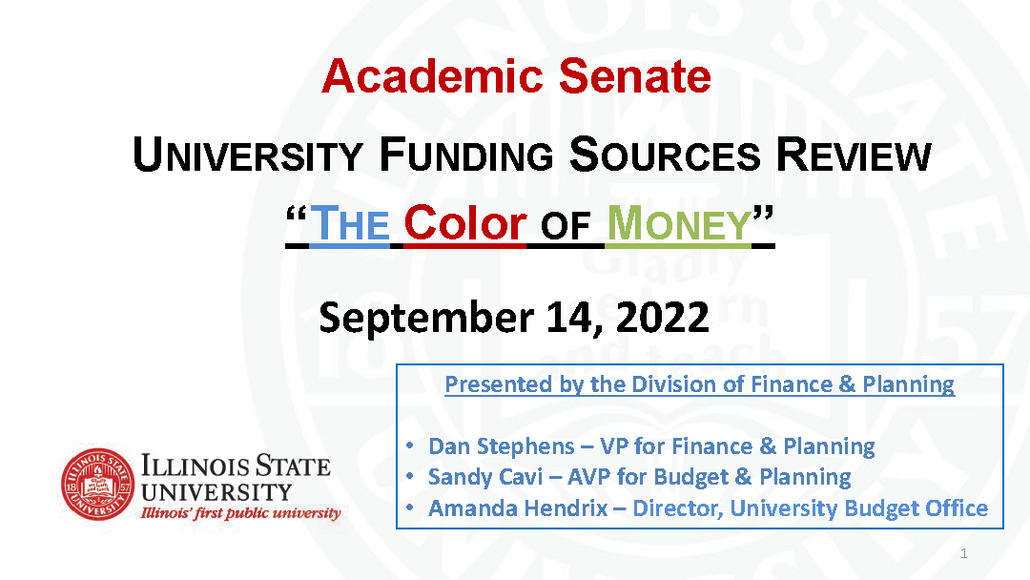
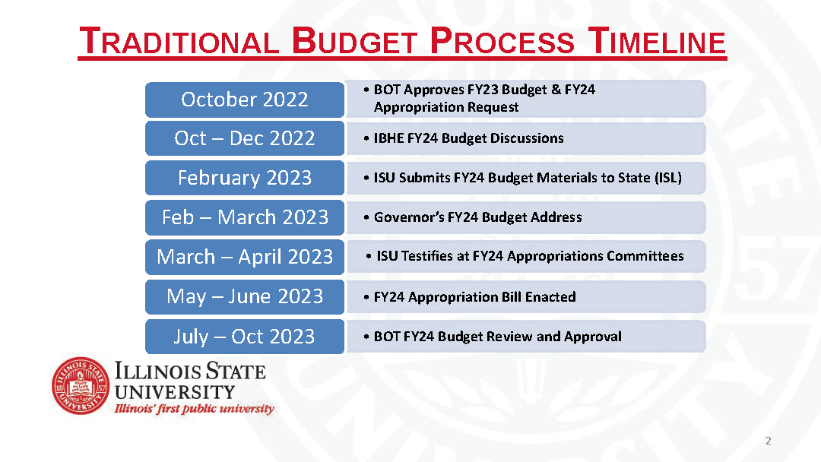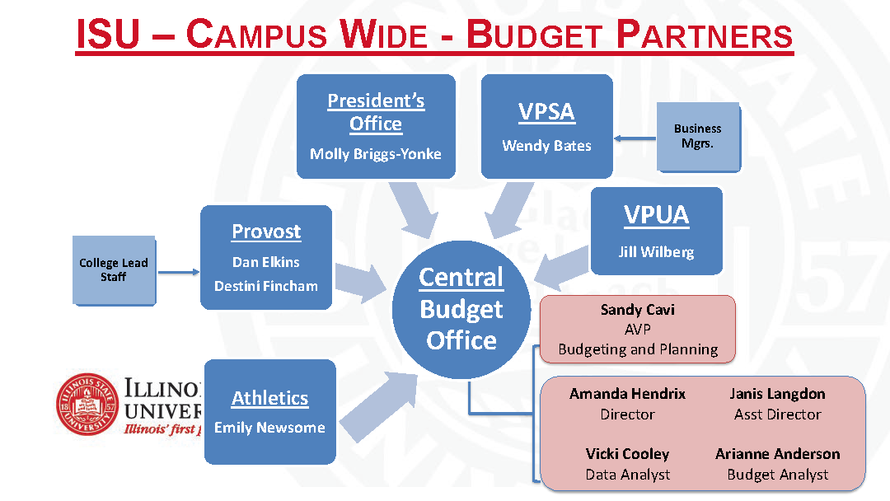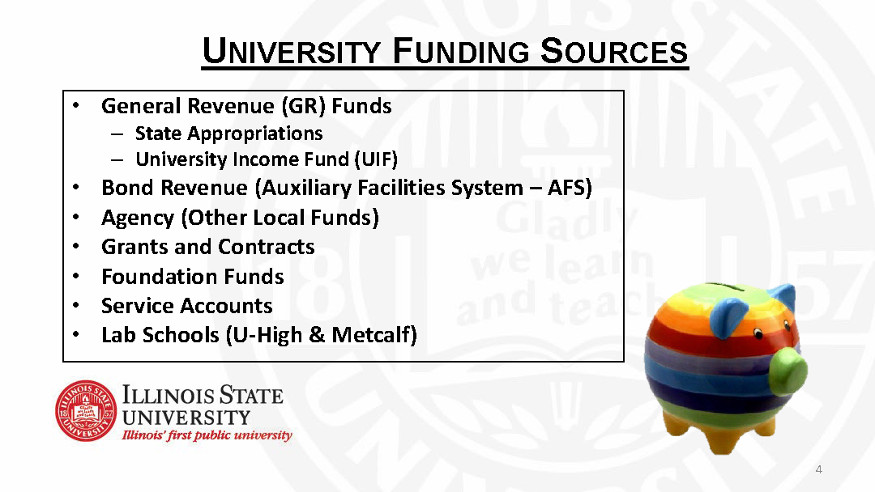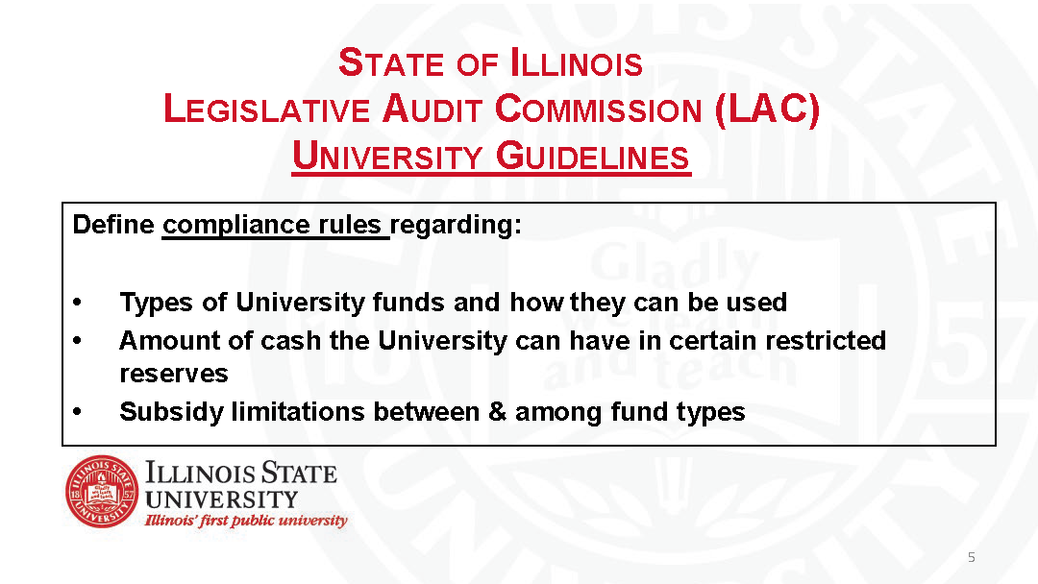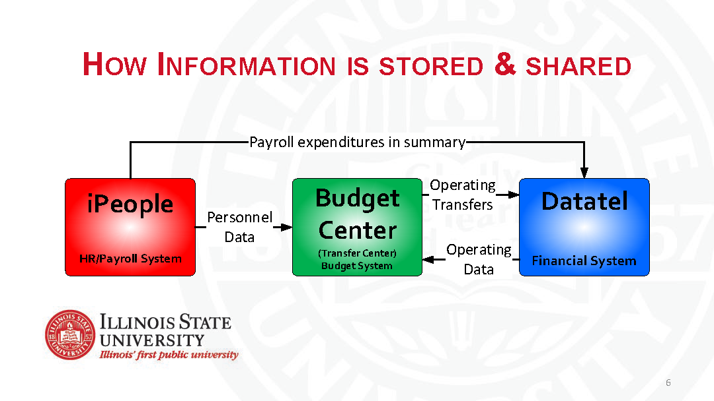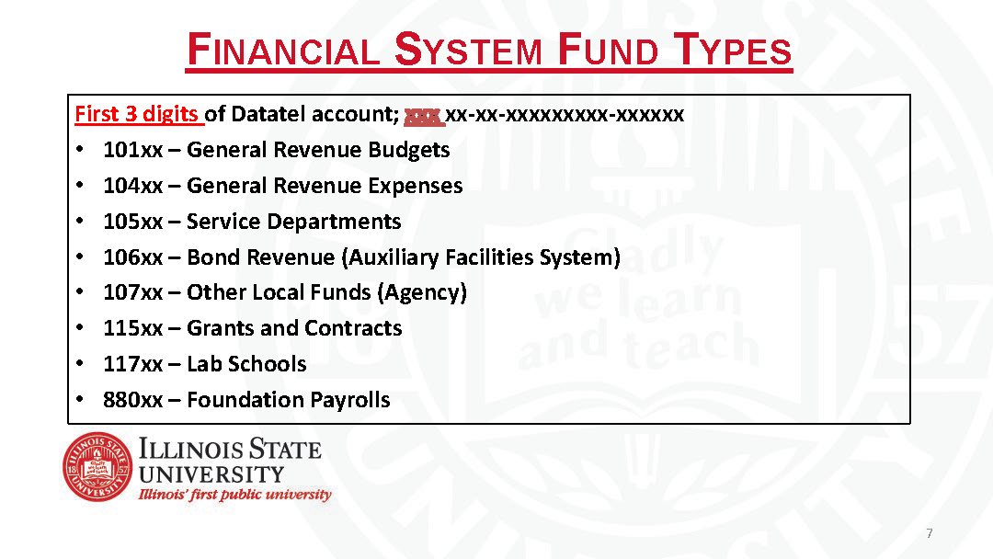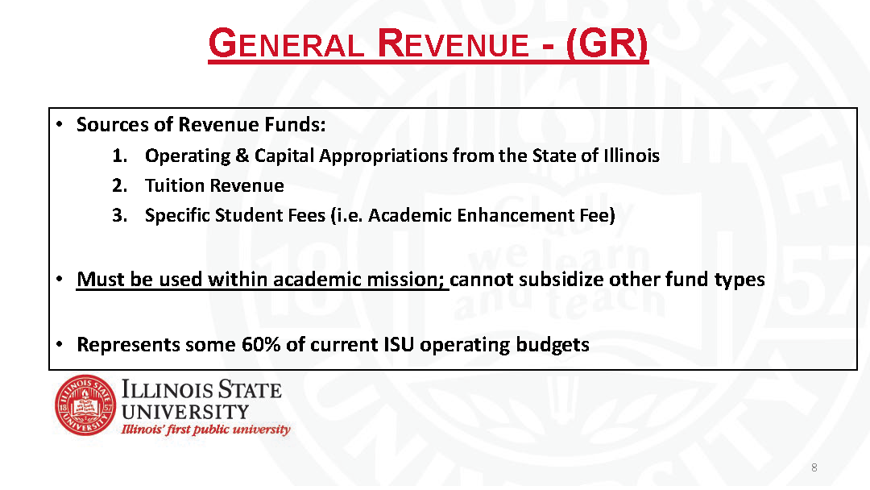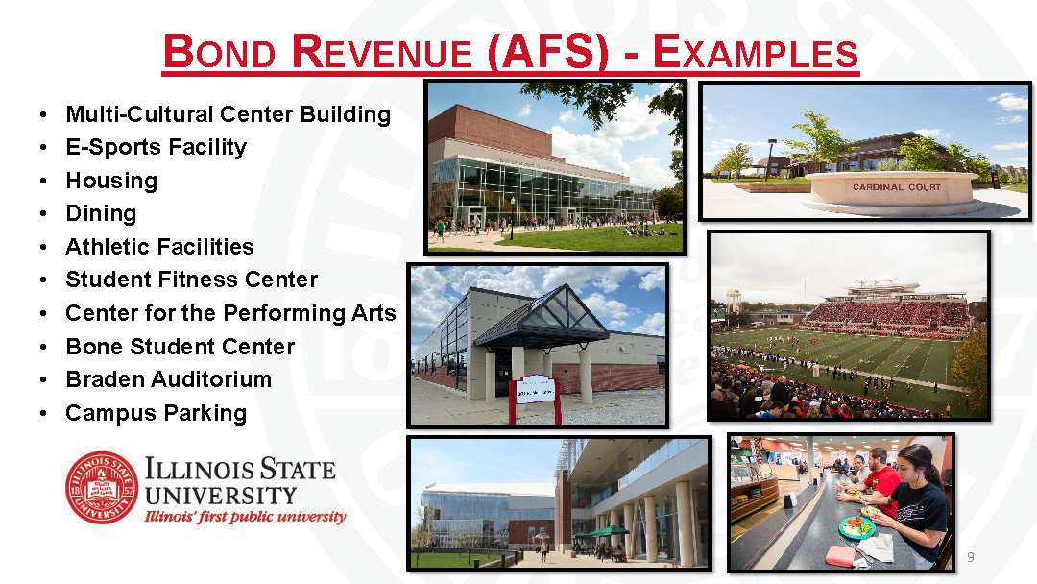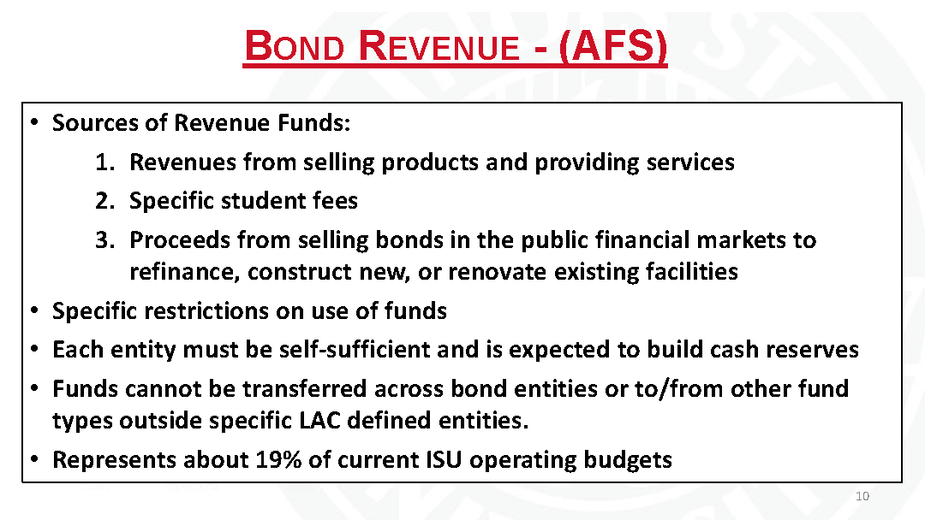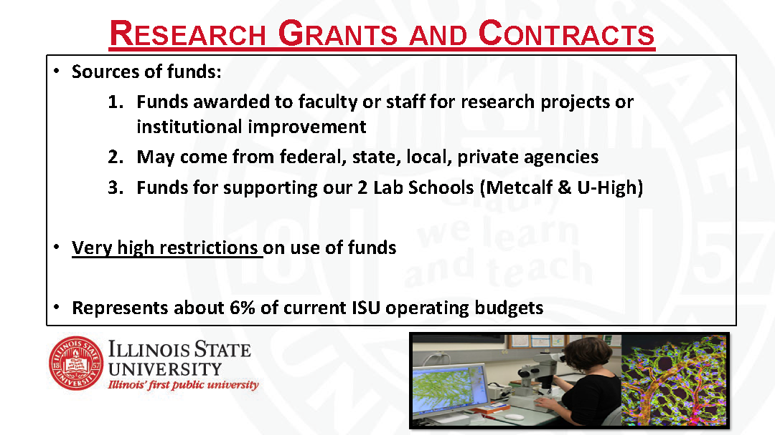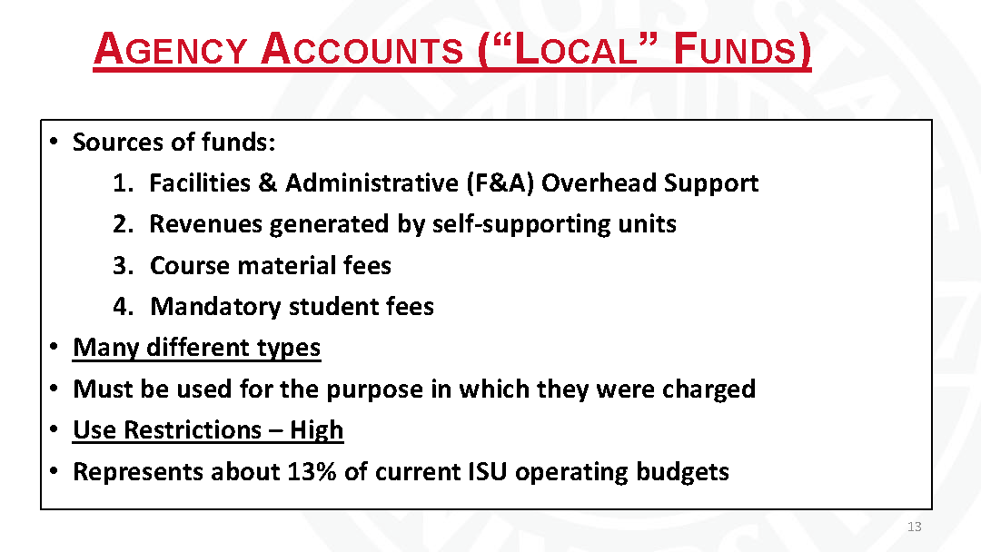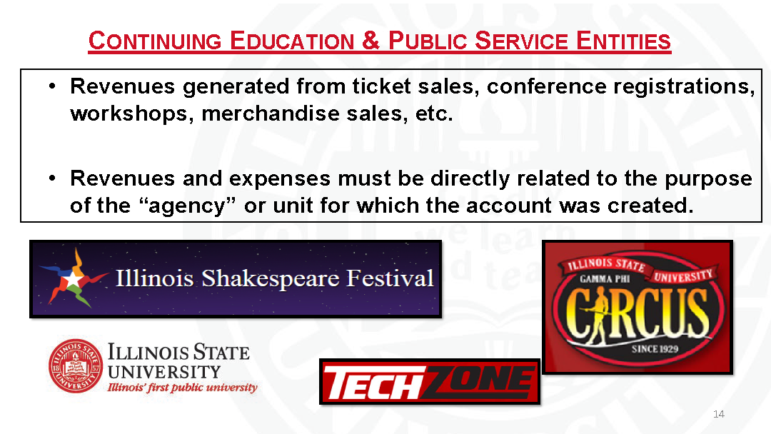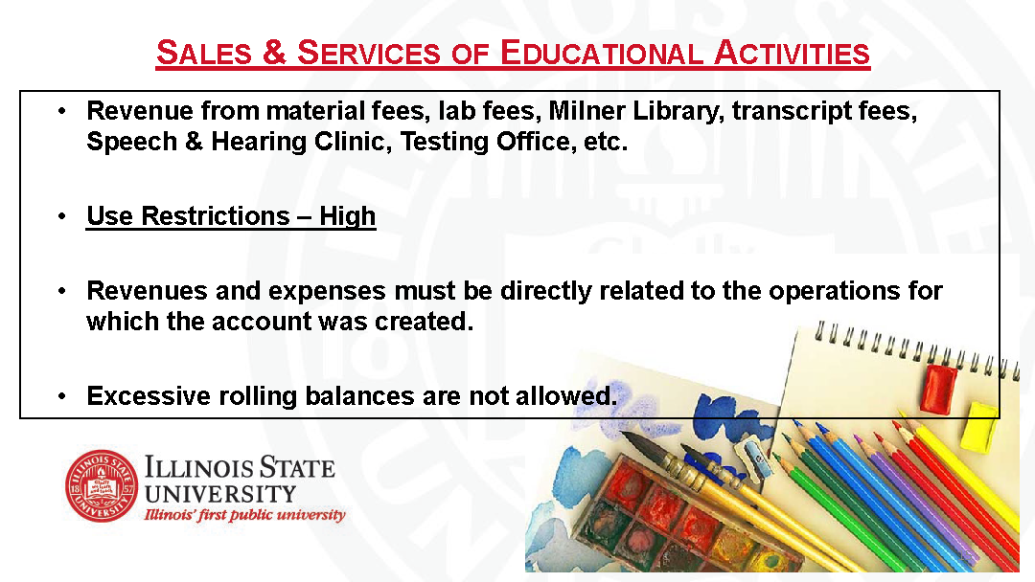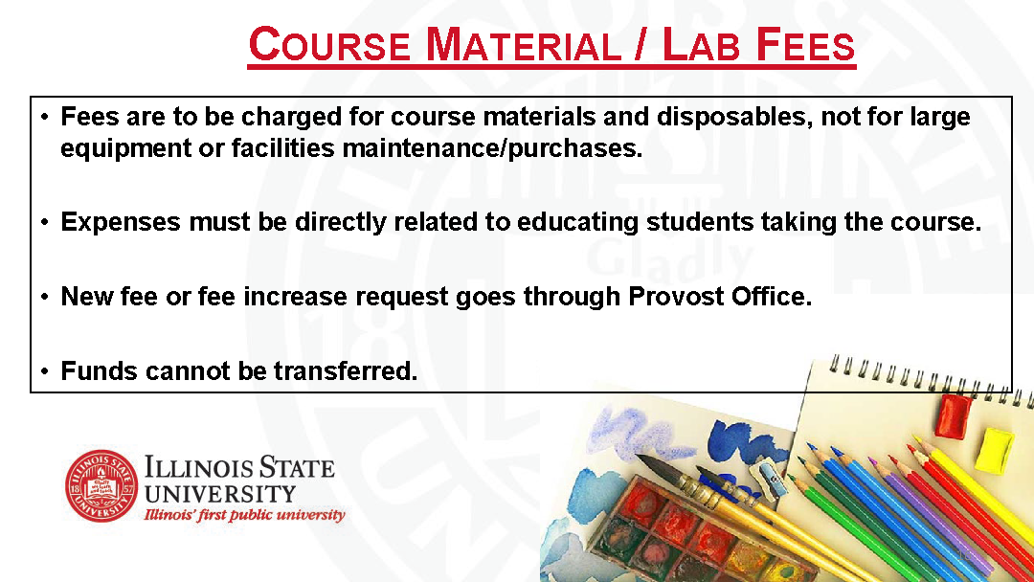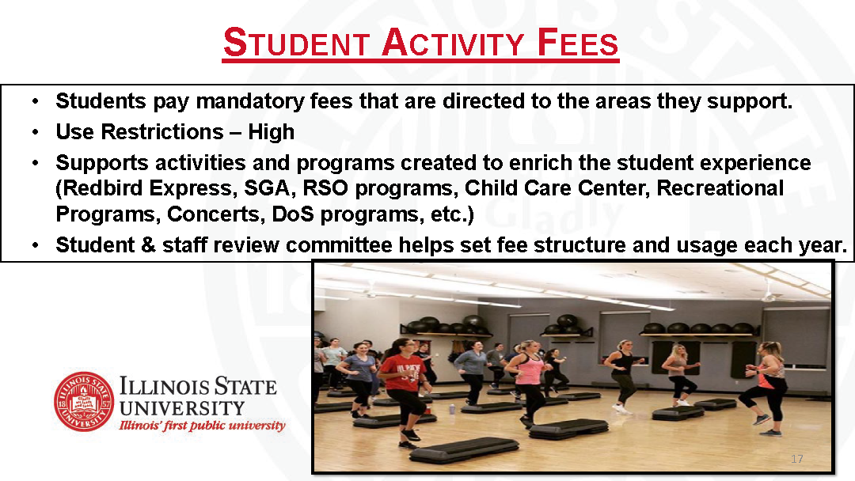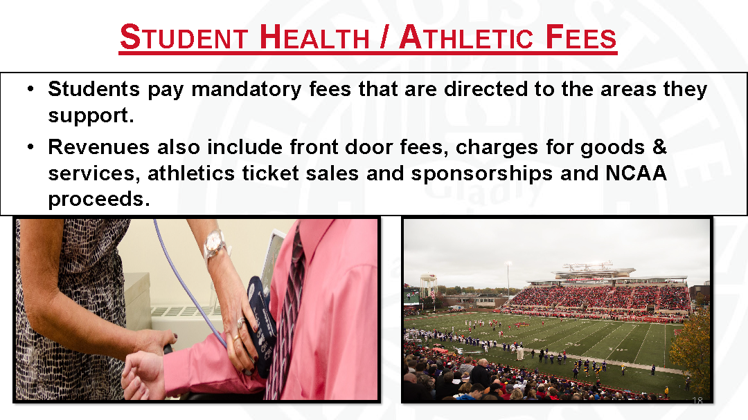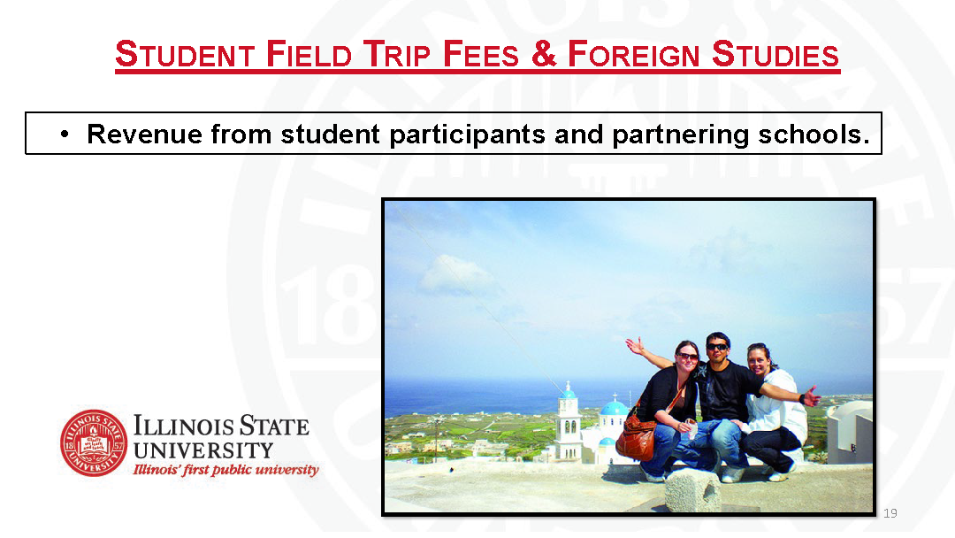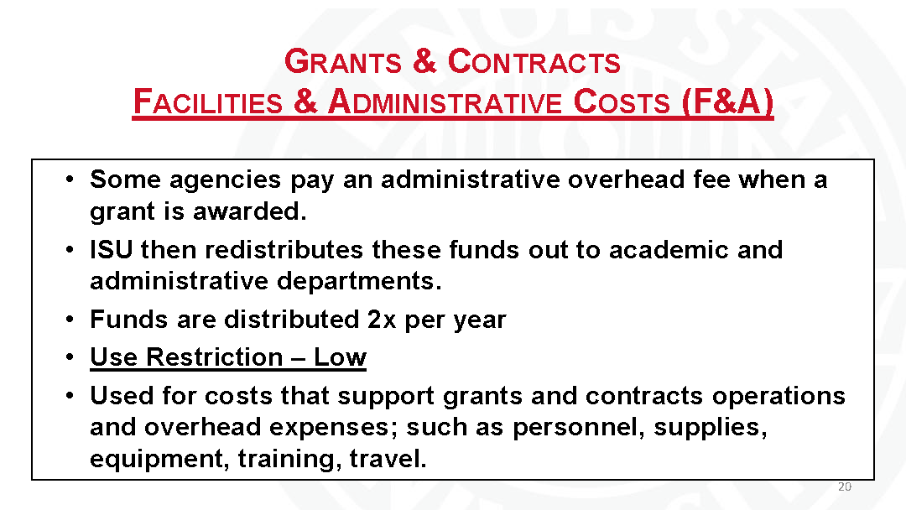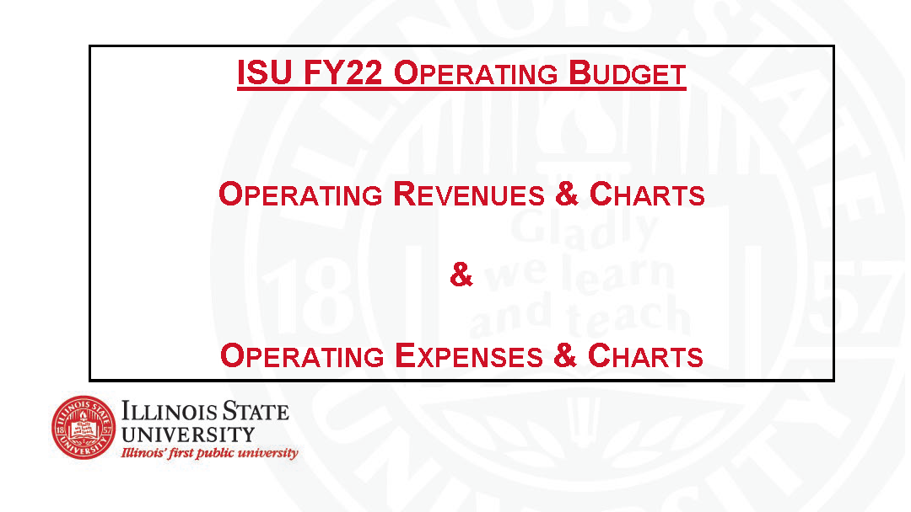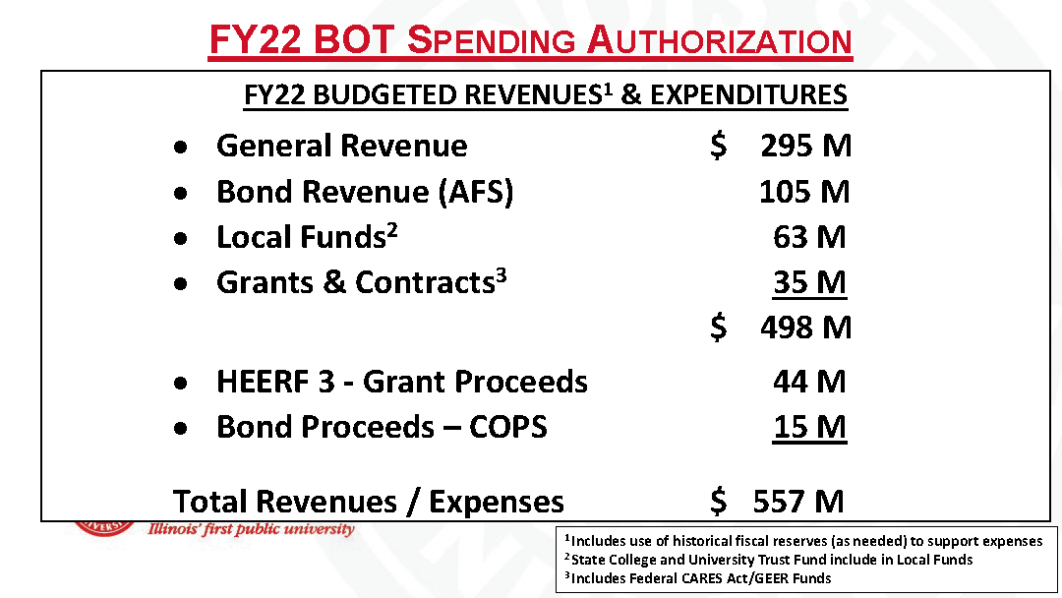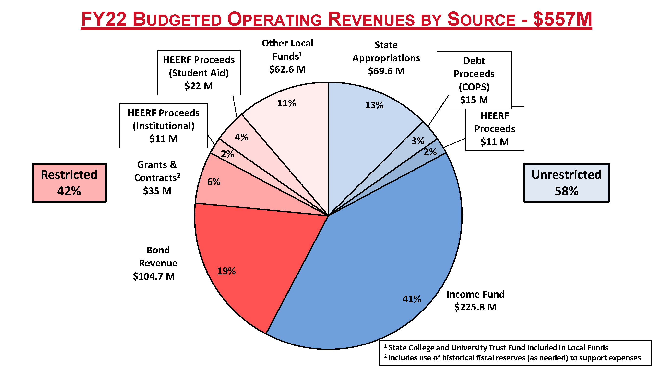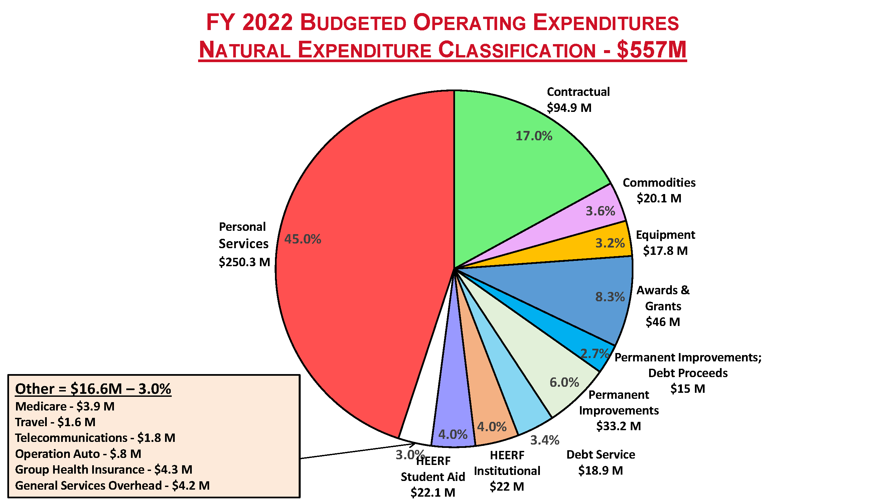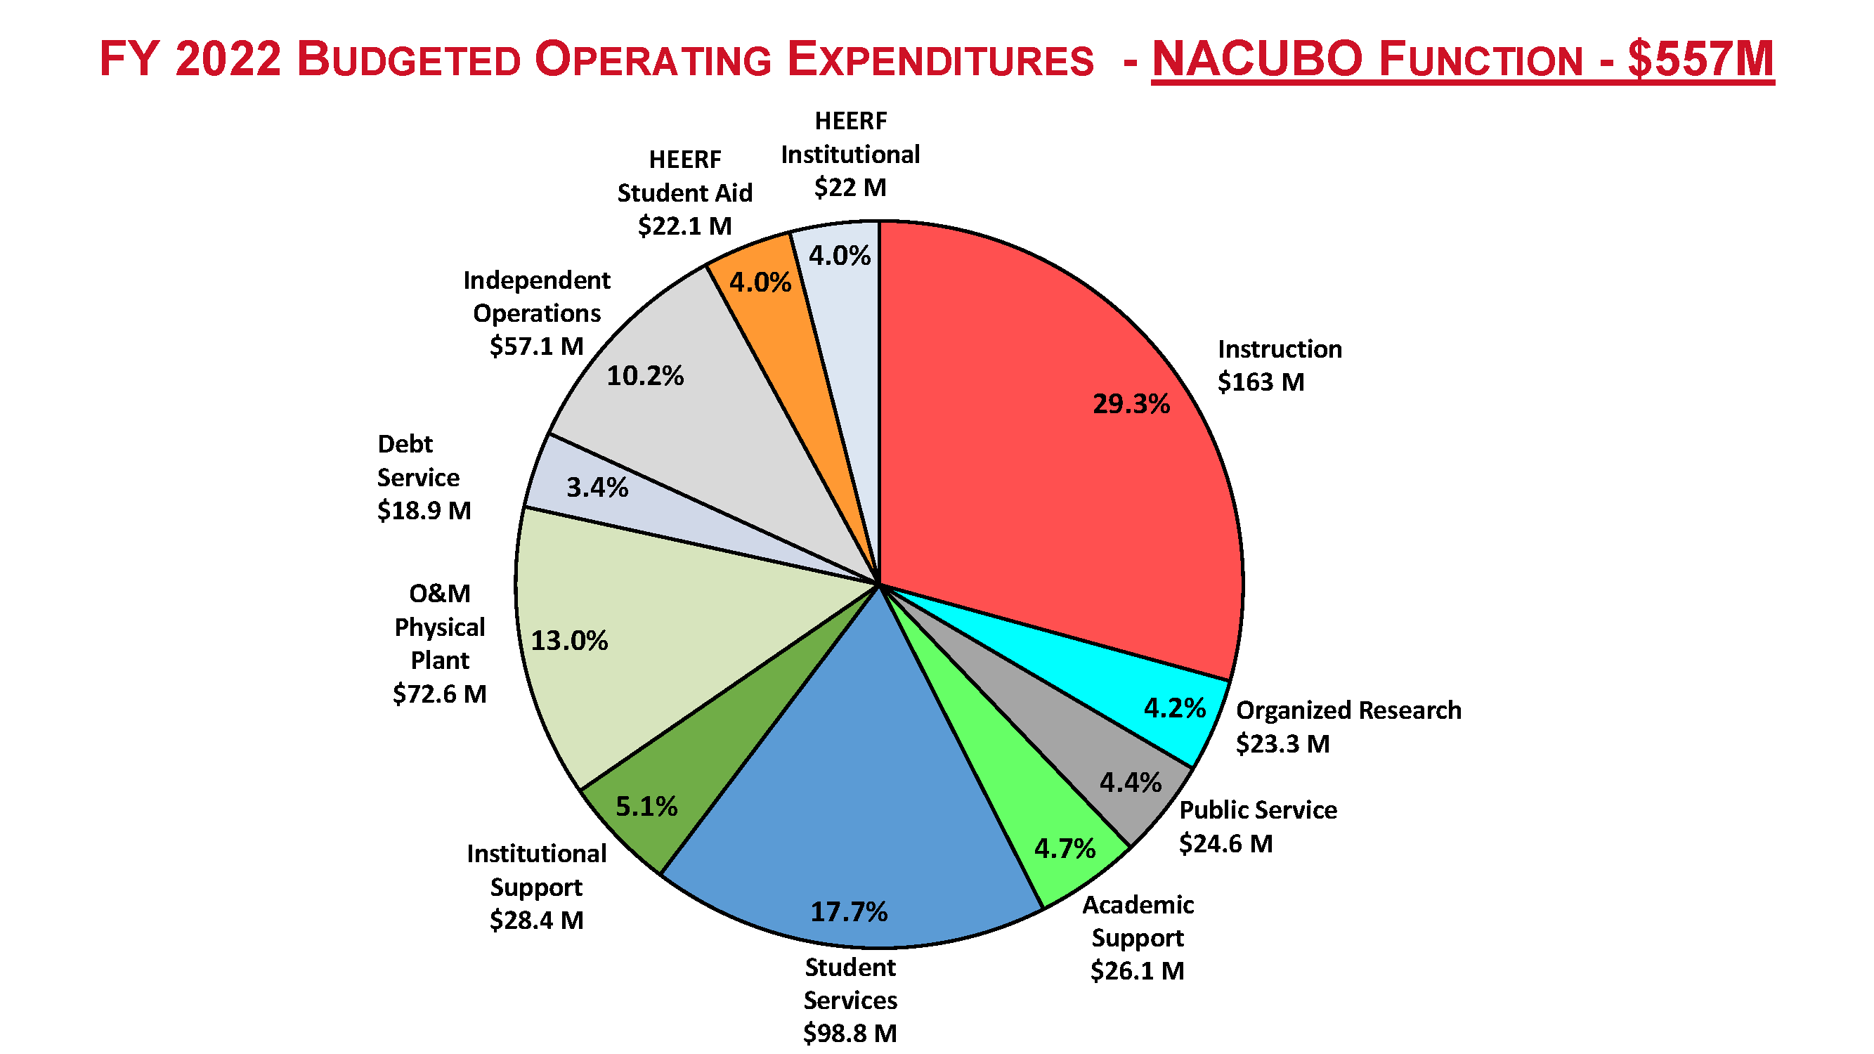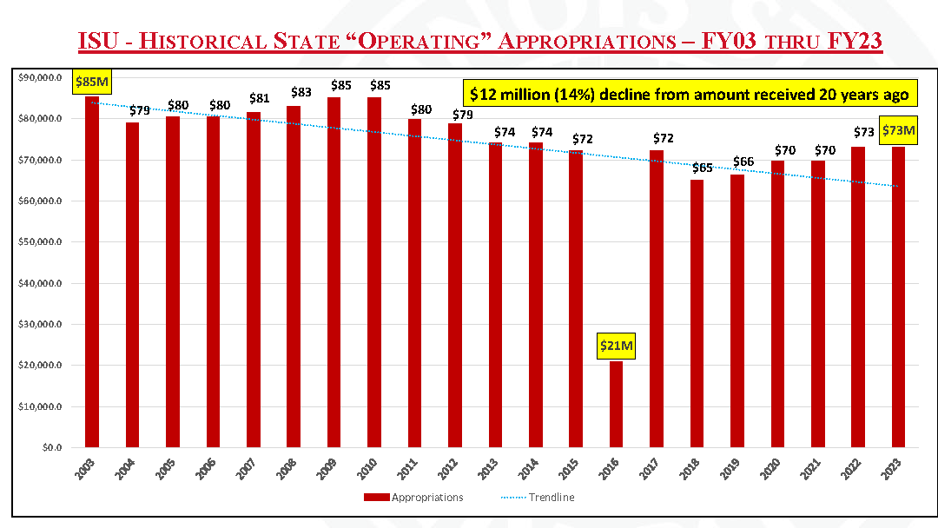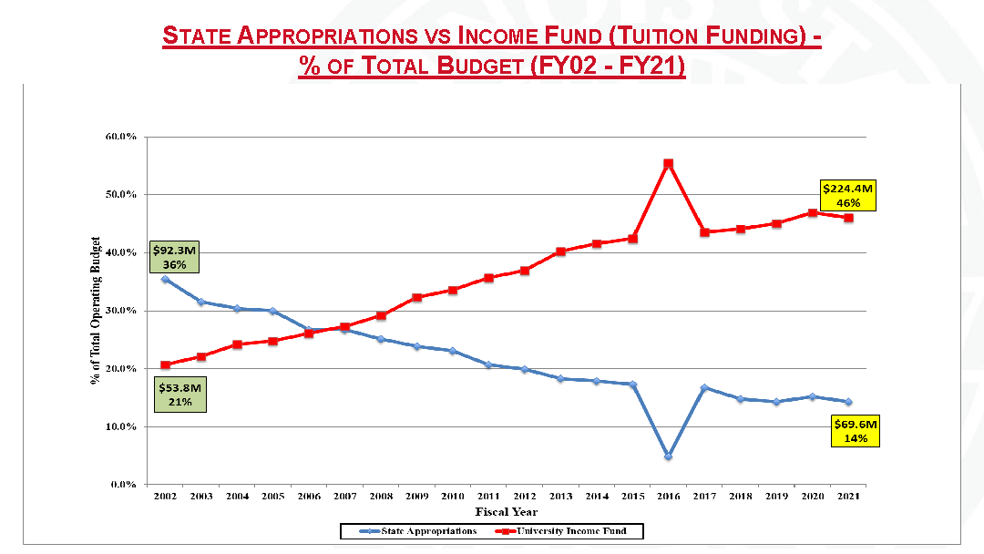

Appendix 2: