Academic Senate Meeting Minutes
Wednesday, October 7, 2026
7:00 P.M. (Hard Stop 8:30 P.M.)
OLD MAIN ROOM, BONE STUDENT CENTER

Call to Order
Chairperson Bonnell called the meeting to order.

Roll Call
Senator Nikoalou called the roll and declared quorum.

Public Comment: All speakers must sign in with the Senate Secretary prior to the start of the meeting.
Senator Seifert: Thank you. I’m making this comment again on behalf of my colleagues in the College of Business. The provost had said that the next permanent dean of the College of Business should have the autonomy to lead the college and we agree. This should include a meaningful role in selecting the department chairs with whom the dean will work. We asked the provost office not to lodge external chair searches before the new dean arrives. Appointing new chairs in advance would leave the dean with a leadership team selected without their participation. It would also bring substantial turnover to a college already negotiating a detransition. Our concern is with committing the college to external searches and new leadership choices before the incoming dean has had a chance to assess the departments, consult their faculty, and help shape the team that will lead the college. Thank you
Approval of the Academic Senate minutes of 9-23-2026
Motion by Senator Smock.
Second by Senator Marshack.
Unanimous approval.

Presentation
Operating and Capital Budget Request to the State
Vice President for Finance and Planning Glen Nelson
Associate Vice President for Budget and Planning Amanda Hendrix
Vice President for Finance and Planning Glen Nelson: Thank you for allowing Associate Vice President for Budget Amanda Hendrix and myself to present tonight. I’ll be doing the bulk of the presentation and Amanda is available also for questions. We’re going to go over the FY27 operating budget and the FY28 operating and capital appropriation request. We went through this with the joint committees a month ago. And so this is a little bit of an abbreviated version of what we presented at the committee, but it doesn’t lack the substantive aspects of it.
As we look at the FY27 operating budget, we want to talk a few minutes about the assumptions. The operating budget is balanced in an all funds level. And the university is planning to use strategic investments from reserves on the GR summit. The FY27 budget assumptions include first and foremost that the all funds budget will balance. What that means is when we look at General Fund or GR, when we look at AFS, agency, all of the various fund types that we have, as we bring all those together in a consolidated view. They will be balanced or produce a positive margin.
The general revenue budget will determine the maximum expense budget. The general revenue budget consists of state appropriation and tuition primarily. Tuition is budgeted based on forecasts from enrollment management. And then we do have other revenues that also come into the general revenue budget. And then those budgets were based on historical information and forecasts. The general revenue expense budgets at the vice president and division level were based upon the FY26 budgets with adjustments for new base expenditures. Expenditures such as those required for the GE road campus operations or campus east operations, negotiated contracts, et cetera. And then there were additional investments that were going to be made in financial aid.
The revenue assumptions in, as I said, the revenue budget determines what our expense budget can be. And so the assumptions for the revenue budget for FY27 were that we would have a 1% increase in state appropriation. That yields $800,000. The fall enrollment was forecast at 22,113 students. We have an additional or new cohort of students paying differential tuition, so there was an adjustment for that. There was a 5% increase in base tuition that all new students paid had their tuition based increase by 5%. But other income was based on revenue projections, primarily from a historical perspective. And then overhead was based upon the revenue projections from the nine GRPs.
The FY27 operating budget that was presented to the Board of Trustees at their July meeting in which they approved the all funds budget was revenue of $595,777,000 plus planned usage of reserves of $7.85 million for a total source of funds of $603,627,000. The expenses were $600 million, $427 million, showing a $3.2 million surplus. I think it’s important now that we have established the budget with the board that we look at where we are now that we’re several months into the year. As I mentioned before, the FY27 enrollment forecast was 22,113 students. Our actual fall enrollment came in at 21,577 students, a difference of 536. So we have 536 fewer students than what we had anticipated for this fall. That means we will be short revenue of approximately $5 million. So we will have to collectively pull together to address that shortfall so that we can end the year balanced.
There are some things we can do to hopefully mitigate this shortfall in revenue. Cabinet has been meeting and has begun discussions about what we can do. And prior to Cabinet meeting, I know Academic Affairs was looking at things that we could do. We could approach the revenue side by expanding winter session offerings or hopefully increasing credit hour production during winter. We can improve our fall to spring retention rates. We can expand summer 27 offerings among some of the revenue options we have. The revenues are one side of the equation. The other side is expenses.
Are there things we can do to perhaps curtail expenses or slow down the expense spent? So we’re looking at both the revenue side of the equation as well as the expenditure side of the equation. Moving into looking at the FY28 operating budget requests that will go to the state. Before I talk about what specific assumptions we have in there, I’m going to go through some historical slides. For those of you who’ve been on the Senate for a long period of time or have been involved in looking at our budget, try not to go to sleep in the next few minutes because you have seen these slides they are simply updated for another year of revenue. For those of you who are new, I think they are informative to give context to the environment, the fiscal environment that we’re operating in.
The first slide is looking at our state appropriation. In 2003, we received $85 million. In 2027, we received $83 million. So it’s been roughly flat for the last 26 years. I will have to say that it is positive. Since 2018, the state has been steadily increasing their investment in us, although it is still not at the level that it was in 2003. On the next slide, you see the same information. Only there’s an added wrinkle and that is adjusting for inflation. So if we go back to 2002, we were at $92.3 million in state appropriation or state funding. 2027 at $83 million, if you adjust that for inflation, that’s only worth 44. So from an inflation standpoint, adjusted standpoint, we’re receiving half the amount of resources now that we were receiving in 2002.
So what does that mean? How does that translate to students? And I think the next slide demonstrates that where you can see the red line is the amount of dollars that are coming into the university income fund was just essentially tuition and fees and the blue line is state appropriation. So as state appropriation goes down, our expenses don’t stop happening. Inflation does not stop happening. We have to get the money from somewhere. And so the balance then ends up being tuition and fees. That’s pretty much how higher ed works and that’s the unfortunate consequence or perhaps the unintended consequence of defunding higher education by the state legislature. That’s not unique to us. It’s common across the country.
If you look at the last 26 years, most states have put less and less of their budget and fewer and fewer dollars into their higher education enterprise. And that simply moves those dollars or costs from the state taxpayers to the users of higher ed, which are our students. The next slide is if there’s any slide in this deck in terms of context that I would like you to take away and maybe sear into your memory is this next one that shows the funding per student in the state of Illinois. These are the public institutions within the state. And on average, the state invests or appropriates $7,931 per student. If you’ll notice the red bar on the bottom, that’s us, Illinois State University. We receive a little over $4,000 per student, roughly half of what the average is across the state.
If we received the same amount, if we simply moved up to the average amount per student in terms of funding, that would essentially double our appropriation. And we would be able to do a number of things from perhaps tuition relief or funding salaries, or maybe even more importantly, or in concert with both of those, funding additional programs, additional services to students. But we don’t have that option, and to the tune of $80 million a year. This is a message that has been conveyed to the legislature for many years prior to my arrival. And since my arrival, I’ve been in two legislative sessions and I’ve heard the president and other members of cabinet express this information to all of the legislators that we run into when we’re at the Capitol.
Another aspect of the environment we’re operating in is in the area of waivers. We have a number of state-mandated waivers. And one that’s particularly costly is almost bittersweet. Because of our standing as an institution educating teachers, and because of our long standing history of being involved with teaching special ed teachers, we want to attract those students to our institution. Our program draws those students to our institution. But because of state waiver policies and the state also values that education, they tell these students they can come to any of the institutions in the state study special ed and get 100% waiver. The unfortunate aspect of this is the state did not fund that program. And so we, all of the students, at the institution are essentially funding that waiver. And so that’s $6 million just for that one waiver. The other mandated waivers we have bring the total to 14.
So we have asked in the past and we haven’t received much help, but this with this last legislative session, there was much more interest that we’ve been hearing from legislators around the state that they are much more inclined to want to do something about this. Our local legislative contingent Representative Sharon Chung and Senator Dave Koehler have very much been advocating on our behalf to get these waivers funded. But this is a $6 million expense that we have. We have no control over. And that limits what we could be doing with those dollars.
So from a contextual standpoint, that’s the environment that we’re operating in, because we looked at the FY28 appropriation request. I just want to walk through the calendar really quickly. This month, we submit to the Board of Trustees to IBHE and the governor’s office our request or we work on it this month and in this month and next month during that time frame, we communicate, we get both the approval of the board and then communicate to IBHE and the governor’s office, what our request is for an operating budget and what our request is for a capital appropriation. In February of 2027, that request is then submitted to the legislature, and then in May, the state of Illinois finalizes their budget. So we’re in that formulation phase right now, formulation and preliminary approval for our request. That request is then heard and debated at both in the House, the Representatives and the Senate. It also provided input to the governor for the governor’s budget for how much the governor is recommending that higher ed is funded.
And so those three entities together come up with what our appropriation is. So one of our jobs is to communicate as effectively as we can what the needs of our institution are and lobby as hard as we can to try to get some of these things funded.
We’ll be asking for $22 million of additional funding in the next session. We asked for $20 million last time. We received $800,000. But that 22 is made up of three major areas. One is in terms of sustainability, it’s relief for those $14 million of waivers that we have to provide to a certain segment of our students. If the legislature would fund either the $6 million of waivers for special ed instruction, teacher training or instruction, or the entire $14 million, that would really change the outlook of where we are. In terms of growth, we’ve asked for $4 million to support the expansion of high need disciplines in Illinois. The reality is we can ask for this $22 million and $4 million was also for additional financial aid for students. The reality is we have a small chance in getting much more than a 1% or 2% or 3% increase. A 3% increase would be $2 million. But this is the package that we would be submitting.
And so if you look at the slide 18, you’ll be hearing us ask for an operating request of $105 million for next year. $83 million of that is our existing operating base. And then you add the 14 for replacement revenue for waivers. Four million for student financial aid for need-based scholarships and support for expansion of high need disciplines of $4 million. That’s the 22 I just spoke about. That brings us to an operating request of $104,997,000. The State College University Trust Fund request is $30,000. That’s really just a pass through of the revenue that’s generated if you buy an Illinois State University license plate, a certain part of that fee. goes to the state and is then earmarked for the university.
So you’ll see us asking for 105. That doesn’t mean we’re going to get 105. And so I think one of the things I’ve found since I’ve been here is we have different budget numbers that we talk about, different budgets at different times. And it’s very easy to confuse this with, oh, well you only received 83 last year and now you’re going to get 105. We probably won’t get 105, but we’re gonna be asking for 105. So you’ll be seeing that number or hearing about it. In terms of capital requests, the state has not funded large capital appropriations for us for a number of years and not just us, but across higher ed. As we discussed in the joint committee a month ago, You know, we can look at each one of these projects, but the reality is there’ll be very little likelihood that we would get this money. So we don’t spend a lot of time debating the priority order that’s on here.
So if the Metcalf school replacement is something that’s very near and dear to your heart and you see that at number three on here, it doesn’t necessarily mean that that’s not important for us or that the two items above are going to get money and then there won’t be money for Metcalf. But we’re trying to signal the state responsibly and accurately what our capital needs are. And if they would have $370 million dollars, these are the projects we would like to have them fund. And then in terms of the capital renewal request or deferred maintenance, there’s another term for that, we’re requesting $42 million. So there’s a total of $412 million of capital appropriation that we’re requesting.
The reality is very little if any of that that we will receive. But if we don’t ask, if we don’t put the message out there. We are also remiss in not communicating to the state leaders, legislative leaders and governmental leaders, what the problems are that we’re facing financially and the long-term aspect of our buildings and the capital investment that the state has made in the university.
If you go to the next slide on slide 20, this is the $42 million of capital renewal requests. We’ve been working, there’s a state senator who has been very active in the last several months in wanting to learn about capital, not only with us, but about our needs and the other higher ed institutions across the state. This was a very welcome phone call to take and we’ve been meeting with Senator Balkema and his staff frequently for the last three months helping to educate him. He is very interested in trying to do something with capital and capital renewal. But he’s only one senator and he isn’t even our senator; he’s from Peoria so he’s close by but he is trying to help. We have characterized our capital renewal list as we work with him around life safety and other issues that we believe may resonate with the legislators or certain legislators.
The campus stormwater management was our number one and we had two devastating weather events in the last three or four months that have caused significant amount of damage and disruption, not just damage our facilities, but disruption to faculty, staff, and students during the summer. I can only imagine what it would have been like if this would have occurred. The last one would have occurred two weeks. It was bad enough that it occurred during move in. But if it would have been two or three weeks later into the semester or around midterms, it would have been even more devastating to us.
And so we’re hopeful that because of the recent memory or recency of this issue, that it may resonate with some legislators. Electronic safety controls, if we had $7.5 million that we could, continue to put the card access on all of our buildings and what not to increase safety. We’re hoping that that plays well. But the 42 million again, don’t walk away from the meeting thinking we’re going to get 42 million dollars of renewal money, but know that that’s what we’re going to ask for.
So that’s where we are with how we got the 27 operating budget, where we are with 27 right now and the challenges that we’re facing and then what our plan is to go to the board for the 28 appropriation request. So with that, Amanda and I can take questions.
Senator Seifert: Are you going to discuss anything more about the operating budget model?
VPFP Glen Nelson: For this presentation, I wasn’t planning to. This presentation I thought was around the appropriation request.
Senator Seifert: The only question I have, and this is an overall question, how much of the overall budget does the academic side of the house get? So in other words, I know you’ve got facilities and you’ve got all the other support areas on campus and everything else that you have to fund with this budget. And if I’m misinterpreting that, just please let me know. But what percentage actually goes to what we do for living, I guess?
VPFP Glen Nelson: Are you talking about the all funds budget or the general fund budget? Which base are you talking about? That makes a difference.
Senator Tarhule: I think it’s about 58%. Don’t take that to court, but I think the number you’re asking for is 58%.
Senator Seifert: Because I know at one time the academic units received less than 50% of the overall budget.
Senator Tarhule: I think it’s about 58, but we can double check those numbers. Sorry if I spoke out of the way.
Senator Meyer: Okay, I want to talk about slide seven and also slide eight, but let’s start on slide seven. I apologize; I think there might be a little context here that you need to understand my question properly. The University Income Fund revenues compared to last year went down and expenses went up. And my understanding was from one of your presentations last year that the UIF is comprised of tuition and some fees. Am I correct on that so far?
VPFP Glen Nelson: Tuition and fees? Yes.
Senator Meyer: OK. All right. So here’s my question. Did you say that we have a $5 million shortfall from enrollment? And that is according to slide eight from 536 fewer students? Is that correct as well?
VPFP Glen Nelson: Yes.
Senator Meyer: Okay. And so you’re saying we need to offset that. So here’s my question. It’s twofold. On slide seven, you’re showing total resources, all funds and that there is a net income of $3.2 million. So, would that help to compensate for it?
VPFP Glen Nelson: The $5 million shortfall is on the University income fund or the general fund budget. If we, from an all funds perspective, yes, we have a $3.2 million more projected revenue than expenses. So that could help in all funds. However, that doesn’t help on the general fund side.
Senator Tarhule: The answer is no. And it’s no because you take the budget is divided into two. What he calls all funds, think about it as general revenue. And then there’s the auxiliary, auxiliary is the fees, housing, and building, things like that. On the auxiliary, this positive margin is on the auxiliary. The all funds, which has the tuition and the expenses you are talking about, is deeply negative. The law does not allow you to take the auxiliary fees to make up for the deficit you have on the general level. So, the answer is no. The university as a whole has a positive object, but we also have simultaneously a deficit that we must manage.
Senator Meyer.: So what law is this?
Senator Tarhule: I don’t know the name of the law, but the law says you cannot charge a tuition or you cannot charge a fee for a service and then use that money for something else. Let me explain. You cannot charge students fees for food and dining and then use that money to pay salaries for faculty. That’s against the law. So, in the budget, where we have fees, all kinds of fees, parking fees, and auxiliary, dining, accommodation, sports, all of the fees that we charge, there is a small positive balance in that fee. In terms of the tuition that we get and the appropriations, we have a deep negative balance and we cannot move money from one area to cover the other area, this area where we have a deficit. We can get you the name of the law. You can’t transfer, but this is what is called the balance. You cannot transfer bond and auxiliary fees and use them for general revenue type expenses and vice versa. In fact, this may be too long, but just so you know, when you guys, when the Academic Senate meets in this room, by law, we have to pay for it because the Bone Student Center is an auxiliary building. Academic Affairs is an academic enterprise. We cannot have an academic meeting in an auxiliary fee building for free. The law doesn’t allow it. So this meeting cannot happen if we don’t pay for it. And if we didn’t pay, this would be against the law. So the Provost Office pays for Academic Senate to have this meeting in this room every fortnight. That’s how strict the law is.
Senator Meyer: Okay. Well, I don’t want to go down that route. So, we’ll go a different way. One question I have for you, Vice President Nelson, is can I help to make up that $5 million shortfall if I save expenses in other areas such as not paying a consultant or an attorney outside the university up to half a million dollars. But could I just do that ten times over and I’d have the five million taken care of?
VPFP Glen Nelson: If we spend five million less than what we budgeted for our expense, yes.
Senator Midha: As you mentioned, for several years, the Senate has seen the slide number 13, which shows that ISU receives the lowest appropriation per student. Each year, the cabinet makes a case to the legislators, but we have not seen a different outcome. So my question is, what different approach has been taken or tried this year in the hope of achieving a different result? I asked this specifically because on slide 18, FY 2028 appropriation request shows that the same operating base has been requested as last year. This suggests to me that ISU is not necessarily expecting or perhaps even requesting a higher appropriation. Could you help me understand the strategy behind this year’s approach and what if anything is being done differently to improve ISU’s position in the state appropriation process?
VPFP Glen Nelson: Well, I think the first and foremost has been continuing to educate legislators and a number of them realize that one of the things we have to realize is each of them represent a different area of the state. If I represent, if my constituency is where Chicago state is, I’m not going to be very inclined to vote for a bill that would move money from Chicago State to Illinois State. And so we work with the leadership of the House, the leadership of the Senate, with the governor’s office. And behind closed doors, most of those individuals we meet with tell us, yep, they understand this but they need a different vehicle to try and reallocate those dollars and one that they can politically get behind and not lose votes in their area.
Second thing, over the last two years, we have been involved, the president has been heavily involved in working and representing the institution on the equitable funding bill. Now, the equitable funding bill that was proposed in the last legislative session or really the last two legislative sessions, it would not fully address this and take us up to the average, but it would give us significantly more dollars than the one, two, or three percent that we get. So we have been involved in working on that legislation as well. This isn’t a situation where you could be doing a better job lobbying to get dollars away from all of the other counties the other universities are in. The legislative leadership knows about this and I can ask any of my colleagues, cabinet colleagues, if they want to chime in here, but every one of us have been talking the story and in different ways to each of the house members and senate members we talk to.
Senator Tarhule: If I may add two perspectives, one relevant, maybe the second, not so much to Senator Midha’s question. The question is the approach. There is only one approach for asking for money from the state. There is a legislative vehicle. That says as VP Nelson explained, there’s a process where you submit the request, you go and define the request, and then you wait for the outcome. That approach is set by the governor’s office and the legislature, and everybody follows the same.
So in terms of the asking mechanism itself, there’s only one approach. In terms of, I think what you’re getting at in VP Nelson, you’re speaking to is what additional lobby efforts or other things could we be doing to make this different. This may not be the answer you want to hear, and maybe this is too blunt, but I think it is fact. Unless the state changes the current funding mechanism, this will not change. The mechanism that the state funds higher education now is locked in. And that is why the process VP Nelson mentions is there’s been a coalition not just higher ed but also other entities that has been working for five years to try to change how the state funds higher ed.
Here’s the thing, the current funding method has no criteria. It’s based on history. It’s not based on saying, if you have this many students, if your performance is that much, if you do this, if you do that, that’s how much money you get. That’s not what it’s based on. It’s based on something that was established pre-1995, there is no criteria, it’s just whatever you got. So we’re trying to introduce a new mechanism that actually has criteria associated with it. And that effort has been ongoing for five years. And so hopefully many states, this is not unique, many states have successfully changed their funding formulas, Georgia, Florida, North Carolina, they have come up with different mechanisms. Illinois is just behind. The last point I would make with respect to this point is the following.
As much as we hate the state funding formula, which is based on history and no criteria, that is exactly what our budget process at Illinois State University was. There was no criteria attached to how much money any department or any college got. Just as we are asking the state to change the budgeting process, so there is at least some criteria, even if it’s not perfect. That’s what we have tried to do with the current budget. The budget we have now introduced for the first time in over 30 years actually has some criteria. Nobody is going to, not everybody is going to agree with it. It’s not perfect. We are going to continue to refine it. But if you look at that budget, it’s based on student enrollment, it’s based on criteria, it’s based on this, it’s based on all sets of variables that we all collectively over 18 months worked together to come up with. We have not had that at Illinois State for 30 years. And so the new budget is the first criterion-based budget. And that’s the same kind of thing that we’re not exactly the same budget. That’s what we would before this new budget, there was no mechanism at Illinois State to give any new college any amount of money different from what they got before. It’s not a rational way to plan a complex entity. That’s where the state is. We can now do that because we’ll introduce a new budget that is based on criteria. The state kept on to introduce a new budget that is based on criteria.
Senator Midha: Thank you for explaining.
Chairperson’s Remarks
Chairperson Bonnell: Thanks to VP Nelson and AVP Hendrix for their budget presentation. And of course, as always, thank you for your important service on Academic Senate. Among the agenda items tonight we have two action items. The action item stage is that occasion when senators may offer their support or against a motion to approve their proposed items and those instances its changes to policies. Also, to faculty senators, a reminder caucus will be meeting directly after Senate adjourns and it seems likely that we will complete caucus’s first review of ASPT alignment with the CBA. We made significant progress last week in our special meeting, when, according to my notes, it looks like we covered 50 proposed changes and that would be about one change per page. So thank you for your work in meeting at our special meeting last week. Tonight we just have 13 more identified proposals to discuss, again thank you for your close reading of the ASPT.
Also, I’ve received white ranging questions from constituents. A quick reminder, it’s a 48 hour timeframe for asking questions to administrators. Some of those questions are directly connected to Cornell University’s sexual assault allegations and Cornell’s investigations and policies, and in particular, how Illinois State University’s processes, investigations, policies, and procedures. may be comparable to Cornell’s. Some of the other questions addressed Illinois State University’s data, some of which had been shared in the recently published Annual Safety Report that reports on statistics for calendar year 2025. I’ve had a chance to communicate with a number of people from a variety of different campus offices today to respond to your questions. We are working to coordinate among the many areas and offices to gather information to provide response, which will be shared back via email to Senate. Thank you for these questions. Thank you for representing your constituents. And I would also say thank you for caring.
And the last item I want to share is, last week I mentioned there is a continuity in the work of Senate. On September 10th, former Illinois State University English Department professor, a faculty member from 1964 to 1993, Dr. Robert, or Bob, Sutherland passed away. I knew of him and that many held him in high esteem as a faculty member, as a colleague, as a social justice advocate, and as a human being. WGLT reported on this passing detailing his accomplishments, particularly as a civil rights warrior, noting there was so, so, so much more to his accomplishments than what they could report on. Some of what I learned coincidentally, some of that extra information, when I attended the premier at Normal Theater for the documentary, “Post-Amerikan, the Newspaper that Wouldn’t Die.” Dr. Sutherland was interviewed in that documentary. And for those who may not know, Post-Amerikan was a Bloomington-Normal underground, alternate newspaper that was published from 1972 to 2004. And in fact, it’s the longest continuous publication run for any underground newspaper in America.
Dr. Sutherland was interviewed, and I learned then that he served as a senator from 1972 to 1975. And he also served as the academic senate chair from 74 to 75. In an August 26, 1974, Vidette article, Chair Sutherland shared that senate’s democratic structure is this is what he said, “gets things done and opinions get expressed.” And I love that. I love how concise it is, and I think it’s accurate. He seems like many of you here now. He seems to have been committed to students, shared governance, and working toward making the University and our community a better place.
To those of you who knew Dr. Sutherland, I am sorry for your loss, and I’m sorry I didn’t acknowledge his passing earlier. Our work here in Senate is founded on dedicated efforts of previous members, our past senators, especially those like Dr. Bob Sutherland, and I want to acknowledge his work in making Senate better at the university and our community.
This concludes my remarks and I’d be happy to answer any questions.
Okay, if not, as it turns out, Vice Chair Zagal was unable to attend tonight, but she asked me to share this, that SGA is partnering with the School Street Food Pantry for a food drive and with the Center for Civic Engagement for a Socktober. And also that SGA can bring a donation box for items to the next meeting too if any senator wants to participate in that.
Student Body President’s Remarks

Administrators’ Remarks
- President Aondover Tarhule

Senator Tarhule: Thank you so much and thank you to everyone. By the end of this week, we would be exactly halfway through this semester. I want to thank everyone, faculty, staff, and students who work so hard to make this university such a pleasant place to be. I ask that we continue that spirit of collaboration and commitment and be kind to each other and to yourselves. But thank you for all you do for the university. I’m happy to answer any questions.

Senator Meyer: I got what I think is a fun question. I saw this in the New York Times. They’re reporting about a Gallup poll that shows confidence in higher education is about 50% among Democrats, 23% among Republicans, and those numbers haven’t improved since June. Rightly, I think trust is also falling in AI and Flock, but I was curious about what your thoughts are about the confidence in higher education going down among political parties. Any reactions?
Senator Tarhule: Thank you for that observation. If you don’t mind, I’ll address it more largely. That poll going back to 2001 had everybody, not by political parties, so mixing everybody together. Confidence in higher ed was at 73% in 2001. It’s now in about 35%. So we have fallen quite a bit. What is driving that I think is a variety of factors. Number one is the divergence, but maybe not number one in terms of priority, but there’s a divergence in the way that people believe what people think higher ed should be or what it should be doing for them. A big part of that lack of confidence is coming from people who say they’ve gone to school, they’ve borrowed money, they’ve undertaken all these expenses and it’s not giving them what they thought they would get. That is a part of one of the issues.
The second issue has to be, and maybe this is where it gets political with people who believe that higher ed is too ideological. There are many people who believe that higher ed as a whole is left leaning, and sometimes you hear allegations about brainwashing, people have been indoctrinated and so that’s reduced trust in higher ed. I think a much larger issue is that in the United States higher ed has gone from being a public good to a private good. So there was a time when we believed that everyone should have a college degree and that it was going to be good for them and for society as a whole. And we were willing to pay for that. That view is different. People no longer believe by and large that higher rate is a college good. They believe it’s a private good if you want it, go pay for it. Why should I have to pay for your higher ed? It’s a private good in the same way that you might buy a car these days. So I’m sure that doesn’t address all of the issues. If I had more time, I could come up with additional ones, but at this, at the once, I can come up with it immediately.
This is not unique to higher ed. Public confidence in all institutions has fallen. So if you look at higher ed by alone, it’s very depressing to look at, oh my goodness, nobody trusts higher ed anymore. But if you look at all institutions, we’re actually doing better than many other institutions. So I think there’s another poll that looked at institutions collectively, the military, the clergy, you know, teachers, police, all of those. Higher ed is actually number three in terms of maintaining confidence. So many of the other institutions have fallen by quite a bit with the public. They no longer trust those institutions. So I just wanted to put that out there. It’s very depressing when I see this being in higher ed. But then you put it in larger context and there is comfort in shared misery. The public has a whole has soured on institutions.
- Provost Ani Yazedjian

Senator Yazedjian: Great, thank you. I have two brief remarks this evening. Number one, at the last Senate meeting, Senator Midha had asked a question. I was out all last week, so I responded to Senator, Chairperson Bonnell to Senator Midha’s question, but also sent an email to the College of Business today, outlining a few things through the College of Business listserv, one identifying members of the search committee, outlining next steps in the search process, outlining some steps for how individuals could get involved, providing the written feedback that was provided to me when I went to each of the four departments to hear from faculty and staff. And then I included also my response so everybody in the college was able to see that. The other thing also in relation to Senator Midha’s question right now about one of the things that actually I see Vice President Sparby here and President Farmer and I, when we met a couple of weeks ago, we did talk about our shared goals and priorities and the possibility of us going together to Springfield, to lobby for the higher, the equitable funding bill for higher education. Last year, we went at different times, but we’re gonna consider whether there’s an opportunity to be a shared united voice on that front about the need to do something different with the funding model for institutions of higher education. Thank you.
Senator Bonnell: And I will add that the response we can add as an appendix into the minutes for this meeting. Does anyone have any questions for Provost Yazedjian?
Senator Midha: Thank you for that remark. I hope the shared approach works this year. But regarding your response, earlier response, I want to thank you on behalf of the COB constituents for addressing the questions. I appreciate you taking the time to provide us a return response. At the same time, some aspects of the response addressed the permanent dean search, which is yet to take place, rather than the interim dean selection that was the subject of the original questions. COB constituents therefore have some follow-up questions and request for clarification and I have organized those into three sets. As the responses to the written questions were received today late afternoon, I’m still receiving additional feedback and questions from the constituents. I will read the three sets of questions I have received so far and I will forward any additional questions I received later through the Academic Senate.
First group: you stated that you consulted with the constituents you felt would be most appropriate. Identifying President Tarhule, staff in the Provost Office, and a representative of the Registry. Could you please clarify what criteria or guidance you use to determine that only these individuals represented the appropriate constituencies? For purposes of University Policy 3.2.13, Section 1A. in particular, what was the basis for determining that consultation with COB faculty, staff, students, donors, or other COB stakeholders was not necessary before the interim appointment? Finally, could you also clarify how the registry as an external organization was considered an appropriate constituency for purposes of the consultation requirements in Section 1A rather than an external source engaged to assist with identifying candidates?
Second set. You indicated that discussions regarding the interim dean occurred before the start of the academic year. Since Dean Samant’s resignation occurred on the first day of the semester, could you please clarify when the Provost Office first began discussions with the Registry regarding the potential interim dean and what prompted those discussions before the resignation occurred? At that point, had the university already determined that the interim dean would be needed? Given that the interim dean would not start until spring semester, could you also clarify the reason for building the process at that point in time?
Group three. You stated that one reason for selecting an external interim dean was that no one within the COB had previously served as a dean. Earlier when you were appointed as the interim provost, you had not previously served as a provost. Could you please explain the differences in these two leadership roles and their respective searches? More specifically, why was prior experience serving as a Dean considered sufficiently important in this case to favor an external candidate rather than considering qualified COB administrators with relevant leadership and accreditation experience who had not previously served as Dean?
These are the three sets. Lastly, I want to apologize to President Tarhule if bringing these follow-up questions to the Academic Senate is contrary to the spirit of your earlier comments. I brought these questions to the last Senate meeting on the request of COB constituents because at that time, the COB constituents felt that the communication had broken down and that the concerns were not being addressed. I’m bringing these follow-up questions forward now simply to represent the concerns and requests for clarification I have received from the COB constituents. I hope they can be considered in the spirit of constructive dialogue and shared governance.
Senator Yazedjian: I guess I would ask for the indulgence of the Senate to be able to see those questions in writing, because I was getting ready to answer. I thought you’d asked all three and you said that’s number one.
Senator Midha: I’m still receiving a lot of questions.
Senator Yazedjian: Sure. So perhaps, you know, give a couple more days, and then if you don’t mind sending it in writing, does that work? Okay. Thank you.
Senator Bonnell: I’m sorry that if I was confusing that because when you would say that you would send the other when you receive feedback, I thought that, maybe I misunderstood, that you were just going to send all of those into what you just read plus any other additional comments. We also have a transcript so we can send what we have here to you.
- Vice President for Student Affairs Levester Johnson

Senator Johnson: Good evening, everyone. I just want to share a heartfelt thanks to the entire community for the outstanding turnout of Illinois State University students, faculty, staff, and administration, and the Town of Normal, their officials, for attending the sixth annual Dr. Adam Peck Nightwalk. For those of you who are not familiar with the nightwalk, it’s an opportunity where we hear from students actually as to, we walk the campus environment. We hear from them as to what might make the campus community safer, them feeling safer. If you could deal with things as far as lighting in and around campus. It can deal with traffic and traffic patterns within the streets adjacent to the institution. It could deal with shrubbery in places where they feel unsafe that we cut things back.
We take that information and we make an impact and changes. And one of the things that we are doing these days is that we’re able to go back literally to some of the places that we went to the previous year to show where those changes took place. So, and every year now, the numbers have just been just tremendous. And last night, it was just outstanding. I think we probably had a good 70, 80 people who attended. And special shout out as well to Michelle Peck, Adam’s wife, who showed up and shared some just remarkable words of support for what we have done in order to carry on Adam’s legacy of keeping students safe and listening to students. And their daughter was there as well, Josie, and shared some words. So that was very special for us to have them in attendance. And again, just my heartfelt thanks for all the support.
Many of us who knew Dr. Peck, Adam, really cherished what he contributed to the campus community in such a short time frame. And it’s a very heartfelt to think that when many of us are long and gone, that this program can continue without us being here to carry it on. So thank you for remembering him and keeping his legacy alive. So much appreciation for that. And that, that’s my remarks.
Senator Meyer: I got one final eSports question for you. I’ve heard from a couple individuals that are in charge of running RSOs and agency accounts and they do summer camps as well like eSports. And they’re telling me that there’s a 10% tax on any new funds going into these agency accounts. And to the best of your recollection tonight, like, does that sound like something you recall happening with the sports camp where they’re getting taxed on the agent if it is an agency account?
Senator Johnson: I think that’s something that applies to all agency accounts across the institution as relates to our new budgeting process and so forth. So they’re not being addressed any differently than anyone else I think in that sense.
Senator Meyer: So just to clarify the eSports camp is an agency budget that does get taxed.
Senator Johnson: I believe so. I’ll do a double check on that, but I believe so. Yes.
- Vice President for Finance and Planning Glen Nelson

Senator Nelson: I think I spoke enough tonight. I will answer any questions.

Senator Meyer: Okay. Same line of questioning. Is this tax on new agency funds approximately 10% is that right?

VPFP Glen Nelson: There is an overhead charge equal to 10% that represents payment for services that are currently being funded by the general fund of which agencies receive benefit and not pay for.
Senator Meyer: So where does this money then go? And if I were running a camp, and I’m already paying for the dorm, I’m already paying for the cafeteria, et cetera, this is money that my registered student organization would use to fund its initiatives for the following year. Why would this 10% not be ours to keep? I want to hear a justification for it, but I want to know where it goes. Like I’m only hearing about it from people who have come to me within our college, but I gather it is university-wide, where does it go? What’s the justification for this? You’ve taken money away from students who have earned money.
Senator Tarhule: So let me give you an example as a faculty member you can relate to. When you apply for a grant, NSF or NEH, there is an IDC, indirect cost. The university incurs a cost to money your grant. Everybody understands that. So the funding agencies all agree. The federal government agrees when we give a grant to a faculty member at an institution, we know the universities incur a cost in administering that grant. There are accountants who receive your money and who pay you. There are auditors who check these compliance officers, there’s equipment we use. So those IDCs, That’s what we’re having a big conversation now at a federal level. Within the university, there are lots of segments that don’t generate money. They need a lot of money, but they don’t generate money. Whether it’s grounds, registrar’s office, presidents, all of those people that the university has to pay who manage directly or indirectly all these different things.
The overhead cost, what you’re calling a tax, is an overhead cost associated with managing these different entities. Somebody is paying the salaries of those people working in those areas and so on. These different overhead costs are collectively agreed to by the different vice presidents as representing this is how we would pay for the registrar’s office. This is how we would pay for the police. This is how we would pay for that’s how those money come about. That’s what they are for. And in the past, again, because of our budgeting process, we didn’t have a budget. Nobody knew how those things were paid for. We just put money somewhere in one box and we paid everybody as we are beginning to give names to those different expenses and to identify how we are actually paying for them. It’s the kind of clarity that we never had before that the budget process allows us.
Senator Bonnell: Okay, I just really quickly to this point out, is this the overhead rate overview? Is this what we’re talking about?
VPFP Glen Nelson: Yeah, it’s all explained in the videos that are on the website. Yeah, so that went through the process with the RISE task force over the past year.

Senator Bonnell: Okay, thank you. So that video is on the website for the VP for Finance and Planning.
Senator Seifert: This is a very quick question. But okay, so my area of expertise is cost accounting and overhead is the big issue for almost all corporations. It’s a big unknown. Like we have this money out there that we spend that we don’t know where, where, what it is really. And at the academic units now, we get our money in and we basically divvy that up among the other academic units. So we’re kind of self-supporting, I guess. But what mechanisms are there to constrain the cost of overhead in the other areas of the university that the revenue? You know, so in other words, I guess what I’m saying is why is it the academic units are being taxed in having to do with a lot less? What is the cost-controlled mechanism for the overhead overall and the headcount in these other areas that we have to fund, that we have no information about and no say about as an academic units? I guess I’m saying it shouldn’t be just up to us to fund unlimited expenses in all areas without any say.
VPFP Glen Nelson: First of all, there’s not an unlimited use of funds on the other areas. Second of all, Academic Affairs actually has more money this year than they had last year. So I’m not quite sure where that premise is coming from. Third, the general fund of the colleges are not paying an overhead. The overhead rate that was developed and explained in the videos with the input of the RISE task force is charged to the non-general fund units to pay for the services that they receive. I’m not quite following the rest of the questions. I’m happy to talk offline as well.
Senator Seifert: Right. I’m looking for benchmarking. Like do we know how much we pay for overhead for, you know, our administrative areas compared to other universities? I have a feeling we have a lot of headcount and a lot of excess.
Senator Tarhule: We do. We’ve benchmarked all those numbers and we have graphs to show those. If you’ve ever been in a meeting, I sit at I always ask for benchmarks. And so, well, first of all, I should go back and say, this is what the RISE task force and all those consultations was for. As we developed this, as we planned, the budget, all these questions, this was things that we discussed in the RISE task force. So we’re almost relitigating something that we went over 18 months of discussions to agree to. So please check with the people who represented you on the task force, all these questions were asked and discussed. Specifically, on the question of the benchmarking, I, over and over, asked Grant Thornton, where do we fit? Where do we fit in terms of these allocations overhead academic cost? In relation to the universities we benchmark against.
And I’m very confident in saying that we fit very well. I would not allow the budget to go forward if we were an outlier. So universities are all different. They all have peculiarities, but yes, I understood that in fact, I made the point to the group several times that if we are an outlier in any way, it will erode confidence in these models and we will have trouble just to find why we’re different. So I specifically consistently insisted on the benchmarking against other schools or for schools of our peers to make sure that the proportions we were spending on overhead or allocating to academic units were consistent with what other schools of our size spend.
Consent Agenda:
(Final Academic Senate approval of all Consent Agenda items will occur during a regularly scheduled Academic Senate meeting. All items presented on the Consent Agenda to the Academic Senate will be enacted by one motion. There will be no individual discussion of these items unless a senator so requests, in which event the item will be removed from the Consent Agenda and considered at the appropriate point on the agenda. All matters on the consent agenda that are not removed will be voted on by one vote. The motion to adopt the consent agenda shall be nondebatable. There will be no separate discussion on consent agenda items.)
- Department of Psychology – People and Org Mgmt UGRD Cert – Link to FIF
- Department of Kinesiology and Recreation – Exercise Science BS – Link to FIF
- Department of Psychology – Industrial/Organizational Psychology name change proposal
- Department of Special Education - Multilingual Grad Certificate name change proposal

Motion by Senator Marshack.
Second by Senator Midha.
Unanimous approval.
Action Items:

From the Academic Affairs Committee: Dimitrios Nikolaou
04.29.2026.01 - 7.7.6 Registration Blocks
Link to current
Link to markup
Senator Nikoalou: So this is the policy we saw during our September 23rd meeting. There are no changes compared to when you last saw it. So on behalf of the Academic Affairs Committee, we bring it forward for your approval.
Unanimous approval.

From the Academic Affairs Committee: Dimitrios Nikolaou
05.14.2026.01 - 2.1.9 Baccalaureate Degree Programs
Link to current
Link to markup
Senator Nikolaou: So this is also a policy we saw during our September 23rd meeting. There are no changes compared to when you last saw it. So on behalf of the Academic Affairs Committee, we’ll bring it forward for your approval.
Unanimous approval.

Information Items:

Internal Committee Reports:
Academic Affairs Committee: Senator Nikolaou

Senator Nikolaou: The Academic Affairs committee met this evening. We started talking about the code of the student conduct, and we had Andy Morgan, Janice Blair, and Donald Reed from the Dean of Students Office.
Administrative Affairs and Budget Committee: Senator Peterson

Senator Peterson: this evening the ABC met and talked about 6.1.37 Naming of University Facilities and Entities and we will continue our discussion next meeting.
Faculty Affairs Committee: Senator Blum

Senator Blum: We met and AVP Kris O’Connor came and actually we had a really good discussion about the indirect cost policy and then possible new directions to be taken.
Planning and Finance Committee: Senator Seifert

Senator Seifert: Yes, we met this evening and our guest was Dan Taube on policy 9.2 and 9.2.1 on appropriate use.
Chairperson Bonnell: About 9.2, if you’re thinking, why was that being discussed since we just passed it in April? And that was the idea that since 9.2 had been so out of date for such a long time, the idea that the committee would review it on an annual basis. And I so am thankful to the committee for reviewing that again.
Rules Committee: Senator Bonnell

Senator Bonnell: I’ll report that Rules Committee did meet. We discussed policy 5.1.20, alcohol policy. We have reached out to a number of stakeholders for their feedback and some of those stakeholders provided feedback. We also talked about a proposal for action items, and we had a really good discussion on that and we’ll move forward with some actions on that. And the last thing we talked about was Wonsook Kim College of Fine Arts College Council markup, and this is something that’s been in Rules, I think since 2024, and we’ll hope to move on this working with the college.
University Policy Committee: Senator Stewart

Senator Stewart: The University Policy Committee did meet tonight. We discussed and approved a revised version of policy 3.2.4 salary adjustments. That’s going to go back to HR for a final review. But we’re pretty confident in it. We then continued our discussion of policies 1.17 and 1.17A code of ethics.

Communications
Senator Smock: I’m just going to speak briefly on the food drive that we’re doing. So it’s being ran by one of the student government secretaries and myself. Long story short, we have currently five drop off locations. You can bring them to the SGA office, which is SSB 375, the Dean of Students Office, which is SSB 387. The Bone at the Welcome Desk on the first floor. And then in the Vrooman Center, right by the office in the Watterson lobby. If you’re curious about what they’re specifically looking for, the best way to find that would either be to go to one of these boxes or go into ISU student government’s Instagram, where we have the flyer posted with all the details.
Senator Yazedjian: I actually just have a follow-up question. Is there like an Amazon wish list that people can click on there if we go to the flyer?
Senator Smock: Yes, so while not click on, there is a QR code, but yes, it’s online.
Senator Meyer: This is from an alum, faculty member, parent of a camper for the last three years. I’ve given to undergrad and grad student groups fundraising drives that have gone to agency accounts. Now there’s that overhead rate with the new budget model. So that money that I’m giving directly to help students that I think 100% of is going to that organization is now going elsewhere. That was what I was referring to earlier. I don’t think because we went through the RISE task force and we’ve had town halls that that settles or ends discussions or questions about the budget model in order to justify taking that money out of the pockets of these student groups. The new budget model wasn’t subject to a vote. There’s the illusion of input from going through these town halls, but it doesn’t mean that we can’t still discuss and question decisions. I seriously question, as an alum, as an employee, as a father of a student going to camp, why some of this money isn’t going directly to those groups?
Senator Tarhule: I hate to do this, but I think it’s important. I want to be 100% clear. Before the budget model, you paid the fees. You just didn’t know it. The people that were managing those monies, those same people I mentioned, all the accountants, all the people who don’t generate money, we paid them exactly the same way. You just didn’t know it. The budget model has not changed how money is collected or where it is going. It’s now putting a cost to what our activities actually cost. We have not increased the cost of administration. We have not changed who has money. We’re still paying exactly the same people, exactly the same way, the same amount. We are just now breaking down where is this money actually coming from? Nothing has changed. I could not be clearer. It is completely mistaken to think the budget model is now taking money elsewhere. It’s putting a name and a cost to our different activities in a way we didn’t know before.
Senator Bonnell: Tomorrow at Milner, beginning at four, there’s an open house and reception. Milner is turning 50. Our current building will be turning 50 and you’re all welcome to attend. They’ll be light hors d’oeuvre with remarks at 5:30. So I hope you can attend.

Adjournment
Motion by Senator Smock.
Second by Senator Pettit.
Unanimous approval.

Appendix 1
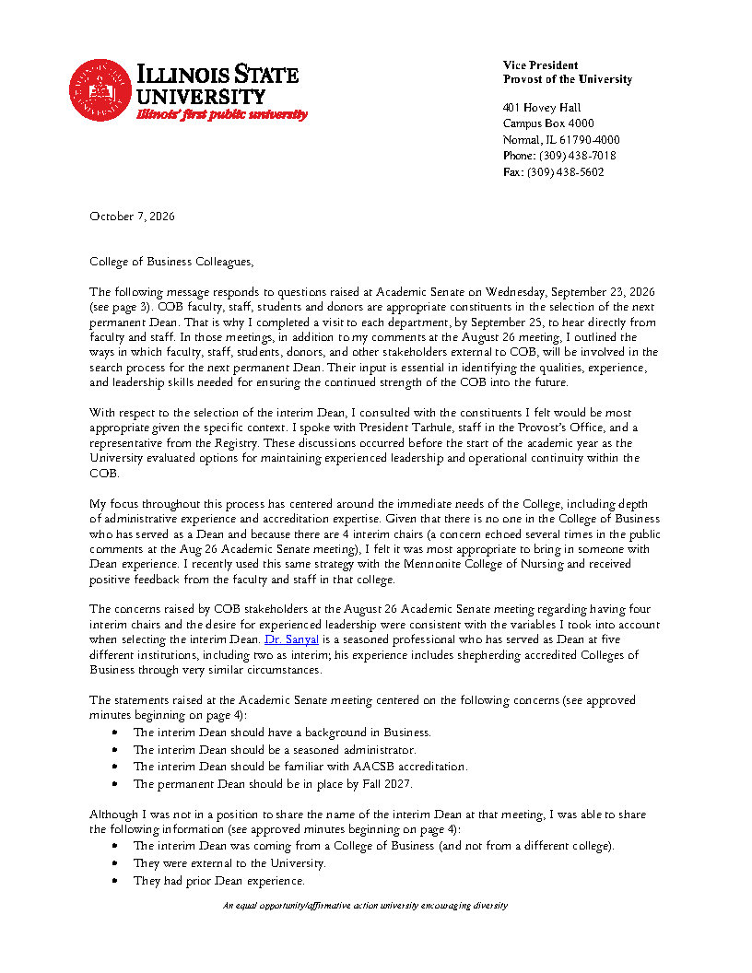
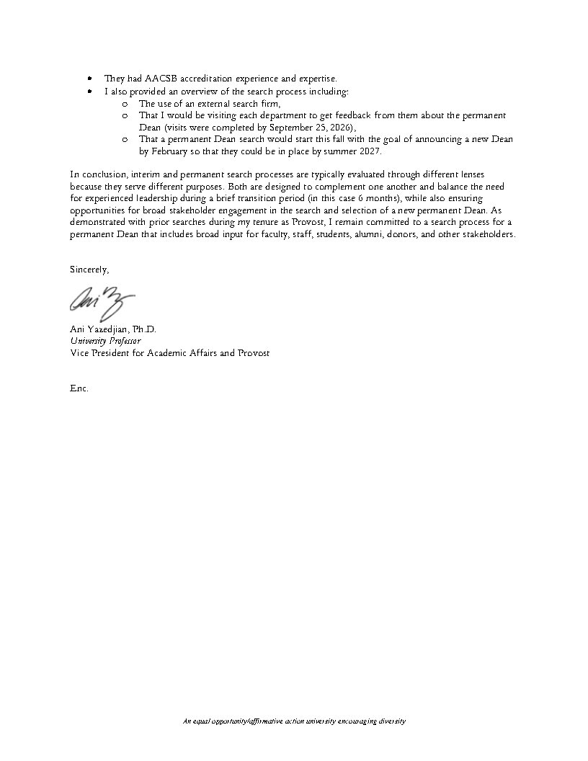
Appendix 2
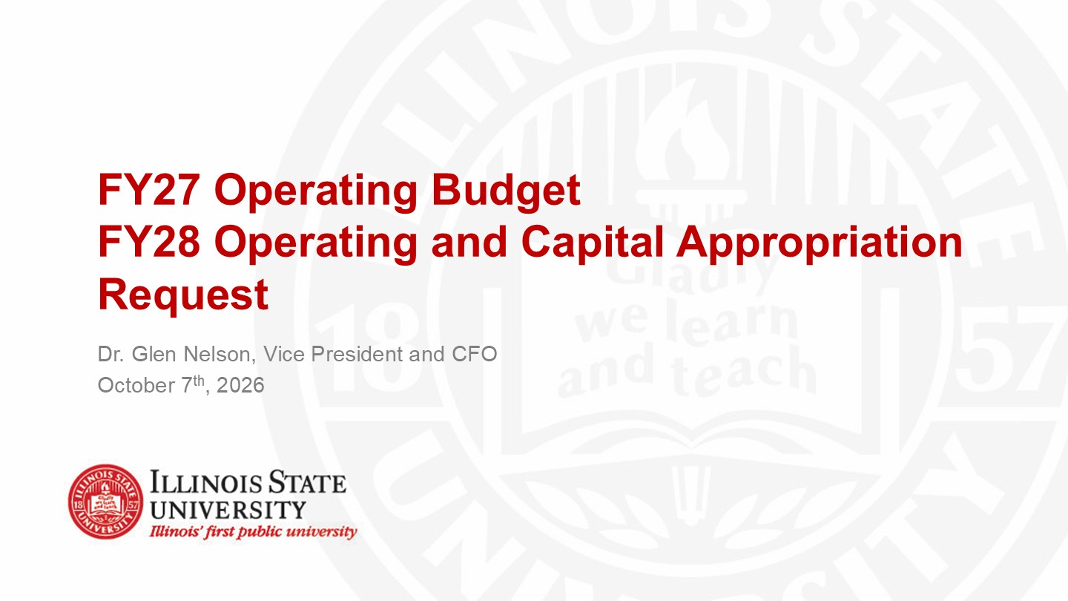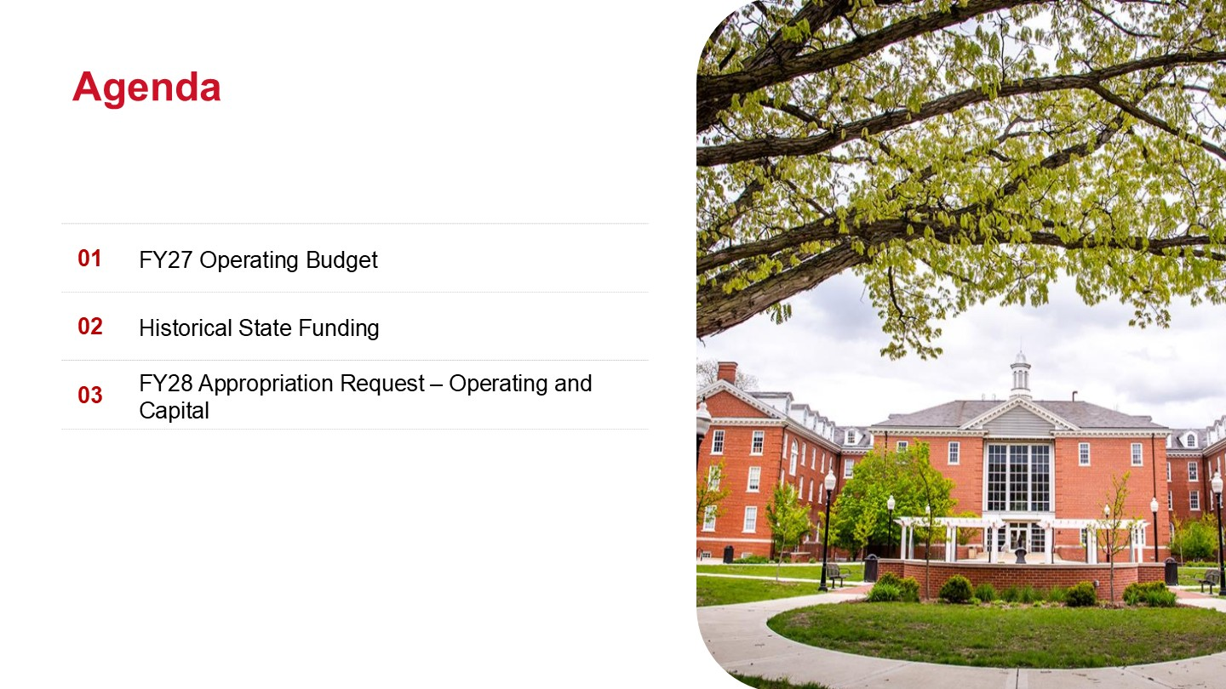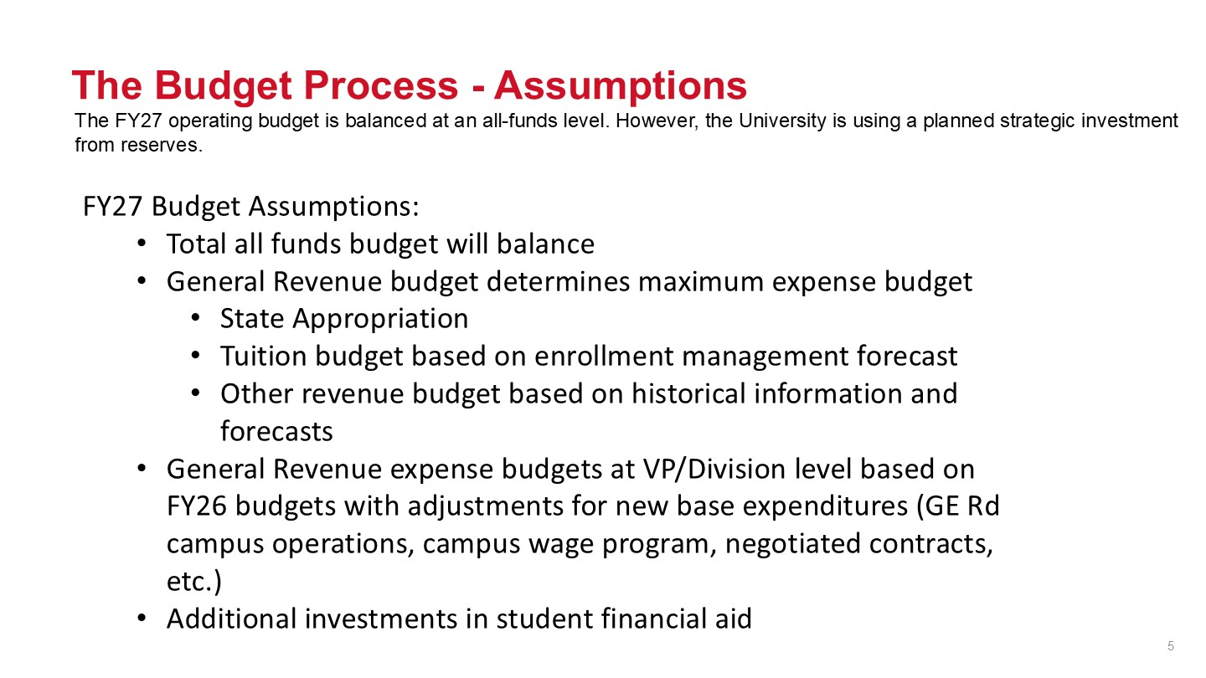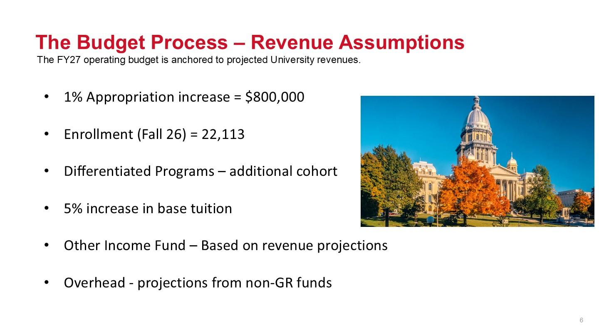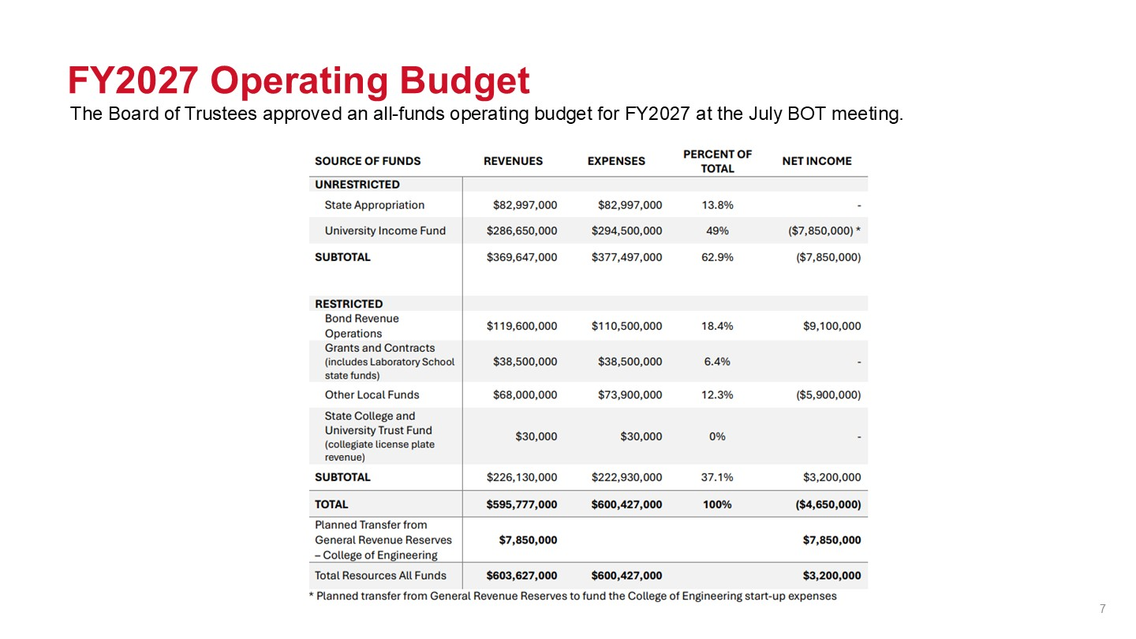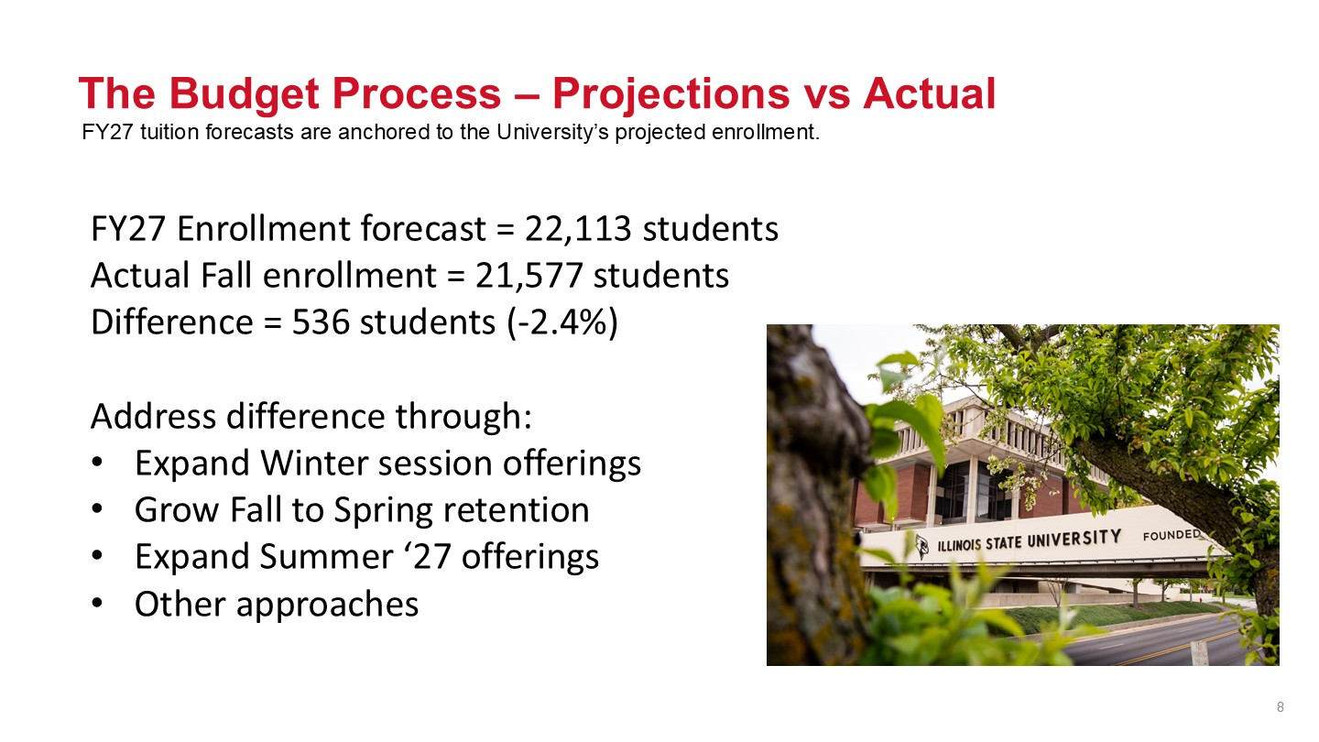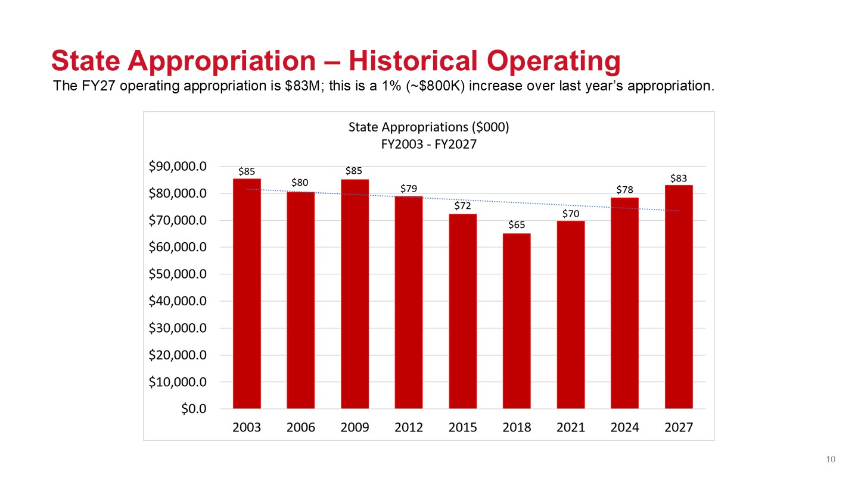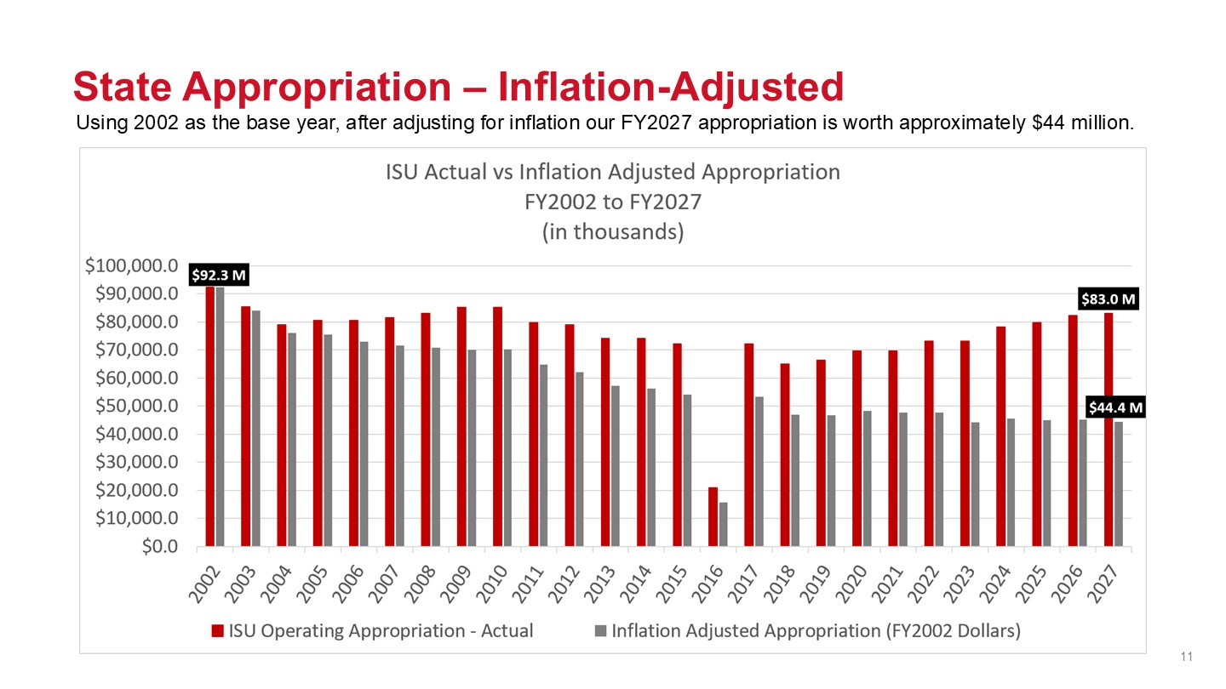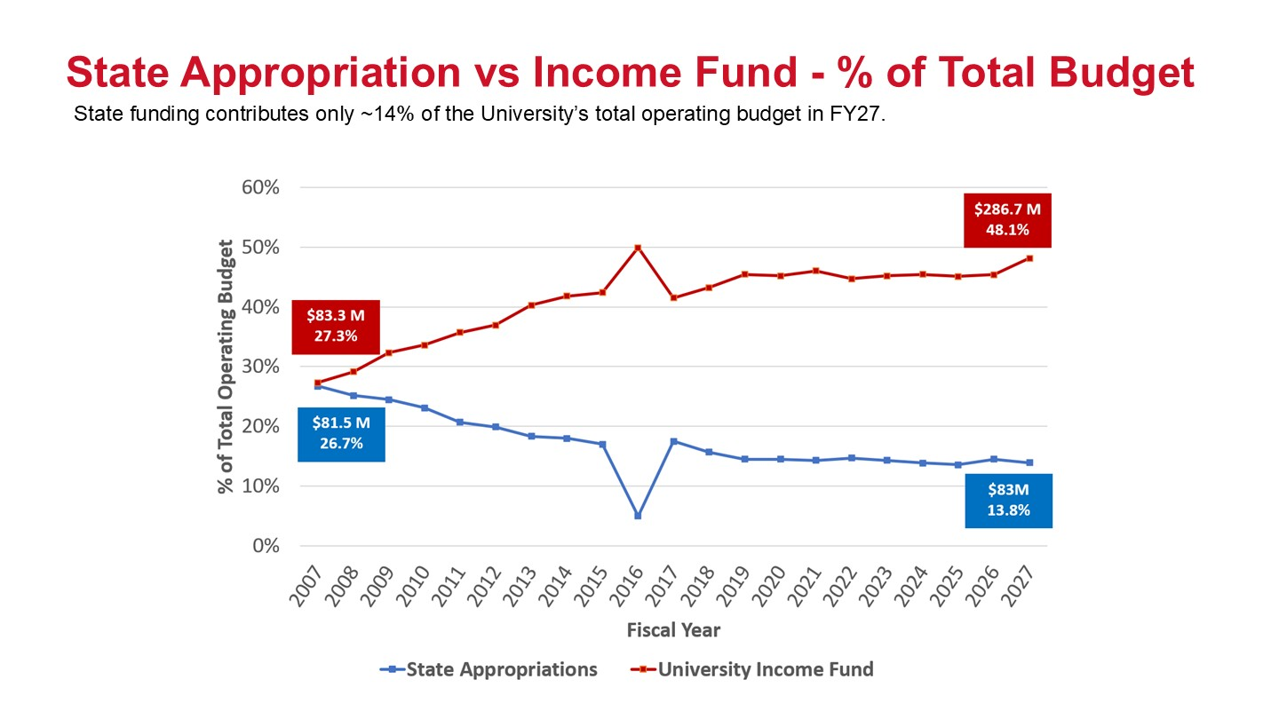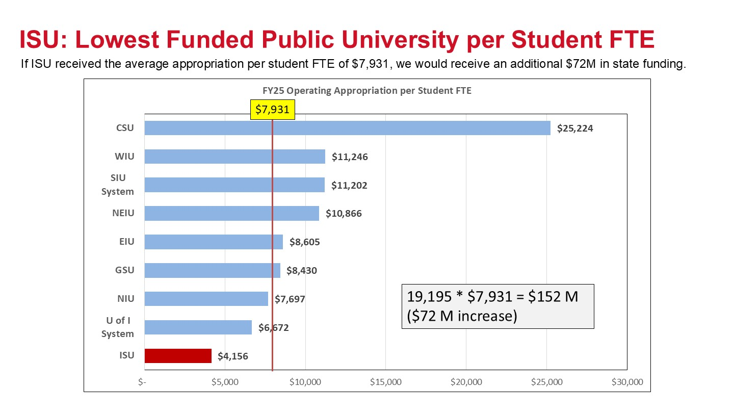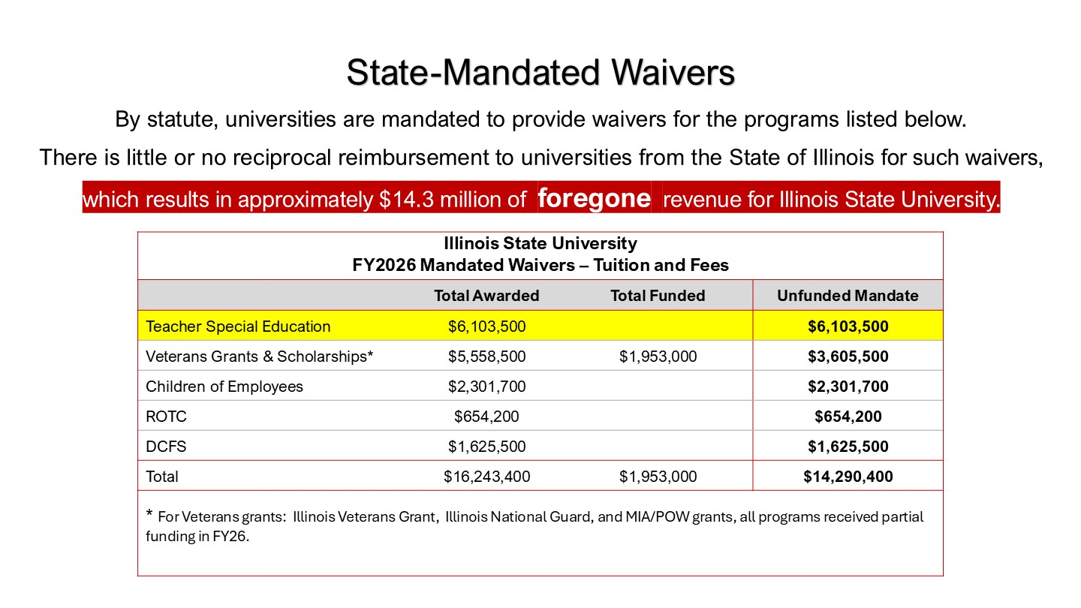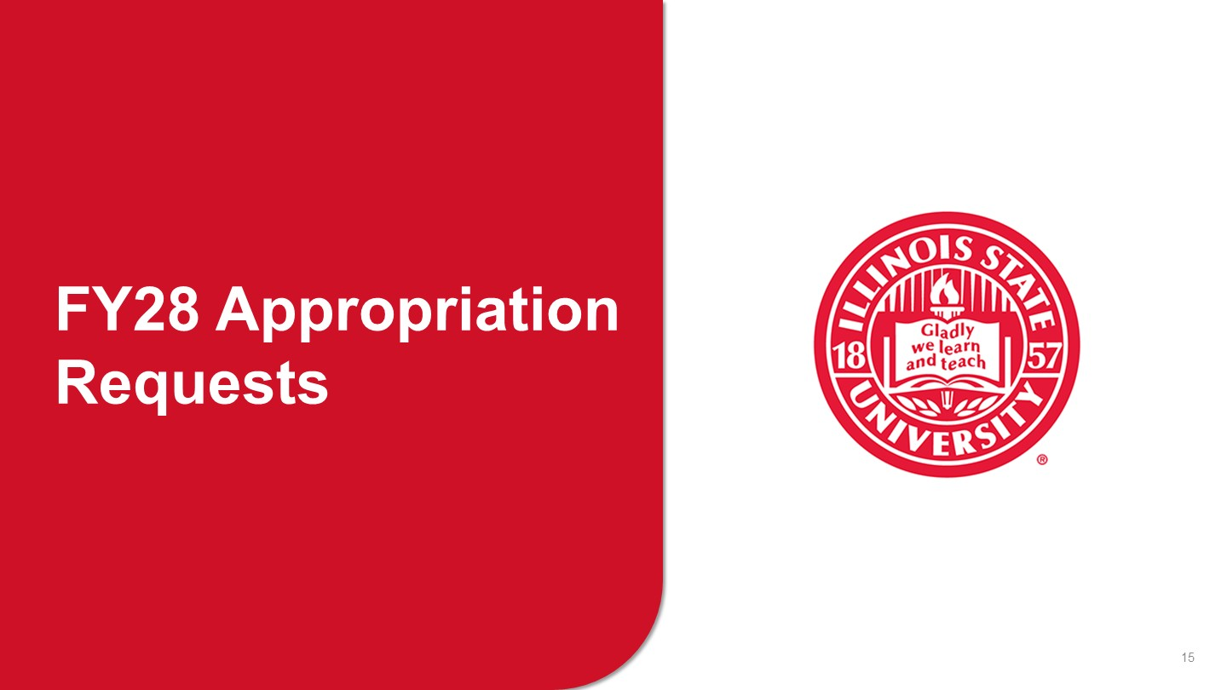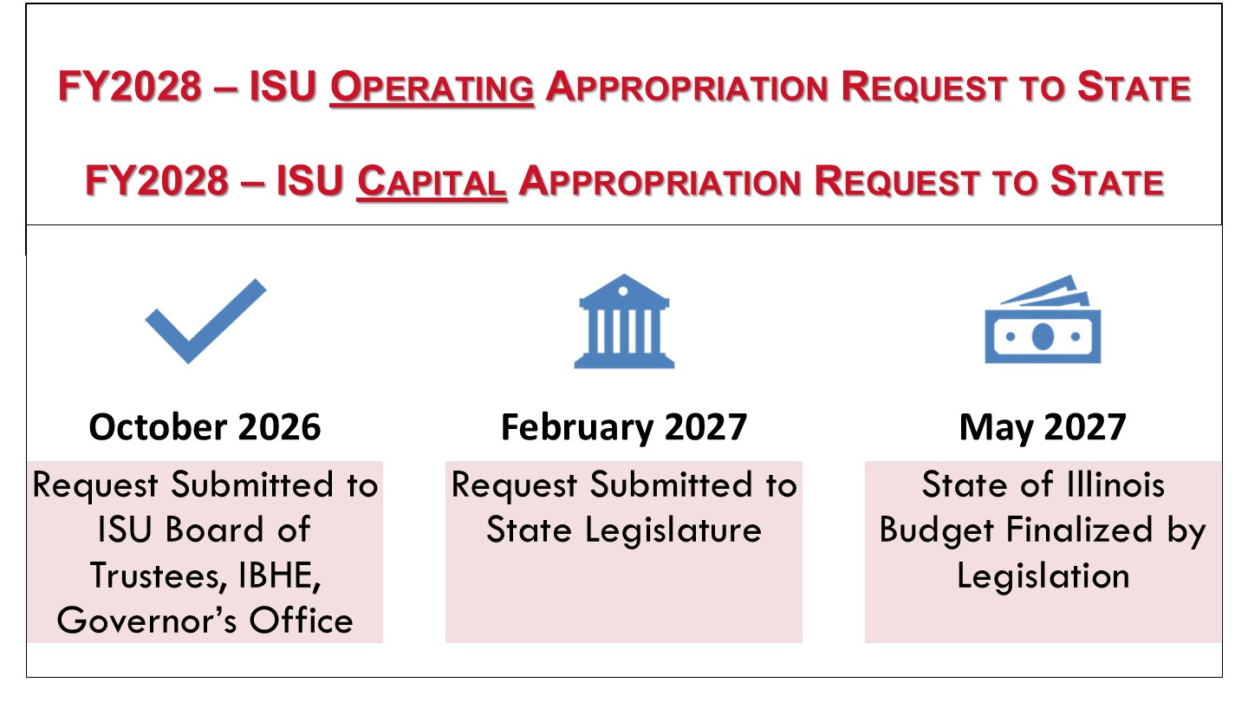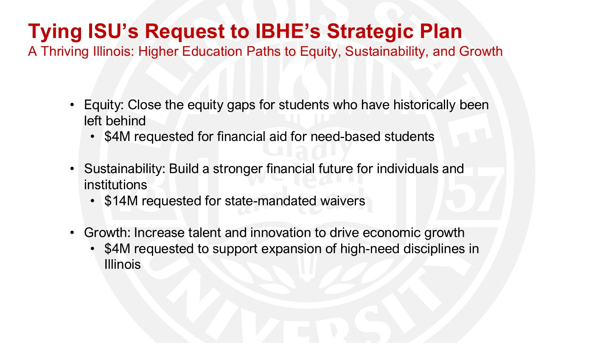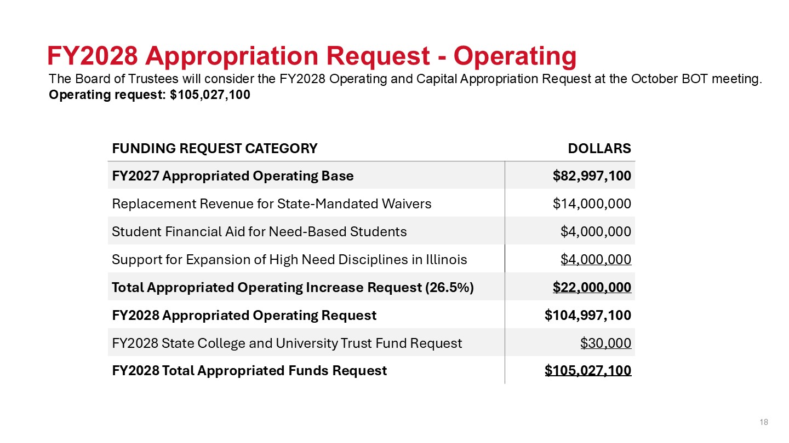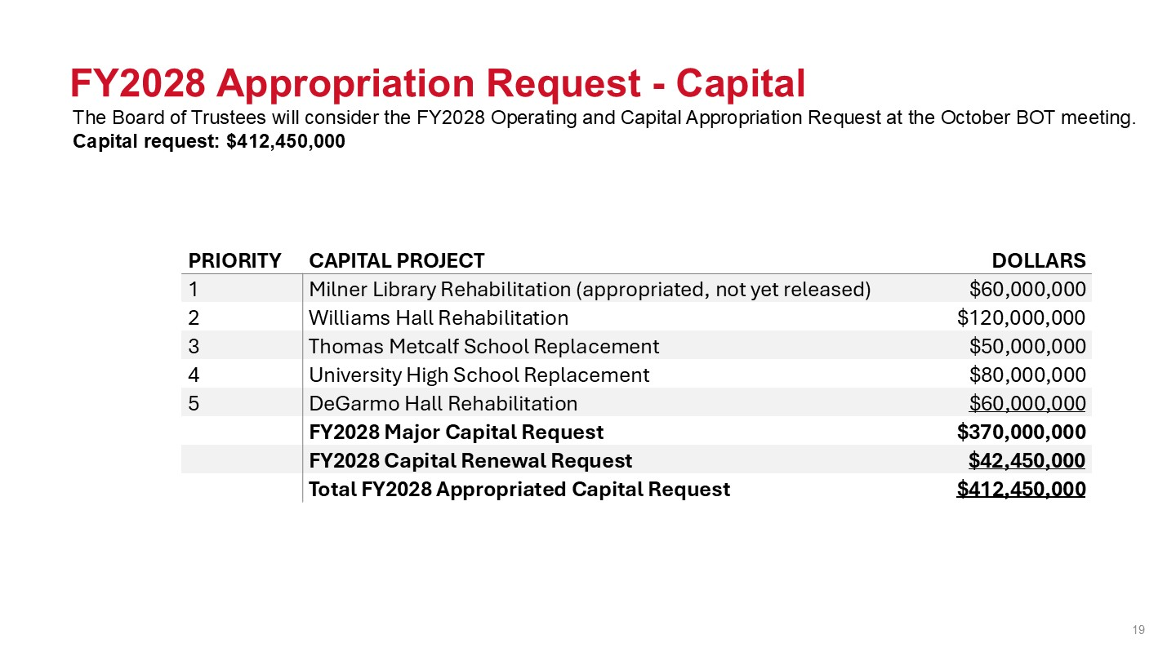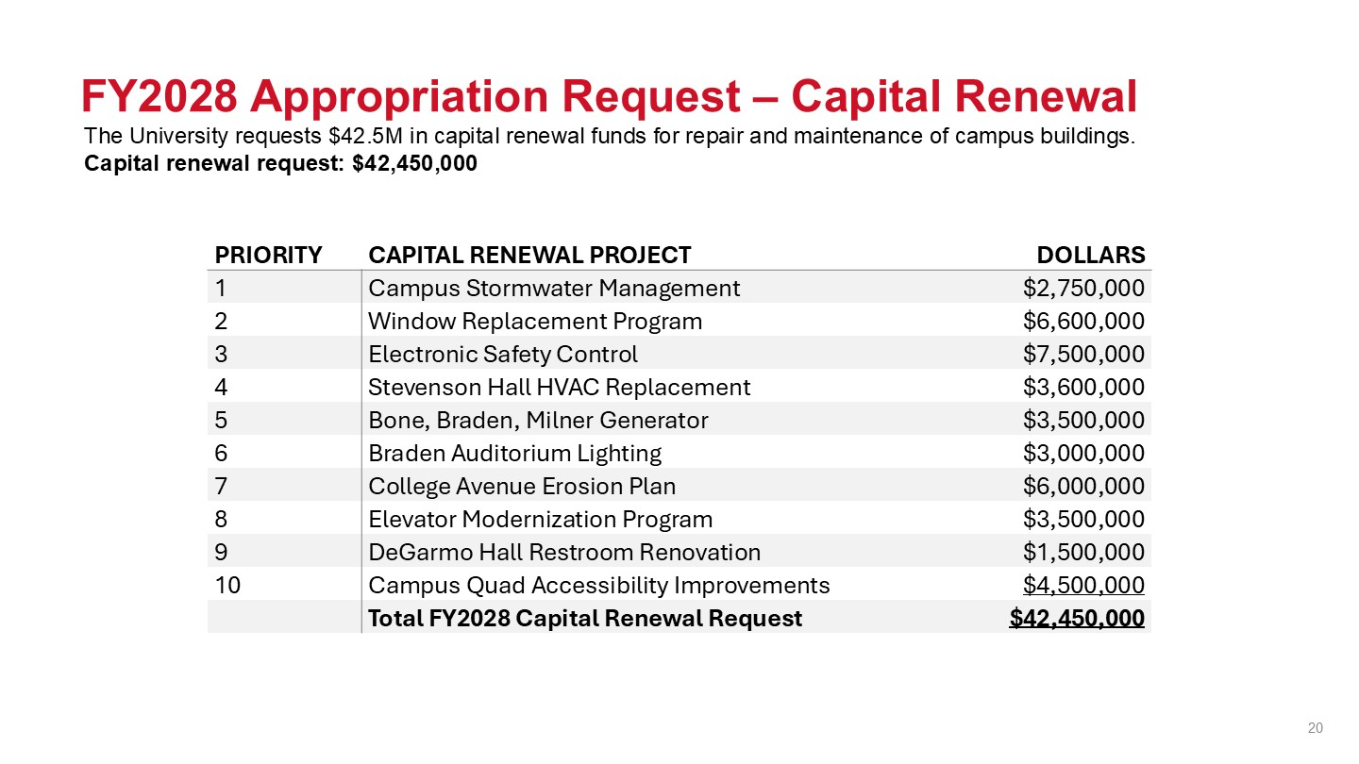

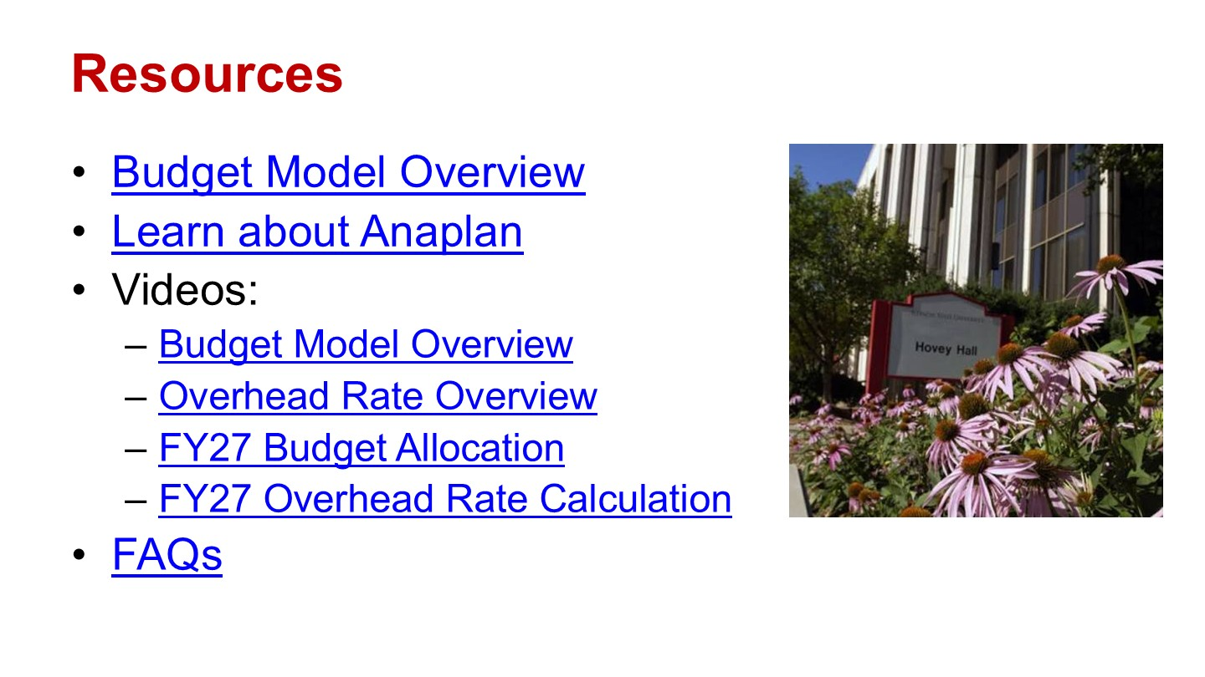

Attendance:
Bediaku, Mavis | 1
Blanco Lobo, German | 1
Blum, Craig | 1
Bonnell, Angela | 1
Campbell, Jamel | 0
Clark, Zakkary | 1
Craig, Byron* | 1
Dumancic, Marko* | 1
Godwyll, Francis | 0
Henry, Sheryl | 0
Hernandez, Maya | 1
Ionescu, Lucian | 1
Jackson, Terry | 1
Johnson, Levester* | 1
Jordan, Scott | 0
Kidwaro, Fanson | 1
Kropp, Tyler* | 1
Lakin, Jacob | 1
Lam, Isabella | 1
Lovos, Josue | 1
Lucey, Tom | 1
Marshack, Rose | 1
Martin, Steel | 1
Mathan, Sahana | 1
McCombs, Angela | 0
Meyer, Kevin | 1
Midha, Vishal | 1
Mohammed, Jaby | 1
Montoya, Noah | 1
Nelson, Glen* | 1
Nikolaou, Dimitrios | 1
Ozalp, Nesrin (remote) | R
Palmer, Stuart | 1
Paolucci, Aaron | 0
Patino-Diaz, Jose | 0
Pedziwater, Marek | 1
Peters, Steve | 1
Peterson, Eric | 1
Petrescu, Claudia* | 1
Pettit, Ella | 1
Riverstone, Lori | 1
Russell, Luke | 1
Saner, Matt | 0
Schmeiser, Ben | 1
Schwer, Allison | 1
Seifert, Deborah | 1
Shourek, Nevin | 1
Smelser, Sarah | 0
Smock, Vincent | 1
Stanlaw, James | 1
Stewart, Todd | 1
Tarhule, Aondover* | 1
Thomas, Amar | 0
Valentin, Rick | 1
Wolf, Kayla | 1
Yazedjian, Ani* | 1
Yount, Amy | 1
Zagal, Alondra | 0
Zhang, Qi | 1
Selkow, Noelle (ALC Representative)* | 1
Samant, Ajay (Dean Representative)* | 1

