Academic Senate Meeting Minutes
Wednesday, March 29, 2023
Approved

Call to Order
Academic Senate Chairperson Martha Callison Horst called the meeting to order.

Roll Call
Academic Senate Secretary Dimitrios Nikolaou called the role and declared a quorum.

Public Comment: All speakers must sign in with the Senate Secretary prior to the start of the meeting.
None.

Presentation:
- Diversity Inclusion Advisory Council annual report to the Senate (Chief Equity and Inclusion Officer Doris Houston)
*Presentation in Appendix I

Senator Pancrazio: Thank you for the presentation. What can you tell us about the advocacy and resources available to support DACA students, for example? Is there any progress in the hiring of a resource and advocate person to provide services for undocumented and DACA students? A person that could provide services both in Spanish and English.

Dr. Houston: Absolutely. Thank you for asking that question. Our council members were very active in working with the Office of Student Affairs to envision that position. And so, I might even ask Dr. Johnson to speak as well. As you know, there is a law now that requires each state university and junior college to have a liaison for undocumented students. Dr. Maura Toro-Morn, who has been very active in advocating for such a liaison within her organization as well as with DIAC, worked very closely in the early stages of envisioning that position. Dr. Johnson, would you want to provide an update on the status of that?

Senator Johnson: Sure. Dr. Houston is correct, that we as an institution do have to have someone who is identified as a person who is the contact. Right now, we do have someone within the Dean of Students office who serves in that role in a temporary type of basis. But we did develop a job description for that position last year, launched the search, but the search, unfortunately, was not successful. We wanted to wait until the new Dean of Students and Assistant Vice President came on board in order to restart that search again for this year. It’s my understanding that that job description has been finalized again, and we’re about to launch the search for that permanent position again. So, you should see information, hopefully, before the end of the semester about us advertising for that important role. Again, it will be housed within the Dean of Students office. We didn’t just go with a person who would be at the level of a counselor in that sense, but actually one of the assistant deans for that area. So, we actually bumped the position up a level, as well as providing some additional support services for that person. We didn’t want that person to just be a standalone individual. So, we’re very excited about actually hiring someone to serve in that role and looking forward to this search process to get launched again.

Senator Pancrazio: Just a quick follow-up. Would that include a person who has that multilingual skills as well?

Senator Johnson: It depends on the person’s background. That’s not a specific requirement. It’s desired, but not a specific requirement.

Senator Pancrazio: I would urge the committee to consider that because DACA students are primarily Spanish speakers, and their families are involved in the decision to send them to college. Thank you.

Senator Nichols: It was mentioned that we looked elsewhere to see what other universities were doing. I think everything here is a great start. But, I’m curious, down the road, do we ever envision rolling into our definitions neurodiversity? So, for example, introversion/extroversion we have policies and practices at the university that affect extroverts and introverts in significantly different ways. Do we envision that being rolled into our definition of diversity? Or do we see that that would be something that would go through Student Accommodations? That we would need to accommodate that difference and the orientation towards social interactions being charging or exhausting.

Dr. Houston: Thank you for that question. And actually, as I mentioned earlier, we do have a representative Tammie Keney from Student Access and Accommodation is a part of our membership. So, as you can imagine terminology related to the expansive work of diversity and inclusion, the terminology changes, it evolves. Currently, we have not established a definition for neurodiversity, but this is how we continue to demonstrate responsiveness to our campus. So, it is certainly something that would be important for us to look at. Again, we started with the three definitions that, really, we see on our campus, and we do have a definition for access. Given that this is a volunteer committee, we do have to balance out the workload, because the definitions aren’t just thrown together. They are researched, they’re reviewed. Just for those three definitions, I think it took us a semester with going back and forth because it’s important. Words matter. Definitions matter. Thank you for that feedback and I will certainly take it back to our council.

Senator Horst: I was wondering if you could talk about how one becomes a member of DIAC? Is it a presidential appointment?

Dr. Houston: It is a presidential appointment for the membership. I will say the membership has grown. Initially, the membership was primarily chairs or presidents of our diversity related affinity groups, as well as some designated departments or divisions like I mentioned, Student Access and Accommodation, OEOA, the Center for Integrated professional development sits on the Council. We then later expanded to include several of the interdisciplinary program. So, those chairs were later added, as well as representatives from Athletics. We did, unfortunately, lose a few people who went on for other opportunities. So, we will be presenting a request to Interim President Tarhule to appoint some additional members.

- Wonsook Kim College of Fine Arts CDB Capital Project Update (Vice President for Finance and Planning Dan Stephens, Associate Vice President for Facilities Management, Planning, and Operations Mike Gebeke, and Director of Finance and Planning David Gill)
*Presentation in Appendix II.
Senator Holmes: You mentioned that there are dead spaces. How many exactly are there?

Ms. Semonis: What you are see right now is the commons building. I think this is actually one of the directing and creative drama labs. In the commons building, there’s approximately five theater spaces or classroom spaces that are related to Theatre and two Dance studios. Much of what is going to be demolished that was in Centennial West is going to be at least some of it replaced in the new commons building.

Senator Holmes: This isn’t really a question, but I just wanted to say that I work here in the Bone and there are always dance practices going on here because there is no other dance practice/dance studio space on campus, which when I came here it was kind of crazy to learn.

Senator Hollywood: Is there going to be any renovation to the classroom space? CVA145-147 those awful rooms.

Mr. Gebeke: Unfortunately, very limited. Some of the rooms will get renovated. We had grand visions when we started, but budgets have taken its toll. Originally, we were doing quite a bit of renovations to CVA.

Senator Horst: Is the budget at all going to get increased because of inflation, or is it fixed at $62 million now?

Mr. Gill: That’s a very good question. What happened was when it got resurrected and announced by Governor Pritzker, the CDB had escalated it up from $53 to $61.9 million. When they got architects on board, they told us that the budget was insufficient. So, there was quite a major effort with our team. Originally, the project was envisioned as five phases over multiple years. That was part of what Dan mentioned, the investment for the University for $15 million. We said we will clean out all these spaces out so you can build the whole thing in one shot without taking five years. I think at that point it was about $17 million over budget, and that exercise was to pull it back in line with the budget.

Senator Stephens: As I said earlier, once the bid process will ultimately create the final cost. We continue to work on a regular basis with the Governor’s office. They’ve been very generous when there were situations, in small amounts, to try to find funds. But we are very excited to finally get to the end and see exactly what the bid process is. Hopefully, it will fit completely inside that. If it doesn’t, we’ll certainly be talking to them. But if there’s an amount above it, it should be something fairly small. Then we’ll be talking about making those investments to make sure it is done right from the beginning. This is a transformational project, as you can imagine.

Senator Cline: I just ask our Assistant Dean Sara Semonis to clarify the rotunda questions, because the rotunda is getting a renovation,; it’s just not with this project.

Mr. Gill: That is correct. That is actually a separate project funded by the University, which we’ll start in spring. It’s going to start in May and be done by Christmas.

Senator Hollywood: I teach in that classroom right now and I’m currently in a boot. Going down those stairs is quite treacherous.

Mr. Gill: When we are finished, the rotunda building will be completely accessible. So, for fall semester this coming year, classes will be held in the Bone Student Center and Normal Theater. When that project is finished, all those classrooms will be fully accessible. That’s not part of this project though.

Senator Horst: This item was announced at the Senate in 2010 and I think I’m probably the only person here who was at that meeting. I will be thrilled when it is finished.

Mr. Gill: We’re trying very hard.

Approval of the Academic Senate minutes of February 22, 2023.
Motion by Senator Myers, seconded by Senator Rardin, to approve the agenda. The motion was unanimously approved.

Chairperson's Remarks
Senator Horst: We have a very large agenda so I’m going to brief. I just want to remind everyone of the schedule going forward. April 12 will be the last internal committee meeting for everyone. Anything that is going to be passed as information and then action item by this year’s senate must be on the agenda for Senate meeting on April 12. If the Executive Committee has not previously approved an item for the Senate agenda, the item needs to be submitted to the Senate office by noon tomorrow. On April 26th, the new and returning members of the Faculty Caucus meet at 6:30 p.m. in the Founders Suite to nominate faculty for the officer and Executive Committee positions. There are no internal committee meetings. The full Senate meeting will not begin until 7:15. This is the final meeting of the Academic Senate for student and faculty representatives with terms ending this spring. On May 10th, there’s no internal committee meetings -- just a full Senate meeting at 7:00 p.m. Tonight, I will try my best to keep this meeting running efficiently, but it might be a long one. We have a hard stop at 9:30 p.m. Committee chairs, if we don’t get to your items this evening, we will roll them over to the next agenda. In the meantime, if the Executive Committee has approved an item to go to the full senate, you may continue to address any edits and revise the wording in the document. You just need to get that version to the Academic Senate office by April 6th at noon so that it can be distributed to the full senate for the April 12th meeting.

Student Body President's Remarks
Senator Walsh: First, I would like to offer my sincerest condolences to the victims and affected families of the national shooting that occurred this last Monday. I encourage anyone affected to reach out to someone and for any affected students to speak to Student Counseling Services. I understand that these atrocities bring many students and members of our campus community great fear. I encourage everyone to share the Safe Redbirds app, where there is detailed information on what protocol we should follow should, God forbid, a terrible event occurs.

Next, Student Government was able to host our new resource awareness fair under the leadership of our secretary of College Affordability Kerem Tasdan, where we were able to have many differing areas around campus fall in one area in the Bone Student Center to provide information and resources for their specific areas. We had many students attend and learn more about the resources available to them. We would like to reiterate our thanks to all the campus areas that participated.

I would like to inform the Senate that, starting tomorrow, the Student Government Association campaigning season begins for our new 2023-2024 association. This campaigning period takes approximately two weeks, with voting taking place April 13th and 14th on Redbird Life. Please encourage students to vote. We always want as much student engagement as possible. This is an extremely contested race with almost every seat being contested, including the Student Body President position. So, please send everyone running some great thoughts and well wishes.

Administrators' Remarks:
- Interim President Aondover Tarhule
Interim President Tarhule: Good evening to everyone. Today is exactly 40 days since I was appointed interim president. I imagine some of you are wondering what the heck has he been doing? I’d like to share with you some very quick thoughts about how I’d like to proceed. I know it’s an interim position, but I can assure you I’m not just sitting there saying it’s interim. I’m not a seat warmer. I’d like to tell you what I plan to do. I’ve divided the way I plan to function into three areas, first is the listen period.

So far, I’ve been listening. Of course, as Provost, I feel like I was very familiar with Academic Affairs, but I was less engaged with the other divisions. I have a whole series of meetings lined up with various constituencies in the other divisions trying to learn those areas better. Trying to get to know those people better. That’s what I’ve been doing, and that’s what I plan to do between now and the end of the semester. So, lots and lots of meetings both internal and external meetings with our external stakeholders. It’s a listening period. Then, over summer, I plan to have a strategic visioning period where I meet with the cabinet, take all those ideas and things that I have learned from the different divisions, and develop a plan about the things that we’d like to prioritize on the remaining time that I’m in this position. So, I expect to have a very clear agenda of priorities and areas of investment that I’ll be working on. Then, by the time you come back in fall, you should start to get information from my office about the very specific types of strategies that we’ll be putting forward and the things that we’ll be doing. So, that’s sort of the plan. Listen, plan, and act is the way we want to proceed.

I’d like to say congratulations to the Culturally Responsive Campus Community for the conference they had today. The title of the conference today was Advocating, Solidarity, and Empowerment: The Struggle is Real. This is the conference where they bring together various people for dialogue, reflection, and thinking about how we can improve diversity and inclusion on campus, and much needed activities. So, I’d like to congratulate the organizers of that conference and to thank all those who participated.

On March 22 this month, Illinois State University signed a collaborative partnership with OSF (Order of Saint Francis Hospital). So, it’s got a connected community initiative. It’s a broad ranging partnership for research. I know when you hear about OSF, your inclination automatically is to think it’s only about healthcare. This is a lot more than healthcare. We expect that it will bring together faculty from ISU and researchers from OSF in a variety of areas, clinical, research, healthcare, engineering, data science, cybersecurity, to name just a few. So, if you are interested in this partnership the key person to contact is Craig McLauchlan. In fact, I’d like to say a big thank you to Craig for making this partnership come true, and for all the people who have worked for many many months planning this. I think we went to OSF three times, and they came down here several times as we planned this. So, I’m very appreciative of that. OSF will put in $500,000 and we will put in $500,000 for a total of $1 million in funding to support joint research between ISU and OSF. More to come on this, and please contact Craig for more information.

Last week, I was in New York City to attend the American Talent Initiative Conference of Presidents and Chancellors. The American Talent Initiative is a program that is funded by Michael Bloomberg who was actually there in person to host 187 Presidents and Chancellors from across the nation. The key thing about this is that participation is by invitation only. So, what they’re trying to do is increase by 2025 the number of people who have graduated in the STEM fields --- especially from high achieving, low-, and moderate-income students. They want to raise that number to 50,000 nationally. So, to accomplish that number, they looked at universities that have very high graduation rates and invited them exclusively to participate in this engagement. So, congratulations to ISU and all of you for all the work that you’ve done. It is being noticed nationally because we did not apply. They invited us because of your record. So, I’m very proud of that. I was very proud to represent you in that initiative.

We also held on March 25th the Gratitude Gala. This is the event to celebrate philanthropy at ISU. By the time that Redbird Rising Campaign ended we never really got a chance to fully celebrate it, and then, of course, the pandemic hit. So, we took this opportunity on March 25th to celebrate that, but also to make it into a bigger event. And we honored three major donors, Jim and Carol Mounier were honored with the Redbird Philanthropist Award. Kay Wilson received the Innovation in Philanthropy Award. Drs Carson and Iris Varner were awarded the Above and Beyond Philanthropist Award. To think about what this represents. All of the people that were participants, and maybe not everyone was there, but the people that were honored at this event, collectively in their lifetime, have contributed close to $98 million to Illinois State University. As you can tell, it’s important that we recognize that.

Finally, we have several searches ongoing in the Office of the President. We’ll be launching two searches in the coming days. One for the Chief Equity, Diversity, and Inclusion Officer, and the second for the Director of Public Policy and Affairs. So, those positions you’ll see them being announced in the next few days. We also have a vacancy in the Office of the Director of OEOA. Debra, who was in that position, has left. We’ve put together an infrastructure we think is going to help us get through until we hire a replacement. But this is an office that was already down, I believe, two or three positions. Now, we have an additional opening. I’m asking you to be a little bit patient. I know that these are very sensitive issues, sometimes very emotional. But we are down significantly in terms of people powering that office. So, if you are seeking help there and you don’t get it as soon as you want, as immediately as you would like, I ask for your patience. We are going to move as expeditiously as possible to fill that position. But I’m just letting you know that that office is going to be shorthanded in the next several months. That concludes my remarks.

- Acting Provost Ani Yazedjian
Acting Provost Ani Yazedjian: It’s my pleasure to let everyone know that Dr. Chad McEvoy has been named the Dean of the College of Applied Science and Technology effective July 1. Dr. McEvoy is currently Vice President for Faculty Affairs and Chief of Staff to the Executive Vice President and Provost at Northern Illinois University. He brings years of experience as a faculty member, a program director, an administer to his new role. He also brings a strong commitment to equity, diversity, and inclusion in student success, faculty development, and all areas of university operations. This experience is really going to serve CAST and the university well in the coming years.

In addition, we had campus interviews last week for the Associate Vice President for Academic Administration as well as on campus interviews for the AVP for Faculty and Staff Development, Diversity, and Learning. We also have two additional searches for chairs of the departments of Mechanical and Electrical Engineering that are a little bit behind that schedule.

I wanted to bring your attention that Grad Bird Appreciation Week is next week, April 2-7. This is the national week to acknowledge graduate students’ contributions to campus and the community. And there will be several events across campus to celebrate.

An update to an announcement I had given a couple of times about the Canvas drop in event. We had about 60 faculty members that attended that Canvas kickoff. The thing I would bring to the attention to the faculty here tonight, if you could let your colleagues know, is that there is still time to request your content from your Reggie Net courses to be migrated to Canvas. If you haven’t already done that, please do so by April 7th. We’ve had about 600 courses migrated already and 400 additional requests. I know that in the middle of the semester this is probably not the thing you want to be thinking about, but we do encourage you to submit your request soon, because Reggie Net is going to be switched to read only access on August 18th, after summer grade submission. And then instructors will still be able to back up their data until the end of November. So, please submit your request sooner than later.

- Discontinue obtaining a CAEP accreditation (Dean Francis Godwyll)
Finally, on Tuesday March 7th, 2023, the Council for Teacher Education voted not to pursue CAEP accreditation after the current accreditation expires in 2026. This motion passed with 18 yes votes, 6 abstentions, 0 no votes, and three members were absent from that meeting. There have been long standing issues regarding buy in, workload, appropriateness or fit for the nature of ISU programs and relevance going all the way back to 2013. In response, the Executive Committee of CTE decided to allow members to revisit this issue, since questions had been recurring at their meeting. So, in February, CTE subcommittee members working on CAEP reaccreditation expressed a desire to revisit the value of CAEP reaccreditation, citing several of these concerns and saying that CTE members had not had a chance to vote on maintaining this accreditation going back to 2013. So, over the next month, they sought feedback from constituents, and then in the meeting on March 7th all programs took turns in reporting their feedback. The majority of programs reported a lack of interest in continuing with CAEP accreditation beyond 2026. Dean Godwyll has detailed these perspectives, shared by the program representatives in a memo that I’ll submit to Chairperson Horst. He is also here tonight to answer any questions you may have. But the crux of the argument is that we already have the Higher Learning Commission accreditation for the University, this is critical to the survival of the programs, whereas CAEP is not. Thus, the CTE would prefer to spend the time they would otherwise be devoting to reaccreditation on energy and resources to develop new processes to continue to ensure the quality of our Teacher Education programs. Thank you.

Senator Garrahy: I don’t have a question per se, but I do have a comment as someone who oversaw this accreditation process in 2019. Just for clarification, ISU does not need this accreditation for Teacher Education as we need HLC for ISU. ISU seeking or not seeking this accreditation has no impact on our 4,000 teacher candidates at ISU. Teacher Education at ISU has to answer to the Illinois State Board of Education because it is the Illinois State Board of Education that grants our teacher candidates their teaching license. And every year, the Director of the Lauby Center must submit an annual report that is made public on the IBHE’s website. So, I applaud the Council for Teacher Education in making this decision because there have been problems with this organization for many years.

- Vice President for Student Affairs Levester Johnson
Senator Johnson: Good evening, everyone. First, Illinois State University Redbird Esports has made history as the only collegiate Overwatch team to secure a spot in the International Overwatch Pro-Am Tournament, where the top eight amateur teams in North American compete against eight professional Overwatch league teams. The significance of Redbird Esports achievement cannot be overstated. They’ve broken barriers and showcased the potential for collegiate level talent to compete on the same stage as professional players. Furthermore, a total of 17 former and current Redbirds are competing across six different teams in this tournament, highlighting the profound impact Illinois State University has had on the professional Overwatch Esports scene.

The second item that I would like to share with you, similar to the presentation that was done earlier, we have made significant progress with our new Housing and Dining project. And it would be our hope that before this semester is over that we can present to you all some of the design that we have some up with, working with our partners, the architectural firm Mackey Mitchell to date as well as with campus constituents. And I will be forwarding a message to our chair requesting time to get with you all and share that, maybe at the start of one of our meetings, before the end of the semester. That’s all I have to share.

Senator Holmes: This is a very random question. Are there plans to put a Subway in the new Housing Complex?

Senator Horst: We’ll find out about that.

Senator Johnson: At this point, there are no plans for that particular retail venue to go there. I think we heard our students and campus constituents loud and clear that we would love to have something different as an option within that area. So, look for more to come in that area as well. We’ll be prepared for that question too.

- Vice President for Finance and Planning Dan Stephens
Senator Stephens: Thank you, Senator Horst, for allowing my team to talk about the Wonsook Kim project timeline. I have a couple of items. One of them I’ll read in a few minutes, a few noted that the Associate Vice President of Human Resources Janice Bonneville provided me about our open enrollment under the Sick Leave Bank. But before I do that, I wanted to talk about, if you remember a couple weeks ago, I said in the springtime we run into the situation of being a shoulder month. So, I believe either tomorrow or Friday it’s going to be in the mid-60s or so. We still have heat in our buildings. Because the temperature has to consistently hit 65 and higher for us to actually move things over from heat to the chiller system for cooling. We’ve got temperatures that likely will be and continue to be in the 30s and 40s. So, this particular Friday, I’m going to speak for our President Tarhule, so you can be wearing short sleeve shirts and shorts anything to make sure you make yourself a little more comfortable until we’re able to announce in a few weeks when those switch overs occur. So, we appreciate your patience for this and we’re hoping to soon make that final decision.

I’ll read the points here that Janice asked me to make sure that I get this important announcement done. Our FY24 Sick Leave Bank open enrollment is going to occur on April 6th-17th. Human Resources announced this enrollment in order to remind people to participate, for those who want to participate in that Sick Leave Bank. Employees must have a balance of at least five days of earned sick leave after the one-day donation is made. Donations are not taken until the start of the new fiscal year. So, the balance on July 1, not the balance of the time of enrollment, determines eligibility. Employees whose sick leave balance is insufficient to meet this requirement will not be eligible to participate in the Sick Leave Bank. There is a Sick Leave Policy that we have, and if any individuals have questions, they’re welcome to contact Human Resources about that.

Advisory:
From IBHE Faculty Advisory Council Rep Lane Crothers:
CSU FAC April 2023
SP2023_active_higher_ed_bills
equity tools and resources - ibhe faculty advisory council
Senator Horst: Our first Advisory Item, we have three items from our IBHE FAC rep Professor Crothers. I’m happy to forward any question you have of these items to him. I would say that there are quite a lot of potential bills going through the legislature right now. But of course, they don’t all make it. So, I talked to Interim President Tarhule about potentially bringing Brian Bernadino, our Government Relations Consultant, potentially in May once the dust clears, and we can hear more details on what actually passed. The Executive Committee will work towards maybe scheduling that a little later on.

Action Items:
From Rules Committee:
03.10.23.12 Summary College of Education Bylaws changes
08.23.17.01 College of Education Bylaws (Current Copy)
03.21.23.02 College of Education Bylaws (Mark Up)
03.21.23.03 College of Education Bylaws (Clean Copy)
Senator Horst: Our first Action Item is from the Rules Committee. Senator Blum is ill today, so I will turn it over to Senator Rardin, who has graciously offered to stand in his place.

Motion by Senator Rardin, on behalf of the Rules Committee, to approve the College of Education Bylaws. The motion was unanimously approved.

From Faculty Affairs Committee: (Action Item)
03.23.23.01 Policy 3.3.11 Endowed Chairs Professorships_Current Copy
03.23.23.02 Policy 3.3.11 Endowed Chairs Professorships_Mark Up
03.23.23.03 Policy 3.3.11 Endowed Chairs Professorships
Senator Hollywood: In the second paragraph on the first page, we considered a friendly amendment to out a period after the first university and then start the next sentence with “This agreement defines,” and I think that clarifies that wording and makes it a little less awkward. We also accept as a friendly amendment, under Appointments to have the sentence after the first paragraph start with a capital “An.” We did discuss the recommendation of changing the paragraph below that, “potential appointments of individuals with tenure and at ranks of professor or associate professor shall be reviewed and endorsed by the appropriate DFSC/SFSC” and that was considered to be inconsistent with the eligibility part where it says, “endowed positions are normally held by a full professor with tenure.” We chose to leave the wording the way it is because we felt that if we put qualifiers in there then we would have to add a lot more verbiage to qualify the qualifiers. So, if we said that if it wasn’t a full professor, it would be for exceptional candidates, then we would have to decide… who decides what exceptional means? So, we thought we would leave that alone. And then we neglected to put in the various (on the last page) under Expiration of Term, Termination, and Reappointment to put down the various different versions of emeritus. We need to add those in. That is a friendly amendment. Emerta, Emeritum, or Emerit.

Motion by Senator Hollywood, on behalf of the Faculty Affairs Committee, to approve policy 3.3.11 Endowed Chairs.

Senator Nikolaou: Under Eligibility, because the wording changed compared to the last time that we saw it, now it says in the third sentence, “and must have receive international peer recognition for this significant impact.” But then earlier the policy says that there is going to depend on what the endowment specifies. If the endowment doesn’t specify that they need to have international peer recognition, this is going to be contradicting with that part. Right now, we say the person must receive international peer recognition. I just don’t know why is it a must?

Senator Hollywood: A lot of the new language that’s new actually came right from General Counsel to be put in.

Senator Horst: Okay, but we can still edit it. So, “To be eligible for an endowed chair or professorship, a faculty member must have had a significant impact on the relevant scholarly or artistic field indicated in the funding source description for the endowment,” period and then strike…

Senator Nikolaou: The second part where it says, “and must have received international peer recognition for this significant impact.” Because if the award wants the individual to have received international recognition it would be specified in there.

Motion by Senator Nikolaou, seconded by Senator McHale, to amend. The motion was unanimously approved.

The motion was unanimously approved.
From Rules Committee:
02.23.23.23 Article III_Section 5 Vacancies and Absences _Academic Senate Bylaws_Current Copy
02.23.23.24 Article III_Section 5 Vacancies and Absences _Academic Senate Bylaws_Mark Up
02.23.23.25 Article III_Section 5 Vacancies and Absences _Academic Senate Bylaws_Clean Copy
This item was not discussed.

From Academic Affairs Committee:
02.28.23.01 Memo Policy 2.1.9 Baccalaureate Degree
02.23.23.01 Policy 2.1.9 Baccalaureate Degree Programs_Current Copy
03.03.23.01 Policy 2.1.9 Baccalaureate Degree Programs_Mark Up
03.03.23.02 Policy 2.1.9 Baccalaureate Degree Programs_Clean Copy
Motion by Senator Cline, on behalf of the Academic Affairs Committee, to approve policy 2.1.9 Baccalaureate Degree.

Senator Cline: There is one repeated typographical error. Throughout the policy where it says hours or semester hours, we are replacing that with credit hours. There are 20 of those changes. I assume you would not want me to read each of them by line. Maybe just trust me.

Senator Horst: Could you give us one example, for instance.

Senator Cline: Sure. First page, total hours, will now read total credit hours.

Senator Helms: Under Senior College Credit Hours it states, “colleges and universities is not counted as senior college credit if freshmen and sophomores are regularly permitted to enroll in such work.” But we, here at ISU, have senior level hours that sophomores can enroll in. So, it seems kind of contradictory to me. I understand toward the end where it talks about community colleges can’t do senior level hours. But I’m confused by the ruling out of classes that can be taken by sophomores when we do that.

Senator Horst: Do you have any amendments?

Senator Helms: My question is, why did we put it in and if so, can we strike it in such a way that it reflects what we at Illinois State University do. The last part, “No credit for two-year colleges may be counted as senior level.” I completely understand that. But if we, at ISU, have a 200-level class that sophomores take on a regular basis, that is counted as senior level credit if UIC does that I would assume we would also count that, but that’s not how this reads.

Senator Horst: Senator Hurd, do you have any response?

Senator Hurd: This is where I wish the Registrar were here. So, community college courses transferred in don’t count as senior hours. Would courses transfer from four-year institutions? We base it on what their transcripts say, because we get a little map as to how to read their transcripts; and if they read as senior hours, then we take those as senior hours.

Senator Helms: So, maybe that’s how we should fix this to say “utilizing the course level map provided by the transfer institution” to determine whether they are. Because this excludes things regularly taken by sophomores.

Senator Horst: Do you consider that a friendly amendment, Senator Cline?

Senator Cline: I’m going to need a minute. If you’re going to make a friendly amendment, I would need the exact wording, please.

Senator Helms: Coursework transferred from other colleges and universities from other four-year colleges and universities will be counted as senior college course level hours if their institution would count them as senior/upper-level classes.

Senator Cline: That sounds like a question. I’m going to defer to Senator Hurd. I’m having difficulty with the mark up. Is that new text, Senator Hurd?

Senator Hurd: My version shows it on page two, and we just moved it from another section. So, it’s been in there forever, but that’s no excuse.

Senator Cline: So, it’s currently in the language of the policy right now. This is not new language?

Senator Hurd: Right.

Senator Horst: Is this something that we need a motion to table or send back to committee to consider Senator Helms question?

Senator Cline: Senator Hurd?

Senator Hurd: Probably so we don’t have to spend time wordsmithing this, and I can get Stacy Ramsey’s input on how this should be worded. I hate to do that, but yes.

Senator Helms: I was the cause of that too, sorry.

Senator Horst: So, is that a motion to send it back to committee?

Motion by Senator Cline, seconded by Senator Helms, to send back policy 2.1.9 Baccalaureate Degree to committee. The motion was unanimously approved.

From Planning and Finance Committee:
02.23.23.04 Policy 5.1.21 Advertisement or Sponsorship of Activities, Events, or Programs_Current Copy
02.23.23.05 Policy 5.1.21 Advertisement or Sponsorship of Activities, Events, or Programs_Mark Up
02.23.23.06 Policy 5.1.21 Advertisement or Sponsorship of Activities, Events, or Programs_Clean Copy
Senator Valentin: There are a couple of minor changes the committee has to the language that is not reflected in the text circulated. The second sentence in the first paragraph, “This policy does not apply to units promoting alcohol or substance abuse awareness educational campaigns,” has been updated for clarity to read, “This policy does not apply to units promoting awareness of alcohol abuse and/or substance abuse.” And in section III, first sentence, after the phrase “the President of the University or designee,” there should be a period ending that sentence rather than a comma.

Motion by Senator Valentin, on behalf of the Planning and Finance Committee, to approved policy 5.1.21 Advertisement or Sponsorship of Activities, Events, or Programs Involving Alcohol and/or Hemp-Based CBD.
Senator Horst: I offer another friendly amendment. It was revised on 03/2023. Will you accept that?
Senator Valentin: Yes.
The motion was unanimously approved.
Information Items:
From Rules Committee:
03.24.23.01 Summary of Academic Senate Bylaws Changes_Article VI and App II
02.23.23.26 Article VI_Academic Senate Bylaws_Current Copy
03.24.23.03 Article VI_Academic Senate Bylaws_Mark Up
03.24.23.02 Article VI_Academic Senate Bylaws_Clean Copy
Senator Horst: We are now at the Rules Committee items. I have offered to present this as Senator Blum is ill. He wrote a memo detailing the extensive changes that have been made to Article VI and Appendix II. This is as a result of work that has been going on over a year and a half. It started with a small subcommittee. It’s gone through Executive Committee. And here we are. There are several items they are trying to address. Making things align with the Open Meetings Act. Clarifying things about the minutes. Creating the Faculty Caucus Executive Committee. They have additional language about liaisons. And there’s an attempt to create a new committee that will take the policy work that is currently being done by the Rules Committee and shift it over to a new committee devoted to university policy. So, with that, I will go item by item. Remember, I’ll be forwarding these questions to the Rules Committee. I’ll start with Sections 1 and 2. Are there any questions? (Pause)

Section 3, Types of Committees? Are there any questions about types of committees, which includes affiliated groups paragraph? Basically, this is attempting to take committees that are related to the Academic Senate, such as the Academic Freedom, Ethics, and Grievance Committee and maintain a relationship with them but as an affiliated group; according to the Office of General Counsel, it will no longer be mandatory that they will have to comply with the Open Meetings Act. And it would be impossible for the AFEGC to comply with the Open Meetings Act for instance. So, we are creating a new category of groups that are affiliated with the Academic Senate. Any questions on that? (Pause)

Are there any questions about Section 4 and 5? (Pause)

Section 6, bylaws related to all Senate committees, are there any questions regarding this section? (Pause) I would like to ask the Student Government a question. In this Section there is language, “If there are student senator vacancies, the vacancies will be filled according to the bylaws of the Student Government Association (also see Article III, Section 5.E of these bylaws).” I know there is some concern about establishing the Student Government Association as the official entity that will still be filling student vacancies. Is there any opinion about that language? Are there any additional documents that need to be listed? Just the bylaw of the SGA is satisfactory?

Senator Holmes: Yeah, that should be fine.

Senator Horst: Okay. Moving forward, there is new language regarding the liaisons. Are there any questions about the liaison language? (Pause) All right. Moving forward, I’d like to go to Section I. This section contains language that is also stated in Article III. This was the document that we pulled from this evening’s agenda because, as you see, all of this language was also in Article III. This evening the Rules Committee and I met, and we agreed to make this language apply only to non-internal committees. So, all of the language regarding Senate attendance, senate vacancies or internal committee vacancies of senators will be in that language in Article III. We reworked this language a little bit to basically be language that applies to non-internal committees and the absence and vacancy policy. So, it’s essentially the same, but we take out all of the language that applies to senators. Are there any questions about that? (Pause) Okay. But it’s essentially going to be the same language it's just not going to have senators. Does that make sense?

Are there any questions about J, K, L, M, N, O, P? All the way through Section 7? (Pause)One amendment that we made this evening was to add language in P that just says, “If it is necessary to change any procedures for a committee, the committee can vote to change the procedures if it follows all requirements and procedures within these bylaws,” we added, “and follows the Open Meetings Act,” just to make sure they are not doing anything that conflicts with that. Are there any questions regarding Section 6? This is essentially bylaws of committees that are not internal committees of the Senate.

Section 7 includes naming the standing internal committees. First off, we have included the Faculty Caucus Executive Committee, which is a committee that has been functioning at least for five years and, in fact, has specific duties assigned to it in policy 3.3.8, which is the AFEGC policy. So, it makes sense that we have to establish that committee formally. This also is establishing the University Policy Committee, which, again, will be an additional committee that will take the burden of some of the policy work that’s being handled by Rules right now. In addition, it is listing the Student Government Association; however, after consultation with members of Executive Committee and the Student Government Association, we are going to shift the name to say the Student Caucus of the Student Government Association. The charge of this body will be drafted by leaders of the Student Government Association and will be presented to Exec shortly. Are there any questions about the establishment of these new standing internal committees or the nomenclature that I just mentioned? (Pause) And then further on it mentions again, the Student Government Association. That will say the Student Caucus of the Student Government Association if we go ahead with that change, just to be consistent. Are there any questions about anything else in Section 7? There’s another mention of SGA at the top of page 13 and again that will be changed to the Student Caucus of the SGA.

Moving on to changes in Section 8. There’s a lot of clarification of language to include description of affiliated groups, which will be the Campus Communication Committee, Graduate Council, University Service Awards Committee, and the AFEGC. Any questions about the proposed changes to Article VI?

Senator Walsh: I just have one thing, going back to Section VI subsection B. The line we were talking about earlier when there are student senator vacancies. If you could just add according to the constitution and bylaws just because not all of our proceedings are specified in the constitution.

Senator Horst: Okay. Which constitution is it?

Senator Walsh: The Student Government Constitution.

Senator Holmes: You can put governing documents, if that’s easier.

Senator Walsh: Yeah. That works well too.

Senator Horst: According to the governing documents of the Student Government Association. Okay, any other observations on Article VI of the Academic Senate Bylaws?

Senator Holmes: Section 8, subsection B, didn’t the Honors Council dissolve itself?

Senator Horst: The proposal from the Honors Council to dissolve itself has not been reviewed by Rules. Okay. We hope that this Article will go forward with Article III next time.

02.23.23.20 Appendix II Academic Senate Bylaws_Current Copy
03.24.23.06 Appendix II Academic Senate Bylaws_Mark Up
03.24.23.05 Appendix II Academic Senate Bylaws_Clean Copy
Senator Horst: Appendix II, formally known as the Blue Book is where all the committee charges are described. Let’s start with the Executive Committee, are there any observations about the Executive Committee charge? I’m going to make an observation that the ISU Constitution in 7 says performing any other duties assigned to it by a resolution of the Academic Senate. That’s the exact wording of the Constitution. (Pause) Okay. Are there any observations on the charge of the Faculty Caucus Executive Committee? (Pause) This again is a new charge. This committee has been functioning for quite some time. However, we are now formally constituting it. As I mentioned before, the Faculty Caucus Executive Committee is charged with specific duties in policy 3.3.8, which is the AFEGC policy. There is a particular appeals process that goes through the Faculty Caucus Executive Committee. So, I’d like to propose to myself, adding a number 6, “performing other duties as prescribed to it by policy 3.3.8 or any other university policies.”

Moving on, we will go to the internal committees of the Academic Senate. Any questions about the Academic Affairs Committee charge? (Pause) How about the Administrative Affairs and Budget Committee charge, any questions on that one? (Pause) It looks like a lot of changes, but it really is clarifying language. The Faculty Affairs Committee charge, is there any discussion on that?

Senator Hollywood: I do have a question for clarification on numbers three and five, where it says elect a chairperson from among its tenured and tenure track faculty members, but I’ve already chaired this committee once. So, shouldn’t non-tenure track be in there, or am I no longer allowed to chair the committee, as I’m doing tonight.

Senator Horst: Does the Rules Committee have any objections to have it say among its faculty members? Because Senator Hollywood is a sole NTT member.

Senator Gudding: I would add it would also include the Faculty Associate member.

Senator Horst: Okay. So, I will strike that. I have a question regarding this charge, and perhaps I’m asking it to Senator Nikolaou who’s on the subcommittee. It says “review all issues including policies procedures and proposals which are specifically to faculty and provide findings and recommendations to the Faculty Caucus.” So, we have a load of faculty policies that do not go to the Faculty Caucus, and I assume the Faculty Affairs Committee would still get all those. So, maybe someone from the Rules Committee or the subcommittee that worked on this can clarify how this would work.

Senator Nikolaou: That would be one of the things that the Faculty Caucus Exec assigns to the Faculty Caucus or the Faculty Affairs. So, if there is a specific policy that they might want Faculty Affairs to review, they could send it directly to the committee. If we want to add a separate charge, we can.

Senator Horst: Okay. So, provide findings and recommendations to the Faculty Caucus or Academic Senate. Could it say that? Because all of these policies that the Faculty Affairs Committee works on that goes straight to the Academic Senate and they don’t necessarily—like the Academic Integrity policy is not under the purview of the Faculty Caucus.

Senator Nikolaou: And item 4 was added because when we were saying that if we have the ASPT and it is a huge revision and we might not want the full Faculty Caucus to start from scratch, that may be to start with the Faculty Affairs. They are going to do some of the work, but that’s specifically for the Faculty Caucus. But if we want to add, and the Academic Senate, that’s also fine.

Senator Horst: Right. Does that make sense to the Rules Committee? So, everything is not going to the Faculty Caucus. Okay.

Senator Mainieri: I have two questions/comments kind of about all of the charges. One is there’s inconsistencies from committee to committee about the secretary and who that needs to be pulled from. Sometimes it says elected, sometimes it says faculty. I think maybe it says non-student. So, I’m just wondering if, across the board, we can say voting, so that everyone in that committee can be eligible for that position. Just say, elected from the voting members. And then secondly, I would have a suggestion, again, inconsistency in how faculty is listed in those bulleted lists for each membership. Sometimes it specifies whether it’s tenured or tenure track, and sometimes it doesn’t. So, I think just being specific so we’re very clear on who is sitting on these committees and whose voices are included or not.

Senator Horst: So, for the Faculty Affairs Committee, there is a specific…

Senator Mainieri: These two are just overall. So, this one has it, but others just say faculty.

Senator Horst: And are you speaking to the internal committees?

Senator Mainieri: Yes.

Senator Horst: Okay. So, you are suggesting that it say what?

Senator Mainieri: If it means that it’s only limited to tenured and tenure track faculty, it should say that.

Senator Horst: Senator Hollywood, you always specifically sit on the Faculty Affairs Committee, correct?

Senator Hollywood: Correct. The non-tenure track faculty is only allowed to sit on the Faculty Affairs Committee.

Senator Mainieri: What I’m saying is we should say in the other committees that only tenure and tenure track faculty sit on those committee so that folks know who is included in those conversations.

Senator Horst: Okay.

Senator Mainieri: And then specifically in the Faculty Affairs charge, 5 says “provide oversite to the use of non-tenure track faculty.” I’m curious about that language. It’s an awkward turn of phrase when we’re talking about human beings about using faculty. So, I’m just curious about that language. I know it’s original language. I wonder if the committee has talked at all about that language.

Senator Horst: Does anyone from the Rules Committee have a comment about that specific language? (Pause) This is also an item I have brought up to Senator Blum. So, the Rules Committee can perhaps try to address that quickly for next time. Because it seems like it’s an overreach from what the Faculty Affairs Committee traditionally does. Provide oversite on the policies related to non-tenure track faculty?

Senator Hollywood: If you say that the non-tenured track faculty can chair the committee, what is the oversite?

Senator Horst: That’s what I’m suggesting, maybe they are speaking of the policies related to NTT. But I’m not sure we have specific NTT policies. So, I’m kind of confused about that number too.
Senator Hollywood: Most of the NTT policies, I mean there aren’t many. We’re contractual, so it goes through the bargaining agreement.

Senator Horst: Except for a little sliver. So, maybe the Rules Committee will consider striking that. Okay. Faculty Caucus charge, are there any observations about that? I would note that the Tenure policy 3.2.6 went through the Faculty Caucus last year, and it directly relates to the ASPT. I would suggest that that be added to the jurisdiction because that policy directly relates to tenure. Any other observations about the Faculty Caucus charge? (Pause) Planning and Finance or the Rules Committee, any observations about those charges?

Senator Helms: Planning and Finance appears to be striking the A/P representative?

Senator Horst: Yes. I believe the Rules Committee has put the Civil Service Council senator on one committee and A/P senator on another. I have requested that they put either one or the other, so you guys have a little bit more options as opposed to always being on a committee forever. Particularly looking forward and the possibility that there will be a staff council. So, I’ve requested, and I’ll write that down, that this read civil service or A/P. Is that something that the Rules committee right now could agree to?

Senator Helms: They use that terminology in another committee. I apologize my forms are misbehaving so I can’t tell you which one, but they used it in one place, but then struck it here. So, using it there would be fine if they are all in agreement.

Senator Horst: Senator Rardin? Senator Bonnell? Senator Gudding.

Senator Gudding: I’m just thinking maybe we could wait for Senator Blum to come back before we decide on that. It seems like an important item.

Senator Horst: Okay. Something you don’t know is that the A/P and Civil Service Councils are discussing a merger. So, they are discussing creating a staff council. So, having one on one committee and one on the other… pretty soon they are all going to be the same. But certainly, we can discuss that with Senator Blum again.

Senator Mainieri: As there isn’t a civil service or A/P rep on Rules Committee, I just had a question as to how those council were consulted? Has Rules Committee made the decisions on where those seats would be placed?

Senator Horst: Senator Nikolaou, can you talk about your consultation with the Civil Service and A/P Council, and your work?

Senator Nikolaou: Yeah. Last year, when we had our ad hoc committee for the Academic Senate bylaws, we did invite the chair of the Civil Service and a representative of the A/P Council just to look at where they might go, about the liaisons, because at one point (if you remember from last year) when there was a request to have two A/P and then two CS senators. But because that would be a change for the Constitution, we came up with the idea to create liaison positions, in like an intermediate way. And then in terms of where they are going to be allocated, we did bring it up if there was going to be a specific preference. But then there wasn’t a strong preference if they were going to serve on the one or the other. But I think that would also be something that the Rules Committee now could consider if the CS or A/P this year, they decided that while it might be better on that committee or the other committee, I think that would be something easily adjustable.

Senator Horst: All right. Trying to move forward on the Rules Committee charge, I would just request a revision to the wording on 5, it says, “Review any propose changes and revise as needed the bylaws of the Academic Senate.” Well, you guys don’t necessarily revise the bylaws, you create proposed revisions to the bylaws. So, I just request that that be fine-tuned. Is there any further discussion of the Rules Committee charge? (Pause)

Moving forward we have the charge of the SGA here and, as discussed, the members of the leadership of the SGA are working with the entire SGA to create a new charge for the Student Caucus of SGA and I believe it’s going to be on your agenda in a week. So, we will probably be bringing this as a separate item coming directly from the Executive Committee later on. So, we’ll skip that for now.

We have the University Policy Committee. Again, I’m going to just point out that they don’t revise policies, they create proposed revisions to policies. Any question about the potential about this new committee? Any questions about the charge that was drafted? (Pause) The Academic Planning Committee charge is essentially what is has been in the past. The Athletics Council charge, which really is a set of bylaws, those will be handled next year, after consultation with the Athletics Council. We have the Administrative Selection Committee Chairpersons Panel (Panel of Ten). Any question on this charge? (Pause) I request that the Functions be revised to say, “individual members in this panel shall be selected by the appropriate appointing officer.” I’m not sure why it says, “after consultation with their immediate supervisor.” Does anyone know where that language has come from? Faculty have never been required to consult with their supervisor to serve on the Panel of Ten before. So, I don’t know where that language is coming from, and I don’t advise it. Also, I would say they will be the chairperson for selection committees for positions described in policy 3.2.13 and leave it at that. The Council for Teacher Education and the CTE bylaws are essentially staying the same. The CGE bylaws are changing. Again, we are always adding the College of Engineering position, because technically they are a college; and once they grow to outstanding numbers, they will need representation on these university committees. So, that change is happening throughout, when required. Also, there is fine tuning of this charge to include recommendations. For instance, they are going to be handling the AMALI, IDEAS, and BS-SMT requirements. They are also going to manage the general education assessment process. That was some fine tuning requested by the Provost’s office. Any questions on the Council for General Education charge? (Pause) Moving on we have the Faculty Review Committee, again, we’re adding Engineering. Other than that, I believe you aligned this with the Constitutional description of this committee. The Financial Exigency Committee, this is the charge. This might be something the Rules Committee might want to dive into later on at some point. They have given the charge as it exists now. The Ombudsperson Council charge is going to stand. As we discussed, there is some discussion about folding the Honors Council, but we’re not going to do that at this time because we really haven’t had an in-depth discussion of that. The Library Committee charge is essentially the same. The Reinstatement Committee charge, again, they are adding the College of Engineering. Textbook Affordability Committee is essentially the same. The Undergraduate Curriculum Committee, this is a request from the curriculum committee. They did not feel that they were correctly being labeled as the University Curriculum Committee, and after discussions with the Graduate Curriculum Committee, we have been making changes simultaneously to both of these committees to fine tune their charge to be specific to either the Undergraduate or the Graduate Curriculum Committee. Are there any questions about the changes being proposed to the Undergraduate Curriculum Committee? Again, this is something that is really aligning it with their visions of themselves as an undergraduate entity. The University Appeals Board, I do have a request that members of the University Hearing Panel may not serve concurrently on the University Appeals Board. This is currently best practice because the University Appeals Board appeals cases from the University Hearing Panel. And I’m going to make a parallel request for the University Hearing Panel; members of the University Hearing Panel may not serve concurrently on the University Appeals Board. This is something that the Rules Committee chair has been doing for quite some time because it’s not proper for someone to serve on both panels. The University Review Committee, any questions about that charge? I do have a question about the University Review Committee “may consult with the Faculty Affairs Committee for review of proposed changes if needed.” Do you remember why you guys did that change? Is this so they could go to them as a working committee?

Senator Nikolaou: Yes. That was the idea.

Senator Horst: Okay. And then we have some language that just articulates that a lot of the changes to the bylaws actually list the wrong articles. Finally, the language about the sunset clause, quorum, and the virtual attendee language that we added, does the Rules Committee think this needs to stay in there because it was a decision of the Senate? (Pause) Any other questions about Appendix II?

Senator Hollywood: I just have sort of a clarification on, why there’s only one non-tenure track member allowed in the Faculty Caucus? Where did that originate from?

Senator Horst: There’s one non-tenure track member on the Senate, as specified in the Constitution.

Senator Hollywood: Okay.

Senator Horst: And that person is part of the Faculty Caucus.

Senator Hollywood: Okay. I was just wondering since there are so many of us.

Senator Horst: I, myself, served as a non-tenure track senator at my previous institution. I was just elected.

Senator McLauchlan: Why did the Mennonite College of Nursing get eliminated from the APC?

Senator Horst: It could be accidental. Anybody from Rules have an answer for that?

Senator McLauchlan: In the mark up it’s obvious Mennonite College of Nursing is stricken, and the College of Engineering is added. And there’s seven (8) faculty. It’s probably a typo, but is it intentional?

Senator Nikolaou: It’s because at some point several items were cut, probably that was one of the items.

Senator McLauchlan: I would just hate to see the college not see any representation on the APC.

Senator Horst: Yeah. This seems like a typo that happened in the mark up. Thank you for that observation. Okay. That’s Appendix II. That will come back to us at some point.

From Academic Affairs Committee:
03.09.23.01 AAC Email_Last date of attendance for students with grade of F
PowerPoint-Last day of Attendance
Senator Cline: The Academic Affairs Committee was asked to give, essentially, Charley Edamala and some of his team a go ahead to investigate a particular issue. The problem is that the federal government requires universities to confirm participation in classroom activities and confirm a last date of attendance for students who do not receive a passing grade. This process right now is manual, time consuming, ineffective, and inefficient for both the Financial Aid staff and for the faculty. Over 1,000 emails are sent to instructors each semester, with only 25% of them going unanswered. Changes need to be made in order to be compliant with the law and in order to avoid a rather hefty penalty from the Federal Government. Members of the Faculty Caucus will remember that we had a presentation from Charley and a group working on this. That PowerPoint has been provided to you in the packet. Essentially, all that we’re being asked to do is give the charge to that group to figure out a way, if there is something that they can do through the LMS system to automate this reporting. At this point, it’s just hypothetical how they will solve the problem, but that they are going to try to see how they can solve the problem technologically rather than relying on this manual system, which takes hours and hours and hours, and nobody likes. We hope to approve the concept and allow them to go forward in the sorting out of how this might happen.

Motion by Senator Mainieri, seconded by Senator Garrahy, to move from information to action. The motion was unanimously approved.

The concept of creating a system to provide attendance data was unanimously approved.

From Administrative Affairs and Budget Committee:
03.10.23.04 Policy 3.1.1 Categories of University Staff (Current Copy)
03.16.23.02 Policy 3.1.1 Categories of University Staff (Mark Up)
03.10.23.05 Policy 3.1.1 Categories of University Staff (Clean Copy)

03.10.23.06 PROPOSE DELETION_Policy 3.2.1 Academic Personnel_Current Copy
Senator Nikolaou: Policy 3.1.1, we have done its five-year review. You see the first paragraph; we just adjusted the language so that it matches the OEOA policy. Under Academic Employees, you see that before there was no reference to how we define faculty, laboratory school faculty associates, or A/P personnel. That’s why I’m going to jump a little bit into the next policy that we have, which is policy 3.2.1 Academic Personnel, which is proposed for deletion. If you remember, we saw this policy a year and a half ago where we added the graduate assistants under the list of who classifies as Academic Personnel. Then we found out that we shouldn’t have added the graduate assistants. So, the idea is that we are proposing to delete policy 3.2.1 but because the ISU Constitution states that, what is the definition of faculty, faculty associates, and administrative professional is going to be specified within university policy. What we, in essence, did was take the definition from 3.2.1 and these are the ones that appear under Academic Employees. That’s why you see the addition about faculty, lab school, and A/P personnel. Since we are at that part, right now you see the definition of faculty; after Exec; I contacted Senator Bonnell and Dean Long to make sure that the definition of faculty is consistent with Milner Library. Senator Bonnell contacted faculty in Milner Library as to whether these definitions were sufficient or if we needed to make some adjustments. The faculty consistently said that this was not enough. So, what we are proposing, we’re going to add one additional sentence, which actually comes from policy 3.2.2 Faculty Hiring Procedure. At the end of, “Faculty include any ranked or unranked appointment for the purpose of instruction, organized research, or public service in one of the academic [credit hour producing] departments and related areas,” we are going to add “included in Faculty are tenured/tenure track and non-tenure track faculty in Milner Library and non-tenure track faculty in University college.” This is the extra sentence we are going to add, and again, it’s existing wording from policy 3.2.2. Thank you to Senator Bonnell.

Senator Bonnell: Thank you for contacting us. Most of the faculty in Milner contributed to this. So, again, thank you.

Senator Nikolaou: And then the next change, next to non-exempt Civil Service Employees and Civil Service, they are deleted. So, AVP Bonneville told us that these are actually procedural issues, and they are covered on the website. That’s why the proposal is to delete these two big paragraphs. And then the other change is under Other Employees. Instead of saying “including students,” that’s where graduate assistants are going to appear; because that’s how it appears in the Board of Trustees Governing Documents. And since now we are talking about faculty, faculty associates, A/P and civil service instead of saying university staff the policy is about university employees. We are also going to send to Cera four other policies where we talk about university staff that we need to adjust to university employees.

From Faculty Affairs Committee:
01.26.23.07 Policy 3.2.14 Assignment of Person Holding Faculty Rank_Current Copy
02.23.23.30 Policy 3.2.14 Assignment of Person Holding Faculty Rank_Mark Up
02.23.23.31 Policy 3.2.14 Assignment of Person Holding Faculty Rank_Clean Copy
Senator Hollywood: This policy we have been talking about for a while in committee. Senator Lucey, do you mind speaking to this, since you were the one working on it the most?

Senator Lucey: Policy 3.2.14 Assignment of Person Holding Faculty Rank to Administrative Non-Departmental positions has a number of changes for clarification. Most of the changes were for clarification.

Senator Nikolaou: Under Part Time Assignment, under item 3, where it talks in general about salary increase according to applicable policies and procedures. I was wondering if the committee talked about if they need to specify more about how these salary increases are going to happen; because if we are talking about faculty, we have specific instructions or procedures that say how the increase are going to happen. So, if you think of someone who becomes an administrator and they were faculty, then what’s going to happen? Are you going to evaluate them based on let’s say half a year as faculty and then the other half year when they were administrators. And then will the money come from partly the AIF and then partly where the money comes from for the administrators? It just seems that item 3 is too broad. And if it is indeed that there are specific policies and procedures that we have in mind, which are these policies? We should include the references to these policies.

Senator Horst: Does anyone in the administration have a response to that question?

Dr. Gatto: If there’s a salary raise at the time you’re discussing a raise, what you are designated at that point is who your superiors, the one who evaluates you, and if it was a half and half, they might inquire with your department chair on how the first half was. But at the decision or evaluation is solely your supervisor at that time. There’s not a mixture.

Senator Nikolaou: And that’s why I’m wondering if that should be clearer in the policy. If that’s how it is done, it should be clear in the policy. And that was my next question, if in the committee this was discussed that more clarification was needed?

Dr. Gatto: I don’t know, seems to be working fine.

Senator Hollywood: We really didn’t change much of the language from the original policy on this. We actually took out the first part of it.

Senator Horst: But it’s good that we got some clarification from Assistant Vice President Gatto.

Senator Hollywood: Would it be helpful if there is an actual policy where the salary is determined, if that is listed somewhere, could we then just refer to that policy in that?

Dr. Gatto: I was speaking to raise. The salaries will be determined when you are appointed, and you negotiate with your person.

AVP Bonneville: So, in that section, if you say: each non-departmental unit” I think that would solve the problem because it’s the non-departmental unit that’s making the decision. So, it’s, “each non-departmental evaluates an assigned salary increase in accord with applicable policies and procedures.” There’s two pieces to it. It could be a salary increase that is on a base, it could also be an incremental increase that the person has temporarily. So, there is discretion for departments to determine if they want to add the increase to just the base or they want to add it to the base as well as the incremental salary. That is a procedure that is not documented in university policy, that’s outreach by Human Resources.

Senator Nikolaou: And then I had another one. When the policy under full time assignments, item 3, it talks about an administrative leave. My question is, even though the policy here talks about an administrative leave, there is nowhere else in the university policy and procedures referencing an administrative leave. And that associates with the other policy we were discussing in Exec about educational leave. So, are we viewing the administrative Leave as a type of Education leave? Is it totally separate from one another? If it is indeed an administrative leave, do we need to create a separate policy that’s going to tell us what is the administrative leave? If it is viewed as a sabbatical, because it seems that we deleted the word sabbatical, and we replaced it with administrative leave. If it is a type of sabbatical, do we need to specify more about what the requirements are for such leave, what are the conditions when you get such a leave? It just seems that we added an administrative leave, but it doesn’t officially appear to exist in any other policy.

Senator Horst: So, I’m going to propose that we take your statement that you just made, and we forward it to the Executive Committee, and we can discuss the best course of action, potentially asking for a new policy, as you stated, or revising some other policies. Is that acceptable? That sounds like an item that’s beyond this revision.

Senator Hollywood: Yes.

AVP Bonneville: It’s actually not beyond, it’s a gap. So, when you have someone who is serving in a non-faculty position, they serve from July 1 to June 30 and then you have a gap. If that person back to faculty from July 1 to August 16th. So, that administrative leave fills the gap because their tenure track faculty position doesn’t begin until August 16th. So, it’s not a separate policy, it’s six weeks, generally, of time. It’s a gap. So, they get put in a non-determinative generic code, administrative leave. It’s not a sabbatical, so it doesn’t count against your sabbatical numbers. It’s purely an administrative leave. It’s a systematic process, not a “leave of absence.”

Senator Horst: But I believe it does appear in other policies. So, perhaps we could have a meeting with Senate Nikolaou, Janice Bonneville, and we could discuss how this shows up in a couple of other policies we’re aware of, if that’s acceptable. I think his point is that it’s all being done off policy. Is that correct?

Senator Nikolaou: Yeah. And that’s fine, but we just need to make it clear what we mean by administrative leave.

Rules. From Faculty Affairs Committee:
01.26.23.09 Policy 3.3.10 Termination Notification of Faculty_Current Copy
02.23.23.32 Policy 3.3.10 Termination Notification of Faculty_Mark Up
02.23.23.33 Policy 3.3.10 Termination Notification of Faculty_Clean Copy
Senator Hollywood: 3.3.10 is the Termination Notification of Faculty. The original policy was very wordy and just seemed to be trying to describe what other policies and other procedures were saying. It was streamlined into very straightforward language with referrals to the ASPT and the Illinois State University Constitution, and the Governing Document of the Board of Trustees where there are specific policies around terminating faculty members. Then the non-tenure track appointments, of course, are based on their contracts that they are give per semester or whatever (sometimes it’s four and a half months, sometimes it’s nine months, sometimes it’s twelve months). But most of what the non-tenure track are governed by is the bargaining agreement so that’s why that one is very short.

Senator Mainieri: I noticed in the second paragraph that the first sentence refers to these faculty as tenure track and then later in the same paragraph it says probationary faculty, and I just wonder if there’s a reason why? Is there a difference that we should be noting, or should they maybe say the same thing? In the same paragraph, I think they are referring to the same people. Folks that are on the tenure track but don’t have tenure yet, but they are referred to in two different ways in the same paragraph.

Senator Hollywood: Okay. We will definitely take a look at that in the committee.

Senator Horst: So, if someone is in their year of decision and they don’t get tenure, then they are terminal. So, I think probationary still is tenure track. You could switch it to either tenure track or probationary.

Internal Committee Reports:
- Academic Affairs Committee: Senator Cline
Senator Cline: The Academic Affairs Committee met this evening. We passed changes to policy 4.1.17 Classroom Disruption policy, which will now be disruption of the Classroom or other Learning Environment. We tasked Senator Hurd with evaluating policy 7.7.6 Registration Blocks, which we anticipate taking several months. Finally, we discussed and passed without revision, policy 3.2.18 Oral English Proficiency.

- Administrative Affairs and Budget Committee: Senator Nikolaou
Senator Nikolaou: The Administrative Affairs and Budget Committee met this evening. We discussed the additional sentence about the faculty. And then we approved the AIF report. We are going to send it to Exec. The Academic Facilities Report. The Athletics Budget we are going to send it back. And then also talked about 3.2.14 Administrator Selection, just based on the items left on our issues pending list.

- Faculty Affairs Committee: Senator Smudde
Senator Hollywood: The Faculty Affairs Committee met tonight. In the absence of our trusted chair Senator Smudde, we spent most of our time discussing the three policies that were discussed here tonight. We did discuss a couple of other things that we thought would be more appropriate to send to Exec asking for clarifying information about some FOIA request issues, if you are using your personal email and what that means if you are using personal email for ISU business. And then this CHAT_GPT thing. So, we thought maybe faculty members would appreciate some updates on these different kinds of issues going forward. I did send an email to Exec.

Senator Horst: Thank you so much. The Office of General Counsel did a whole FOIA memo trying to address that question.

Senator Hollywood: I think that’s what generated the question.

- Planning and Finance Committee: Senator Valentin
Senator Valentin: The Planning and Finance Committee reviewed revisions to policy 6.1.40 Unmanned Aircraft Systems with Director or Risk Management David Marple. And the committee worked on finalizing their policy brief on Campus Pedestrian and Vehicular safety for submission to the Senate very soon.

- Rules Committee: Senator Blum
Senator Rardin: Rules Committee met today. In the absence of chairperson Blum, so I got to run it. We focused mainly on Article III, Article VI, and Appendix II of the bylaws and we talked about some of those tonight.

Communications
None.

Adjournment or Hard Stop 9:30 p.m.
The meeting was adjourned.

2022-23 ACADEMIC SENATE ROSTER
Wednesday March 29, 2023
 | Senate
Name | Attendance
Blair, Cobi | 1
Blanco Lobo, German | 1
Blum, Craig - EXCUSED | 0
Bonnell, Angela | 1
Carney, Lania - EXCUSED | 0
Cline, Lea | 1
Duffy, Alex | 0
Ebikhumi, Ash (student trustee)* | 1
Fulton, Megan | 1
Garrahy, Deb | 1
Gillan, Aneel | 1
Graham, Rhiannon | 1
Gudding, Gabriel | 1
Hammond, Tom | 1
Harpel, Tammy - EXCUSED | 0
Helms, Jeff | 1
Hofstetter, Paige - EXCUSED | 0
Hollywood, Mary | 1
Holmes, Jimmy | 1
Horst, Martha | 1
Hurd, Amy* | 1
Johnson, Levester* | 1
Larson, Ethan | 1
Lucey, Tom | 1
Mainieri, Tracy | 1
McHale, John | 1
McLauchlan, Craig* | 1
Midha, Vishal | 1
Miller, Chloe | 1
Monk, Eduardo | 1
Myers, Braxton | 1
Nichols, Wade | 1
Nikolaou, Dimitrios | 1
Novotny, Nancy - EXCUSED | 0
Palmer, Carl | 1
Palmer, Stuart | 1
Pancrazio, Jim | 1
Peters, Steve | 1
Rardin, Nate | 1
Samhan, Bahae - EXCUSED | 0
Schmeiser, Benjamin | 1
Setnan, Matthew James | 1
Smith, Zoe | 1
Smudde, Pete - EXCUSED | 0
Stephens, Daniel* | 1
Tarhule, Aondover* | 1
Torry, Mike | 1
Valentin, Rick | 1
Walsh, Patrick | 1
Wilburn-Johnson, Jayden | 1
Wollard, Jason | 1
Wollard, Justin | 1
Woodard, Jewel | 1
Yazedjian, Ani* | 1
Vacant - 1 CAS SCI Faculty | 0
Vacant - 1 CAS SS Faculty | 0
Vacant - 1 COB Faculty | 0
Vacant - 1 COE Faculty | 0
Vacant - 1 Faculty associate | 0
Vacant - 1 Student senator | 0
Vacant - 1 Student senator | 0
Samant, Ajay (dean rep)* | 1
Bowden, Rachel (chairperson rep)* | 1
QUORUM (VOTING) (28) (*=NV) | 39

Appendix I

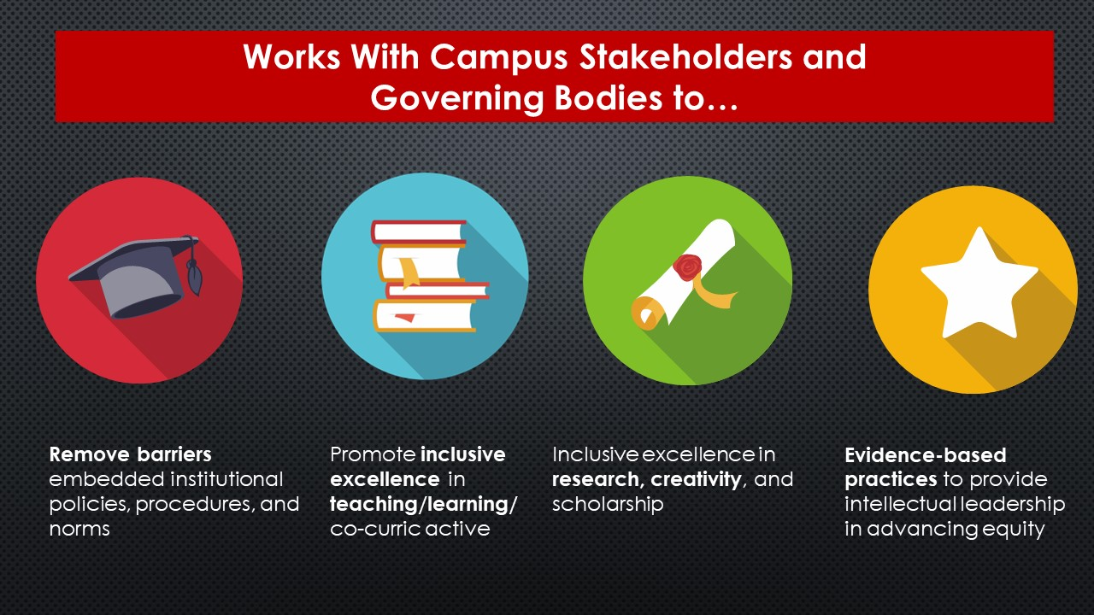

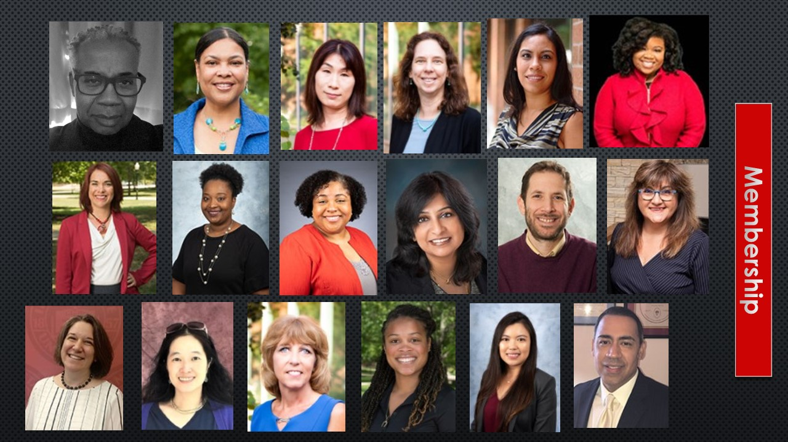

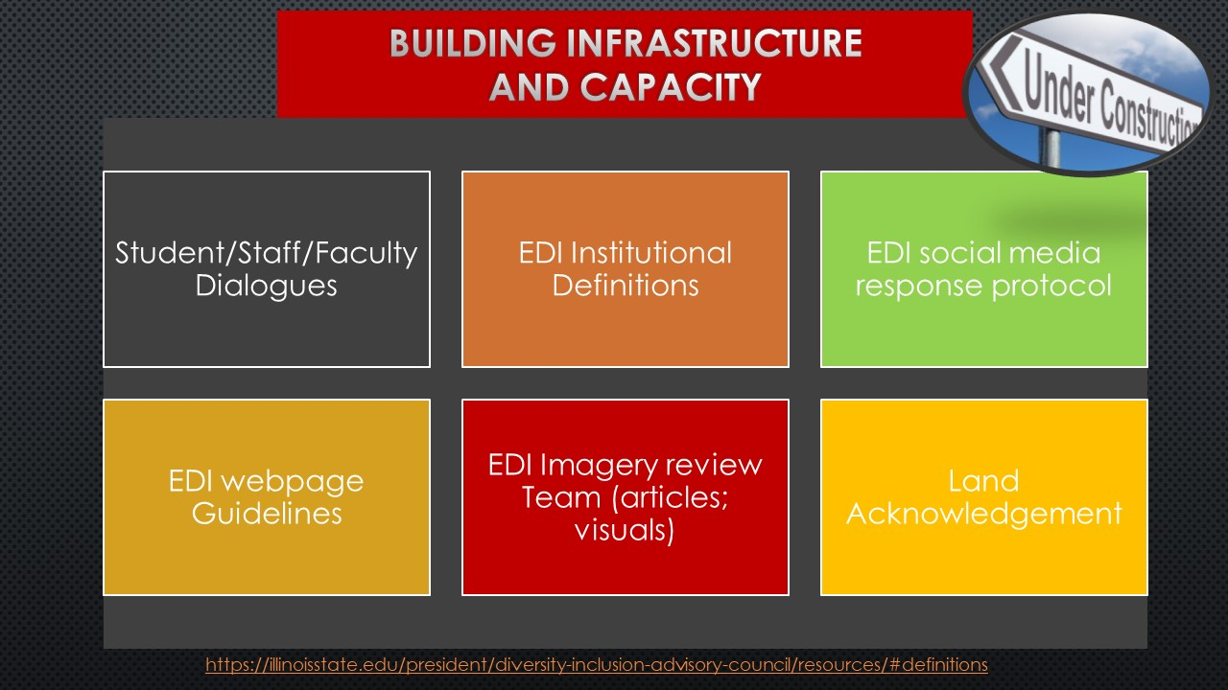

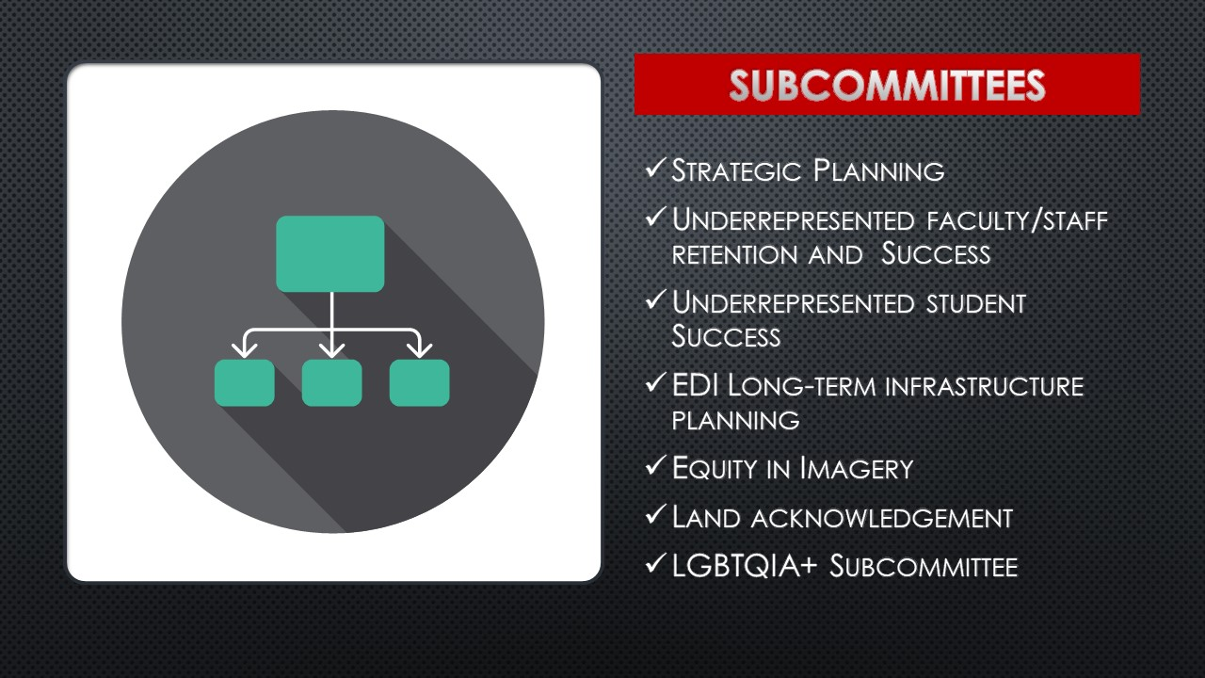

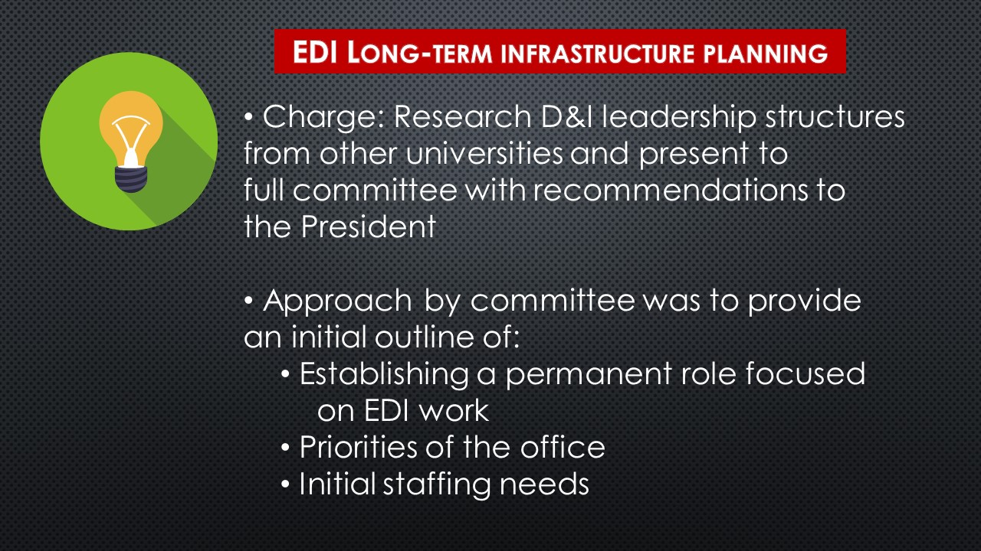

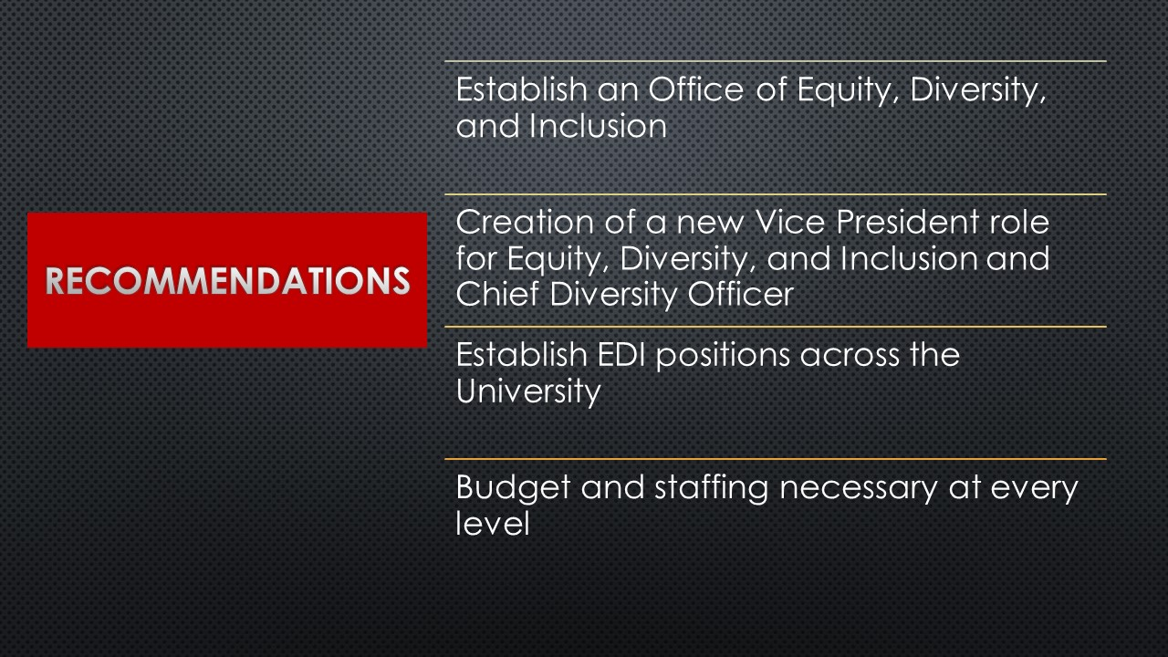
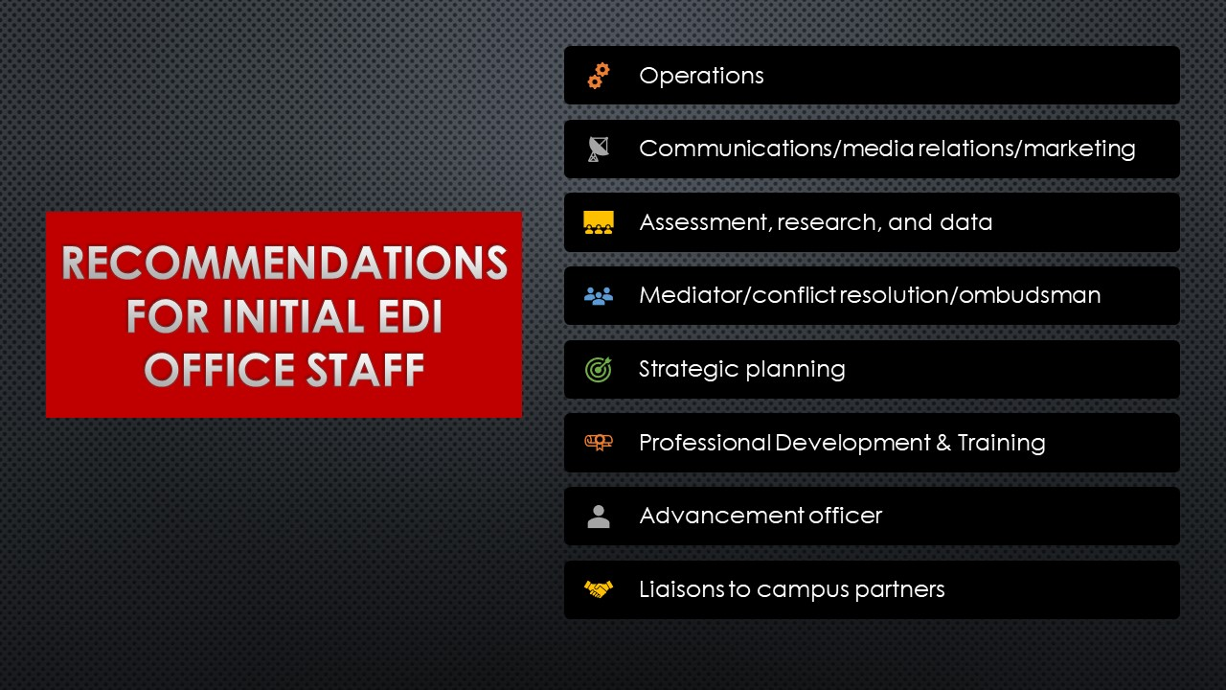
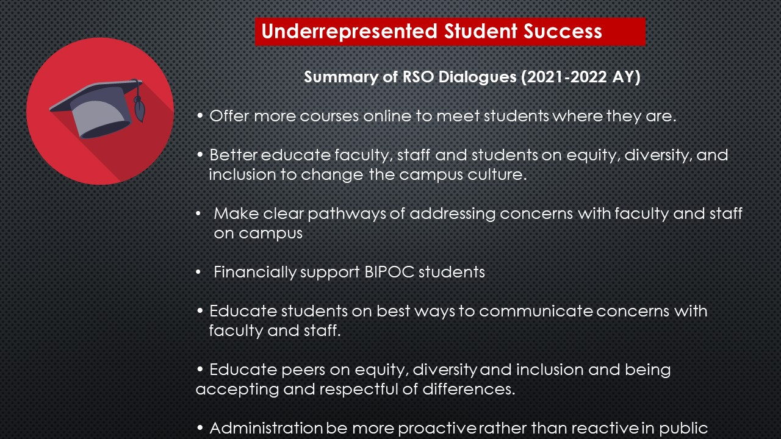

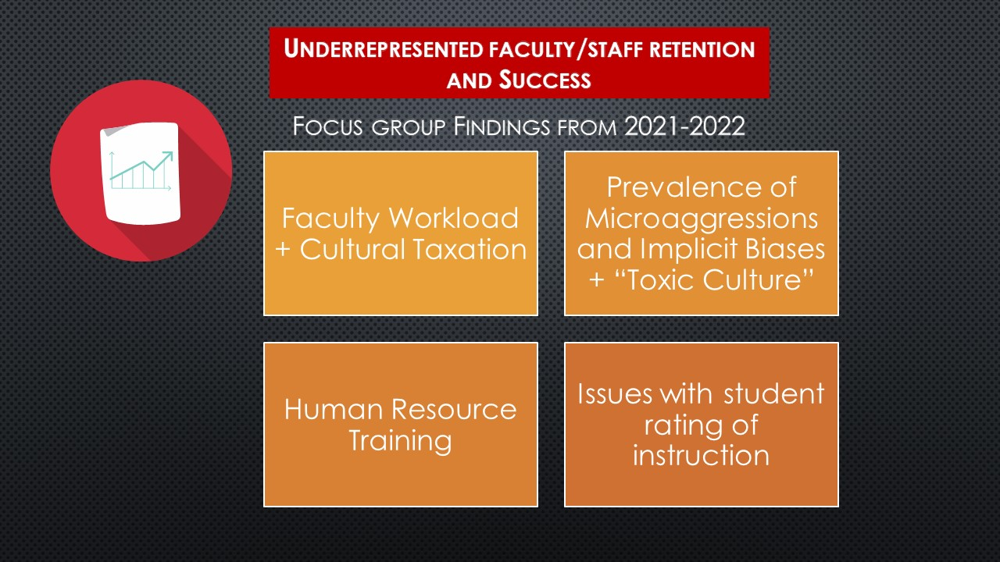

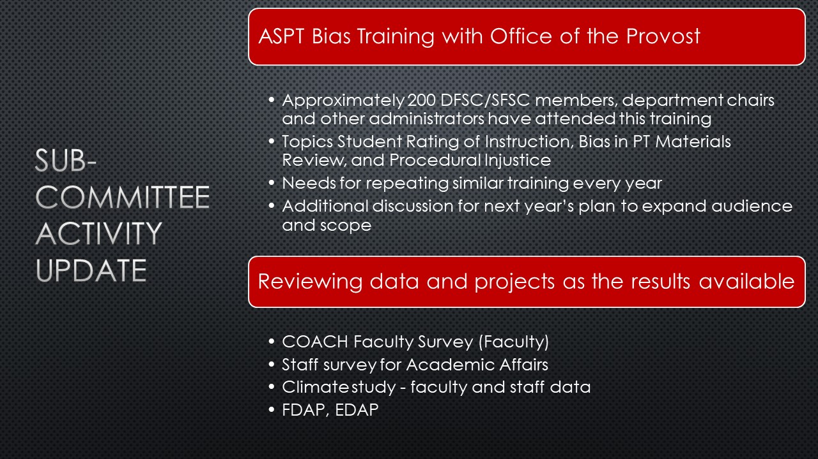

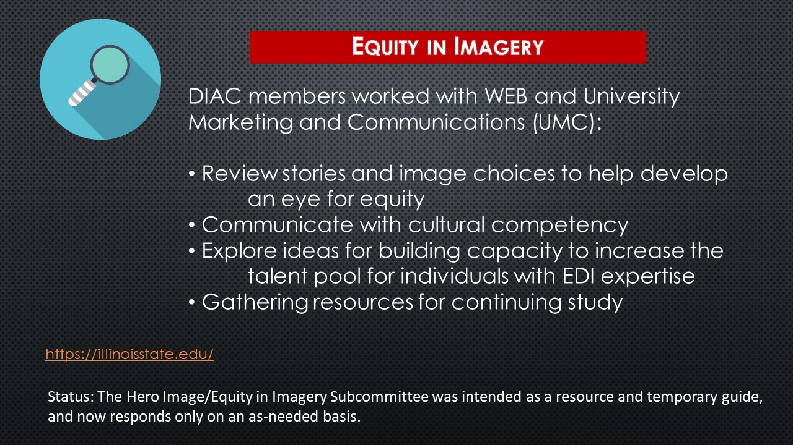

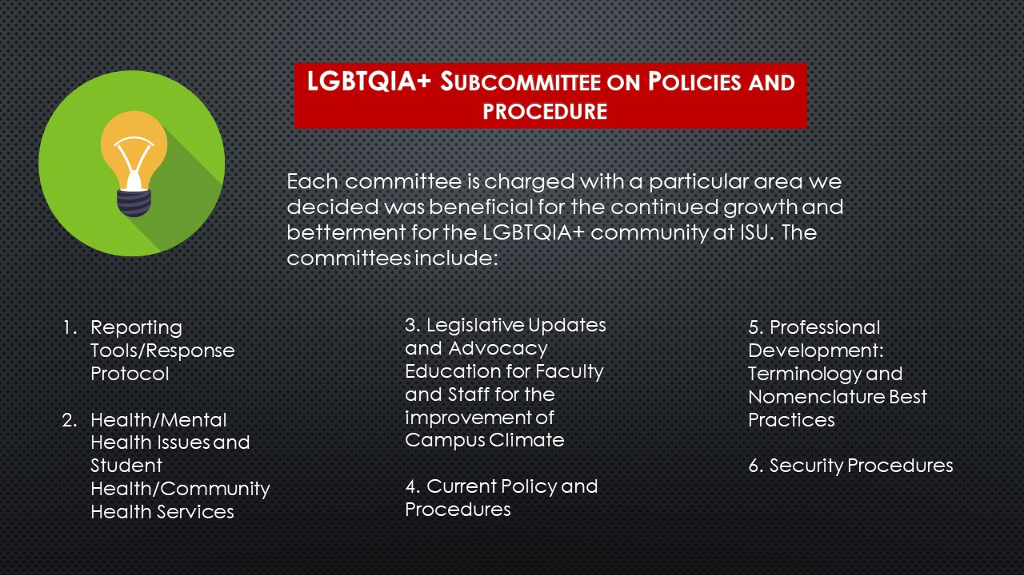

Appendix II

